

Planning & Highways Policy Appendices:
Appendix A – Primary Shopping Area Map from Lewes District Local Plan (Core Strategy)
Appendix B – Details of Road Schemes as Prioritised in Policy

APPENDIX A:
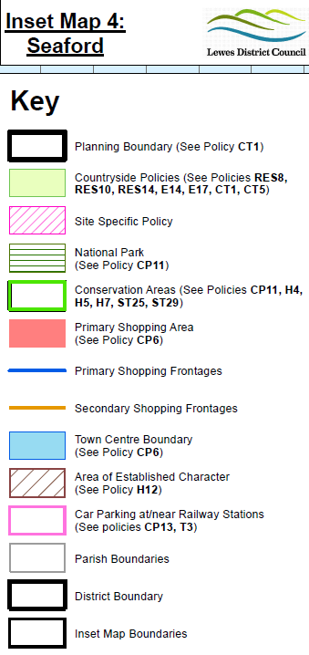
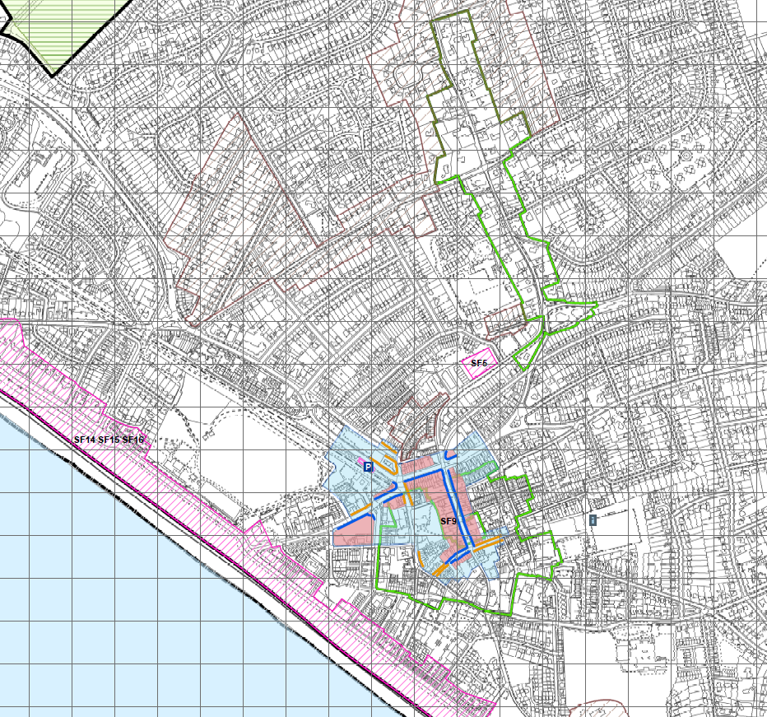

APPENDIX B:
3.3.i The Town Council has prioritised the road schemes that it deems the most important to be addressed within the town as (in no particular order):
  - Provision of a pedestrian crossing on the A259 Buckle Bypass in the vicinity of Claremont/Belgrave/Beacon Roads; at present there is a pedestrian island in the centre of the road however this does not provide adequate safety for pedestrians or slow down the speed of the traffic. A proper pedestrian crossing (pelican, puffin, toucan or zebra) would force the traffic to slow or stop completely, therefore making the area safer for pedestrians and other road uses. There is a stream of school children that use this crossing at peak times of the day and the current crossing offers little in the way of safety. East Sussex County Council are aware of the issue with vehicles travelling too fast on this stretch of road, evidenced by the use of a flashing speed limit sign that is activated when a vehicle is in excess of the speed limit, in particular as they enter Seaford from the west, going from a 60mph road to a 30mph road.

