CANCELLATION OF MEETING

Due to current circumstances, the planned Finance & General Purposes Committee meeting that was due to take place on Thursday 19th March 2020 at 7pm has been cancelled.

The next scheduled meeting of this committee is Thursday 9th July 2020.

Updates regarding other planned Council and committee meetings will be made as soon as possible.

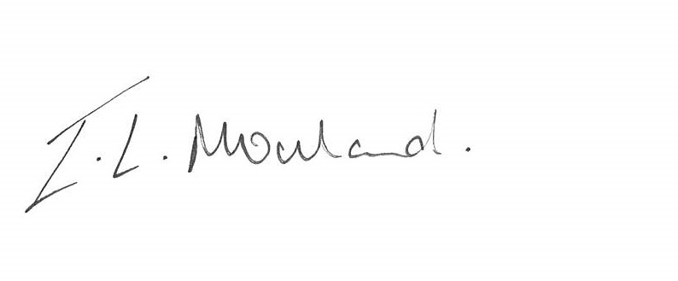

Isabelle Mouland
Assistant Town Clerk
19th March 2020

