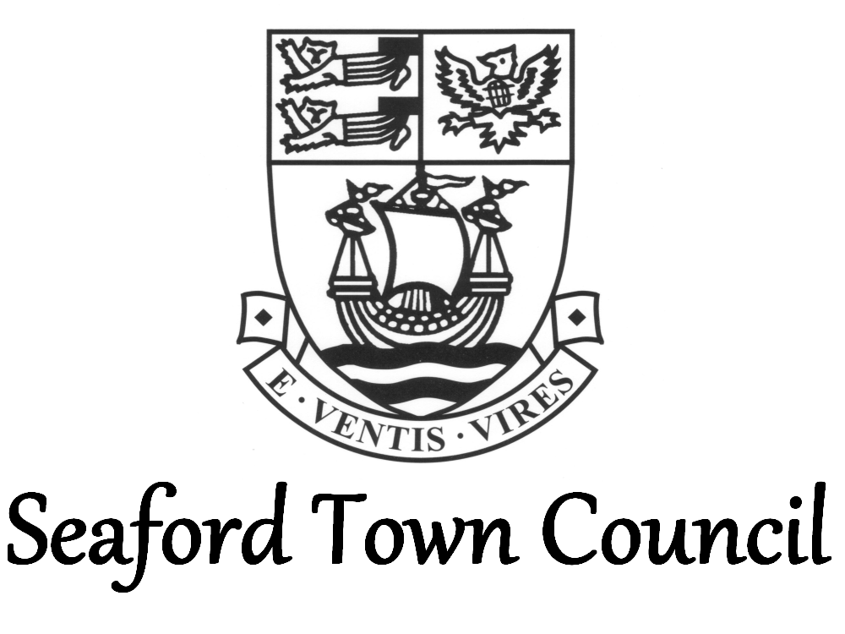

Corporate Sponsorship Policy
1. Introduction
Seaford Town Council will look to maximise sponsorship from the following
- Events e.g. Christmas Magic and Armed Forces Day
- Activities e.g. Sports equipment
- Campaigns and Initiatives e.g. The Seafront and The Salts Development Plans
- Assets e.g. Buildings, land (e.g. flower beds), memorial benches and sculptures
As well as helping the Council to generate revenues this will also provide opportunities for local businesses and other organisations to market their goods and services thus contributing to the growth and well-being of the town and local area.

2. Objectives
- To ensure the Council maximises income through commercial sponsorship
- To ensure the Council adopts a consistent approach to sponsorship agreements
- To ensure the Council’s position and reputation are sufficiently protected in sponsorship agreements
- To protect officers from allegations of inappropriate dealings or relationship with sponsors

3. General Principles
- The Council will actively seek opportunities to work with both local and national
organisations by identifying sponsorship opportunities of common benefit and which are
in keeping with its strategic objectives and core values.
- While the Council welcomes opportunities to work with partners, it will not put itself in a position where the partnership has, might have or maybe thought to have
- Influenced the Council in carrying out its statutory functions
- Gain favourable terms with the Council in any business or other agreements
- Aligned the Council with an organisation that conducts itself in a manner that conflicts with the Councils values
- The Council will not agree to sponsorship from the following:
- Religious Organisations
- Organisations in financial or legal conflict with the Council
- Organisations with a political purpose
- Organisations involved in racial, sexual prejudice or discrimination on the basis of disability
- The above list is not exhaustive, and the Council retains the right to decline sponsorship from any organisation or individual or in respect of particular products which the Council considers inappropriate.
- The Council also retains the right to remove sponsorship advertising, with no refund due to the sponsor, should, during the period of sponsorship, the sponsor fall under one of the categories at 3.c. or a similar situation deemed inappropriate.
- Consideration for sponsorship will take the form of an opportunity for publicity and advertising, thus raising the profile of the sponsor within the town. The Council will agree with the sponsor the nature and content of the advertising and will retain the right to approve all publicity material.
- The Council will at all times comply with its procurement policy and procedures and may, in accordance with those procedures, advertise a sponsorship opportunity to potential sponsors.

4. Procedures
- Before seeking sponsorship, Council officers must consider the Council’s sponsorship policy document and follow the guidelines provided.
- The Council will maintain a sponsorship register. It will be the responsibility of the officer responsible for the sponsorship agreement to enter the completed agreements on this register.
- All sponsorship bids shall be considered and approved, where relevant, by the Town Clerk. In the Town Clerk’s absence, an appropriate Service Manager will be able to consider and, where relevant, approve a bid through delegated authority but must report the sponsorship bid to the Town Clerk in writing as soon as practicable.
- The Council will agree the duration and monetary value of the sponsorship, assessing each sponsorship individually and referring to previous sponsorship agreements, where relevant. This will be recorded on the sponsorship register.
- All potential sponsors will be referred to this policy and will sign a copy of this policy upon entering the sponsorship agreement.

Adopted: 21st June 2018
Review: August 2022

