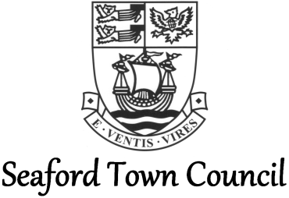

Twinning Policy

Town Twinning:

Town twinning was developed in Europe after the Second World War as a way of building strong links and friendships with communities in other countries to avoid another war and to bring unison across Europe.

The idea is to pair towns and cities in different countries with the focus of fostering human contacts. Twin towns often, but not always, have similar populations and characteristics.

Seaford:

In 1984 Seaford twinned with Bönningstedt in Germany after talks originally began on the subject in 1979. The twinning was a result of Bönningstedt’s quest to find a twin within East Sussex; an interest which began with the Royal Sussex Regiment’s ‘occupation’ of that area of Germany in 1945, the eventual twinning of East Sussex with the ‘County’ of Pinneberg and the good relations which grew out of that.

Initially a group called The Friends of Bönningstedt formed with monthly social gatherings, a visit to Bönningstedt every other year and welcoming visitors from their twin town in the intervening years.
The group became known as Seaford Twinning Association, having also had friendship links with Bönningstedt’s other twin, Crivitz in the former East Germany, and their twin of Crivitz in Wisconsin.

Seaford Twinning Association:

Following 35 years in existence, the Seaford Twinning Association disbanded in September 2017.

The Association aimed, and succeeded in, promoting and fostering friendships and understanding between the peoples of Bönningstedt, Crivitz and Seaford. The Association encouraged visits by groups and individuals of all three towns with the aim of broadening the understanding of the cultural, recreational, educational and commercial activities of the towns and promoting a network of Citizens within the European Community which wouldenhance the understanding of Europe.

Regular exchange visits were organised by the Association between Bönningstedt and Crivitz, and Seaford on alternate years. The Association also hosts the Seaford German Conversation Group once a month, the ‘Plauschgruppe’, which has continued to run since in its own right.

The Seaford Association received no funding from corporate bodies in England so fund raising activities were regularly held to ensure it could meet its monetary commitments.

The Association was run by a small committee that worked hard to promote the group; whilst there was a small and loyal membership, there was no-one able to run the Association.

Seaford’s Town Crier who became Town Crier of Bönningstedt in 1982, was the Honorary Chairman and Publicity Officer of the Committee.

The Twinning Charter is still in-force and will remain so. If at a later date a group wishes to reinstate a Twinning Association or similar such body, this option will remain.

Working in Partnership:

Seaford Town Council supports the twinning of its town and the work of the Seaford Twinning Association prior to disbanding. As one of the first towns to twin with a German town as a community effort (in the absence of a Town Council at that date) and having part of the promenade named in honour of its twin in 1993, the relationship between towns is held dearly.

In order to continue the working partnership it was agreed that the Mayor of Seaford each year be invited to be the Honorary President, should they wish to take on the role.

Seaford Town Council is committed to supporting the Twinning links of the town and the previous and any future Association where possible.

The Town Council recognises all that was done by the Seaford Twinning Association, and its members, for the town in nurturing and maintaining these important links to, and activities with, other communities.

Policy:

Seaford is twinned with Bönningstedt; it is felt by the Council that the existing twinning relationships should be focussed on and remain a priority. The Council therefore does not look to form any further twinning arrangements.

