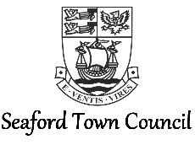
Risk Management Policy Statement

Seaford Town Council recognises that it has a duty to provide for the health, safety and wellbeing of its employees and others that may be affected by its activities. It is committed to continuous improvement and to allow this it will measure accidents, ill health, near miss incidents and losses.
Seaford Town Council also recognises its duty to ensure, so far as is reasonably practicable, to prevent or minimise emissions and wastes and any possible adverse impact of its work activities on the natural environment.
The Council will ensure, as far as is reasonably practicable, to provide safe and healthy working environments and premises, safe work equipment and safe systems of work and will strive to attain legal compliance as a minimum standard.
Suitable and sufficient risk assessment will be used throughout to ensure that arrangements for health, safety and the environment are adequate and remain current.
Employees will receive adequate and appropriate health, safety and environment training and will be expected to cooperate and to contribute towards a level of excellence.
Contracted work will be carried out by fully competent persons who will be expected to provide both risk assessment and method statement 28 days prior to work commencement and will work in such a way as to ensure safety for themselves, Town Council employees, the public and the environment.
Health, Safety and Environment procedures will be documented and used during employee training and will periodically be reviewed to ensure they remain current and relevant. Failure to follow procedures will be taken seriously and may result in disciplinary action being taken.
Roles and responsibilities for health, safety and environment will be made clear to all employees and those working in a contractual role (example: maintenance and cleaning) from the on-set of employment.
Seaford Town Council will aim to benchmark its performance wherever possible against available data from similar work environments.
The Council will take seriously any complaints made about health and safety or environmental issues from both employees and the public and will ensure that these are followed up in a prompt manner.
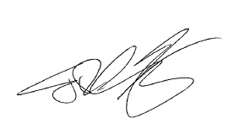
Seaford Town Council will ensure that its performance records are made available and discussed at employee meetings/consultations.

Signed: …………………………………..…………… (Town Clerk) Date:…28th March 2017………….

