CANCELLATION OF MEETING

Due to current circumstances, the planned Council meeting that was due to take place on Thursday 26th March 2020 at 7pm has been cancelled.

The next scheduled meeting of the Council is Thursday 21st May 2020.

Updates regarding other planned Council and committee meetings will be made as soon as possible.

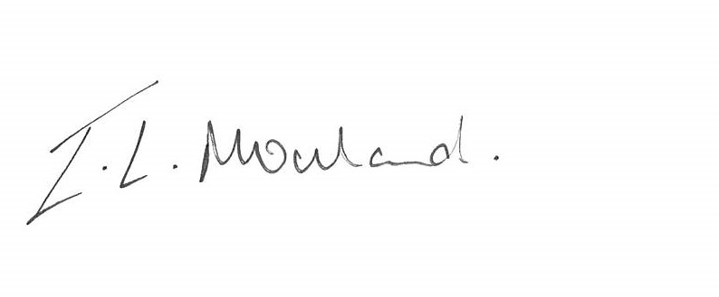

Isabelle Mouland
Assistant Town Clerk
20th March 2020

