Seaford Neighbourhood Plan
Housing & Development Focus Group
Working Paper – October 2017

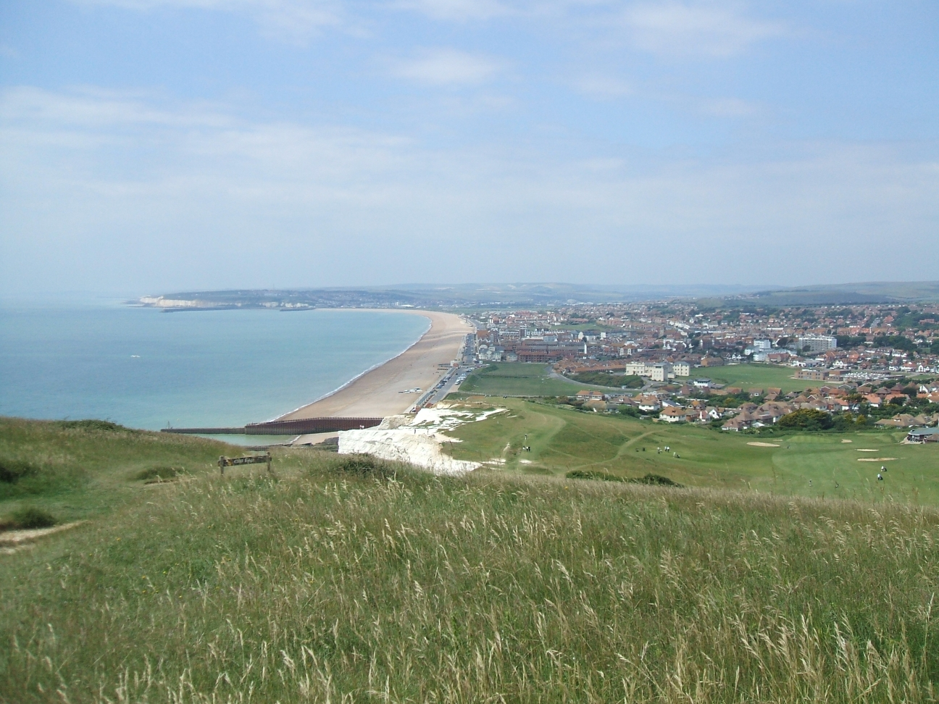

The following volunteers contributed their time to support the Housing & Development Focus Group

John Alcock
Chris Ashley Miller
Gee Auwkit
Bob Bayley
Paul Bower
Janice Broxup
Mack Burnside
Di Bushell
Sue Cornish
Tom Exley
Vicky Garland
Pauline Gower
Linda Green
Charlie Grimble
Stewart How
Tom Hulbert
Cllr Alan Latham
Melanie Locke
Sheila Lothian
Andy Lowe
Patrice Marsh
Teresa O’Brien
Jane Polling
Philip Pople
Lis Rosser
Denise Savage
Denise Scott Fears
Pat Short
Suede Stanton-Drudy
Alun Tlusty-Sheen
George Taylor
Gabby Tofts
Debbie Ward
Kate Welch

Contents
Page
- Executive Summary 3
- Introduction and Background 3
- Aim and Objectives 7
- SWOT Analysis 7
- Objectives and Evidence 8
- Policy Recommendations 23

Annexes:
A Seaford Planning Boundary Map 24
B Call for Sites 25
C Land and Site Schedules and Maps 26

D Sources of Evidence 47
E Existing Policy 51
F Site Assessment Criteria 53
G Site Assessment Template 54
H Suitability Assessment Table 55
I Strategic Environmental Assessment Criteria 56
J Consultees 58

K Questionnaire to Young People & Heads of Household 59

L Seaford Sports, Recreation and Play Facilities 61

M Character Assessment (separate report)

N Landscape Character and Key Views (separate report)

1. Executive Summary

Lewes District Council (“LDC”), in the original draft Joint Core Strategy of 2015, and subsequently approved by Public Examination in 2016, identified 13 sites that were developable and deliverable and that would produce 185 homes to be delivered in Seaford by 2030 (see detailed breakdown below paras 2.5-2.9) to meet a projected population increase of approximately 2,050 between 2015 and 2030. This Working Paper examines how those sites have performed subsequently, and proposes alternatives for those that have failed to achieve LDC’s expectations of 2015. The locations and nature of those 185 new dwellings can be influenced by a robust Neighbourhood Plan for the town. The proposed sites are found on page 45 of this document Annex C.

This Working Paper incorporates the Housing & Development Focus Group Evidence Report published on 30th November 2016 and presented at a public consultation event on that date.

In that Evidence Report, the Housing & Development Focus Group (the “Focus Group”) set out how it planned:
- To identify a range of types and tenures of high quality open market and affordable housing:
  - in the most sustainable locations
  - accessible to local services and facilities
  - complementing and enhancing the built and natural environment
  - that meets the needs of the individuals and families seeking housing in Seaford
- to catalogue all potential sites for development
- to assess and categorise those sites according to a set criteria
- to thereby optimise the construction of additional housing in Seaford

This Working Paper has been published to report the work of the Focus Group in achieving these plans.

2. Introduction and background

Seaford is in a unique setting, bordered on all sides by either the South Downs National Park or the sea. The town has seen extensive development and growth over the past few decades noticeably because of the closure of private schools, with their land being used to build housing estates, and other development opportunities. Seaford has seen a doubling of its population since the 1960’s, making it the largest town within Lewes District by some margin. There is now very limited space available for new building, and this is reflected in the Lewes District Joint Core Strategy (para 6.39 page 54. JCS 2016).

The Neighbourhood Plan survey carried out in June 2016 revealed that Seaford's housing is subject to a fair amount of comment. It is generally thought to be too expensive for younger households and too large for pensioner households. Local opinion is mixed over the design quality of new housing; most think it could be better. Existing older areas are valued, and green spaces are welcomed. There is some attractive historic housing which should be protected.

“Neighbourhood planning gives communities direct power to develop a shared vision for their neighbourhood and shape the development and growth of their local area. They are able to choose where they want new homes, shops and offices to be built, have their say on what those new buildings should look like and what infrastructure should be provided.”

This Working Paper sets out the aim, objectives and recommendations of the Focus Group on how we propose to deliver Seaford’s housing allocation. Work has also commenced on a design guide for Seaford to encourage a higher standard of design for development within the town, and it is hoped to publish this for public comments at a later stage, and to have it adopted by the local planning authorities as a Supplementary Planning Document.

“Once a neighbourhood plan has demonstrated its general conformity with the strategic policies of the Local Plan and is brought into force, the policies it contains take precedence over existing non-strategic policies in the Local Plan.” Seaford residents can expect LDC decision makers to determine applications for planning permission in accordance with Seaford’s Neighbourhood Plan, unless material considerations indicate otherwise.

The LDC Local Plan Part 1 Joint Core Strategy May 2016 sets the minimum number of dwellings expected to be completed in the District in the period 2010 – 2030. However, the situation is more complex than it appears. The planned level of housing growth for Seaford over this period is a minimum of 554 units. This comprises: homes built between April 2010 and April 2015, known as completions and account for 216 units; all proposals for development that, as at 1st April 2015, are the subject of a current full or outline planning permission or are unimplemented allocations in an existing local plan, known as Commitments and account for 153 units; leaving a minimum of 184 net additional units that will need to be delivered through future allocations such as the Neighbourhood Plan. LDC has rounded this number to 185 units in its documentation. If the Neighbourhood Plan does not allocate sites for development, then LDC will control this allocation through Part 2 of its Local Plan.

The planned growth in the Core Strategy (2016) | Seaford allocations: 553 (min.)
Completions April 2010 – April 2015 | 216
Commitments as at April 2015 | 153
Total remaining | 184 (rounded to 185)

The details behind these figures relate to LDC’s assessment at the time of what identified sites would yield. Completions are a matter of record, and so do not need identifying further. The 153 homes identified under ‘commitments’ are as follows:

Site address | App. No. | LDC assessment of reason for inclusion | Total  *Indicates implemented
Tudor Manor | LW/07/1584 | Planning Permission | 6(8) *
34-40 High Street | LW/12/0020 | Planning Permission | 8
Former Gasworks site |  | Allocated in 2003 Local Plan | 30
1-10 cons Talland Parade | LW/11/1321 | Planning Permission | 10 *
Beachcomber | LW/10/1048 | Planning permission (net  additional housing gain  figure-37 completed) | 5 *
Mardon, Claremont Road | LW/10/0359 | Planning Permission | 18
Former Central Garage | LW/11/0923 | Planning Permission | 27(38) *
6 Steyne Road | LW/12/0693 | Planning Permission | 6
Sutton Garages | LW/12/0851 | Planning Permission | 9*
Small sites |  |  | 34
 |  | Total | 153

2.7 Within the total of 153 homes above is an allowance of 34 ‘small sites’. LDC listed all the small sites they were aware of, which totalled 45. To allow for some falling by the wayside, a discount of 25% was applied yielding the figure of 34 that appears in the table. The sites yielding those 45 homes is listed in the table below:

Site address | App. No. | Total | Loss | Net supply  *Indicates implemented
22-24 Sutton Park Road | LW/11/1202 | 4 | 0 | 4*
Land NE end, Antony Close, B’stone | LW/12/0123 | 1 | 0 | 1*
Annecy Convent, 10 Sutton Avenue | LW/12/0319 | 5 | 0 | 5
Land adj. 12 Pitt Drive | LW/12/0585 | 1 | 0 | 1
1 Vale Close (resubmit of LW/05/1571) | LW/12/0644 | 1 | 0 | 1
The Cottage, Cliff Road | LW/13/0254 | 1 | 0 | 1
Land R/O 1 Chyngton Gardens | LW/13/0398 | 1 | 0 | 1
11, Blatchington Road | LW/13/0306 | 3 | 0 | 3*
26, Broad Street | LW/13/0517 | 2 | 0 | 2*
V Bar, Pelham Yard | LW/13/0444 | 3 | 0 | 3*
Land R/O 29, Chyngton Road | LW/14/0073 | 1 | 0 | 1*
2 Salisbury Road | LW/14/0111 | 3 | 1 | 2*
Paignton House, Warwick Road | LW/14/0237 | 1 | 0 | 1*
Land R/O 53 Vale Road | LW/14/0130 | 2 | 0 | 2*
Malbro, Wilmington Road | LW/14/0298 | 2 | 1 | 1*
8, Clinton Place | LW/14/0554 | 4 | 0 | 4*
2, Claremont Road | LW/14/0486 | 1 | 0 | 1*
16, Bowden Rise | LW/14/0489 | 2 | 1 | 1
1, Belgrave Road | LW/14/0234 | 3 | 1 | 2*
Gable End Cottage, Arundel Road | LW/14/0351 | 2 | 0 | 2*
New Barn, Silver Lane, Bishopstone | SDNP/13/05879/FUL | 1 | 0 | 1
Sutton Corner Garage, Sheep Pen La. | LW/14/0640 | 3 | 0 | 3
Flat 1, 47, High Street | LW/14/0748 | 2 | 1 | 1*
Sutton Parade, Alfriston Road | LW/14/0795 | 1 | 0 | 1
Total |  |  |  | 45
25% discount applied |  |  |  | 34

2.8 Of the 45 identified small sites to date (August 2017) 30 have been delivered. A further Planning Approval was given to Diella’s Restaurant, Dane Road (LW/15/0024) on 25 February 2015, and it has been implemented as an additional flat. This is therefore eligible to be counted, and has been added to the 30, making 31 homes delivered against the target of 153 homes. Of the other larger sites, 70 homes have been delivered. These are marked with an asterisk in the above 2 tables. Thus, of the total 153 homes, 101 have been delivered. Of the remaining large sites, The Former Gasworks site (30 homes), is within the Dane Valley Project area, and therefore likely to be delivered. We have therefore to make provision for the resultant shortfall of 22 homes in our proposals, to achieve our overall contribution of 554 homes during the plan period.

The 184 homes figure was based upon the following sites, and their capacity assessment. It was rounded up to 185 by the Examiner:

Site | LDC assessment | No. of homes | SHELAA reference
Land S of Chyngton Way | Deliverable | 40 | 01SF
East Street Car Park | Developable | 10 | 05SF
Old House Depository, Claremont Rd | Deliverable | 35*
Buckle Car Park | Developable | 10 | 15SF
Chalvington Field, Normansal Pk. Ave (NP) | Deliverable | 20
Land at Florence House, Southdown Rd | Deliverable | 10 | 22SF
Land at Crown Hill | Developable | 7 | 08SF
Holmes Lodge, Claremont Road | Developable | 12 | 20SF
51-53 Blatchington Road | Developable | 9 | 21SF
Ex. Wynne’s Nursery, 53, Sutton Drove | Developable | 7 (4*)
Station approach, Dane Road | Developable | 10 | 24SF
Elmcourt, Blatchington Road | Developable | 8
Land at East Albany Rd/Sutton Drove | Developable | 6 (3*)
- Denotes achieved |  | 184

  - It will be noted that all the above sites have been assessed as part of this housing review, and on the evidence amassed for each site, housing development of some of these sites fails to meet several of the 10 Sustainability Objectives (as set out in the Scoping Report) used to assess development potential in the light of current policies. These are highlighted in yellow in the table above. Further, 42 of these homes have now been delivered. These are asterisked. It will be noted that 2 of these achieved sites have produced less homes, and fall below the threshold of 6 homes per site. Accordingly, the Working Group has not counted them in their revised proposals. Elmcourt was granted planning permission on 7 June 2016, and is expected to be sold by East Sussex County Council shortly, and so is on the way to being achieved. All the other sites in the table above in this paragraph do not have a planning application, and so needed to be reviewed by the Focus Group.

2.11 To summarise the ACTUAL performance of Seaford in meeting its 554 homes target, the current position is as follows
Completed 2010-2015 216 homes
Achieved Commitments on identified schemes 131 homes (101 +30- Old Gasworks site)
Achieved homes in 184 JCS target 35 homes
Revised current shortfall 172 homes

2.12 The Neighbourhood Plan therefore proposes sites that will more than meet the current revised shortfall of 172 homes. This will have 2 elements:

- 43 homes on sites not yet developed, and identified by LDC since 2015 and in the table in para 2.9 above, (Holmes Lodge, 51-53 Blatchington Road Station ~Approach & Elmcourt)
151 Homes on new sites identified by the Seaford Neighbourhood Plan and appraised by our consultants as meeting the 10 Sustainability Objectives set out in the Plan.

ANNEX C has the table (List of proposed development sites) that sets out the elements in the Neighbourhood Plan that more than achieves this target. Together with the Old House Depository Site, the above programme provides 229 new homes in all, 127 of which will be affordable.

2.13 Units on small sites and unidentified larger sites that have obtained planning permission since 1st April 2015 to date and units that obtain planning permission between now and when the Neighbourhood Plan ‘has gained sufficient weight’ will be considered as windfall or ‘unidentified ‘and cannot be counted against the original 185 figure at this stage. The definition of a windfall site as described on page 138 of the Core Strategy is “a site not specifically allocated for development in a development plan, but which unexpectedly becomes available for development during the lifetime of a plan. Most "windfalls" are referred to in a housing context. They tend to be small sites for a small number of homes.” In addition, sites outside of the Neighbourhood Plan that obtain planning permission will also be considered as windfall. Thus, the Newlands School development, The Constitutional Club, Sutton Leaze site, totalling 212 approved homes, all contribute to the overall District wide target of 200 homes. Since 1 April 2015, small sites have received approvals for 48 homes, not all of which will proceed.

- Aim and Objectives

3.1 The Focus Group’s aim and objectives are based upon a strong foundation of evidence from the following sources:
- Responses given in the Neighbourhood Plan, Housing Needs and Young People’s surveys;
- Comments received at and following Neighbourhood Plan public consultation events;
- Comments received by the Steering Group during the Plan to date;
- Input from the Neighbourhood Plan Steering Group and Focus Groups;
- Input from Neighbourhood Plan workshops;
- Input from local stakeholder groups;
- Evidence from the sources listed in Annex D.

3.2 The Focus Group’s aim has been: Within the constraints of the limited space available, to meet the demand from and needs of the local community for high quality, well designed new market and affordable homes within sustainable locations whilst conserving and enhancing the natural and historic environment. We will do this by setting out specific recommendations in the Neighbourhood Plan that complement the existing national and district policies.

3.3 In delivering this aim, the Focus Group has had the following objectives:
- To meet the needs and expectations of local people by allocating high quality new open market and affordable homes on previously developed land within the planning boundary.
- In accordance with local and national policy, to provide for a range of housing mix, types and tenures in the most sustainable locations that are accessible to local services and facilities.
- To set out design specifications to ensure that new homes and developments complement and enhance the town’s built and natural heritage.

- Strengths, Weaknesses, Opportunities and Threats
4.1 To inform and shape these objectives, we undertook a SWOT analysis:
SWOT Analysis for Group
Strengths:  - Active housing market  - Small amount of dereliction  - High proportion of existing housing is accessible to public transport  - National Park provides some protection of green field sites given the South Downs National Park Authority's objectives are set out in Parliamentary legislation  - Attractive for commuters to Brighton, Eastbourne, Lewes  - House prices lower than county and regional average | Weaknesses:  - Inadequate number of 1 & 2 bedroom dwellings and bungalows  - Need for more affordable open market and rented accommodation  - Adequacy of current housing stock (some too large)  - Lack of Infrastructure (e.g. doctors and schools), particularly local amenity in the South-East corner of the parish and uncertainty over future train services.  - Geographic constraints mean limited space available for building
Opportunities:  - To maximise opportunities for identifying potential brownfield sites for redevelopment over the next 14 years  - The opportunity to maximise residential accommodation in the town centre by re-using or converting vacant upper floors above shops and offices  - To ensure opportunities to sub-divide larger dwellings into smaller units are identified  - The opportunity to create design specifications that complement and enhance the town’s built and natural environment | Threats:  - Decreasing amount of amenity open space, which any further development may impact  - Demand from pensioners who retire to Seaford from outside the area  - Ageing population structure  - Loss of young people who cannot afford to stay in the town  - Risk of flooding, both from sea and surface water  - Some archaeologically sensitive areas  - Potential impact of any development on the South Downs National Park Authority’s statutory objectives

- Objectives and Evidence

  - The remainder of this Working Paper describes the evidence the Focus Group has collected against our three objectives, which we believe will deliver the aim we have set for this Focus Group, and the wider Neighbourhood Plan vision.

  - The Focus Group has also been very aware of the fact that our role is to look at where we think the Neighbourhood Plan can make recommendations which add to the policy framework, which we refer to as our key recommendations. As a result, we have undertaken a review of what we see as the key current policy framework – this is set out fully in Annex E, but overall covers:

- The National Planning Policy Framework
- Lewes District Local Plan Part 1 – Joint Core Strategy 2010 - 2030
- Lewes District Council saved policies,
- Policies and Proposals specific to the town of Seaford
- The South Downs National Park Emerging Local Plan

  - The Working Paper also sets out where we think an issue is important, but where additional recommendations are not needed. An example of this is Core Policy 1 – Affordable Housing, where LDC already has a robust policy.

5.4 Objective 1

To meet the needs and expectations of local people by allocating high quality new open market and affordable homes on previously developed land within the planning boundary.

National Planning Policy Framework (NPPF)

5.4.1 One of the Core Planning Principles set out in Paragraph 17 on page 6 of the NPPF is to “encourage the effective use of land by reusing land that has been previously developed (brownfield land), provided that it is not of high environmental value.”

5.4.2 As 61.4% of the Neighbourhood Plan area is within the South Downs National Park. Therefore paragraphs 115 and 116 of the NPPF are very relevant to the Plan.

“115. Great weight should be given to conserving landscape and scenic beauty in National Parks, the Broads and Areas of Outstanding Natural Beauty, which have the highest status of protection in relation to landscape and scenic beauty. The conservation of wildlife and cultural heritage are important considerations in all these areas, and should be given great weight in National Parks and the Broads.

116. Planning permission should be refused for major developments in these designated areas except in exceptional circumstances and where it can be demonstrated they are in the public interest. Consideration of such applications should include an assessment of:
- the need for the development, including in terms of any national considerations, and the impact of permitting it, or refusing it, upon the local economy;
- the cost of, and scope for, developing elsewhere outside the designated area, or meeting the need for it in some other way; and
- any detrimental effect on the environment, the landscape and recreational opportunities, and the extent to which that could be moderated.”

5.4.3 The NPPF does not define major development. The SDNPA sought a legal opinion on this matter, initially in 2011 in relation to paragraph 22 of Planning Policy Statement 7 which preceded the NPPF. This opinion, from James Maurici QC, was reviewed and updated in 2013 to take account of the NPPF and the Planning Practice Guidance (“PPG”), as well as relevant case law which had emerged in the meantime.

5.4.4 While it may well be appropriate, as part of the determination of whether a proposal is “major development”, to consider whether, because of its scale, character or nature, it has the potential to have a serious adverse impact on a National Park or AONB, “major developments” are not defined in paragraph 116 of the NPPF by their actual, assessed impacts but by the nature of the development.’

5.4.5 Maurici sets out principles –derived from the case law, guidance and appeal decisions - to be applied by decision makers when determining whether a proposal is for major development. These are summarised as follows:
- The determination is a matter of planning judgment to be decided by the decision maker considering all the circumstances and the context of the site.
- The phrase “major development” is to be given its ordinary meaning. Accordingly, it would be wrong in law to:
- Apply the definition of major development contained in the Town and Country Planning (Development Management Procedure) (England) Order 2010.
- Apply any set or rigid criteria.
- Restrict the definition to proposals that raise issues of national significance.

5.4.6 The decision maker may consider whether the development has the potential to have a serious adverse impact on the natural beauty and recreational opportunities provided by a National Park or AONB because of its scale, character or nature. However, that does not require (and ought not to include) an in-depth consideration of whether the development will in fact have such an impact. Instead, a prima facie assessment of the potential for such impact, considering the scale, character or nature of the proposed development is sufficient.

5.4.7 As a matter of planning judgement, the decision maker must consider the application in its local context. The same development may amount to “major development” in one National Park, but not in another; or in one part of a National Park, but not in another part of the same National Park. Having considered all the circumstances, including the local context, the decision maker must take a common-sense view on whether the proposed development can appropriately be described –in ordinary language -as “major development”.

5.4.8 In a further opinion dated October 2011, Maurici clarifies that any consideration of what is ‘major development’ should encompass wildlife and cultural heritage as a limb of the statutory purposes of a National Park. He also considered that “scenic beauty” (as used by the NPPF and PPG) is concerned with what can be seen, and “natural beauty” as now defined by statute is clearly wider, encompassing wildlife and cultural heritage. In relation to principle 3 above, therefore, potential impacts on ecology, geodiversity, archaeology and cultural heritage should be considered in addition to ‘scenic beauty and landscape’.

Core Strategy

5.4.9 Seaford is very fortunate that the Joint Core Strategy Local Plan Part 1 was adopted by LDC in May 2016 and the South Downs National Park Authority in June 2016. This sets out very clear strategies and policies promoting sustainable development and protecting and enhancing the distinctive character of the built and natural environment.

5.4.10 One of the key paragraphs of this strategy, which the Focus Group has reviewed and supports is paragraph 6.39 on page 54 which states:

“In the case of the District Centres within the plan area (Lewes, Newhaven, Peacehaven/Telscombe and Seaford), the National Park designation either covers the whole settlement, or immediately borders it in most locations. Given the need “to conserve and enhance the natural beauty, wildlife and cultural heritage of the National Park” (the first National Park purpose), opportunities to expand these settlements outwards into the National Park whilst ensuring this purpose is not compromised are limited. This has been particularly evident for Seaford, which is the largest town in the plan area, where any significant expansion of development into the surrounding countryside cannot be achieved without damage to the landscape value and scenic beauty of the National Park. This has been a key contributing factor in very limited planned growth being identified for the town.”

5.4.11 The Core Strategy also sets out the planning boundary, which “has been drawn largely to reflect the edge of the existing built-up area. To the north, west and east of the town the Sussex Downs Area of Outstanding Natural Beauty closely follows the line of the Planning Boundary.” The Core Strategy also includes a series of maps and the Seaford map, setting out the planning boundary, is included in Annex A.

5.4.12 According to paragraph 7.22 on page 87 of the Lewes District Joint Core Strategy “The Local Housing Needs Assessment has identified that the main growth in demand to 2030 will be for dwellings for older people and small homes for single person households and couples with no dependents. However, there will also be a need for family homes, particularly due to the level of under-occupation of larger family homes in the district, creating pressures of demand (and therefore on affordability) for homes of this type.” Paragraph 7.6 on page 82 confirms “there is still significant evidence of a considerable need for affordable housing in the district.”

Policy Recommendation 1: We fully support the Core Strategy and upholding the approach that it takes towards planning and development across the district. We support the retention of the planning boundaries as set out in Policy CT1 and the redevelopment of brownfield sites within these boundaries.
5.4.13 The Focus Group is aware that the Saved 2003 Policy E4, which related to Town Centre development, has been replaced by Core policy 6 – Retail and Sustainable Town and Local Centres. Although there is no longer a specific reference to encouraging residential accommodation in town centres and encouraging the re-use or conversion of vacant upper floors above shops and offices, the Focus Group believes that encouraging residential dwellings above non-residential premises should be actively encouraged as it supports Core Policy 13 – Sustainable Travel, which states: “The local planning authority will promote and support development that encourages travel by walking, cycling and public transport, and reduces the proportion of journeys made by car, in order to help achieve a rebalancing of transport in favour of sustainable modes by:

- Ensuring that new development is located in sustainable locations with good access to schools, shops, jobs and other key services by walking, cycling and public transport in order to reduce the need to travel by car (unless there is an overriding need for the development in a less accessible location).”

Policy Recommendation 2: We support the conversion of upper storey space to housing and encourage building residential dwellings above non-residential premises such as shops and businesses, particularly in the town centre.
Land and Site Assessments

5.4.14 Once we had concluded that several sites identified by LDC in 2015 could not be developed, the Focus Group was very aware that would have a significant challenge to identify suitable replacement sites within the planning boundary for at least 185 homes. To meet this objective, sufficient previously developed land and buildings needed to be identified and put forward to the Neighbourhood Plan by land/property owners and/or their agents.

5.4.15 A Call for Sites (see Annex B) was launched on 1 June 2016 and advertised in the following places:

- Seaford Town Council website
- Seaford Neighbourhood Plan website
- Seaford Town Council Facebook page
- Seaford Residents Voice Facebook page
- Seaford Notice Board Facebook page
- Seaford Notice Board 2 Facebook page
- I love Seaford Facebook page
- Seaford Information Station Facebook page
- Seaford Open Noticeboard Facebook page

5.4.16 The initial Call for Sites ended on 29th July 2016, but was then extended until 30th November 2016 to allow more sites to be submitted. By 30th November, a total of ten sites had been put forward, of which, one was the Newlands School site, which we would not count towards our allocation, and four were in the South Downs National Park. Our draft Evidence Report proposed, therefore, that the dialogue with owners of potential sites should continue, to encourage more sites to come forward, particularly brownfield sites. Seaford Town Council put forward 25 sites on 19th December 2016, all green field sites, except for the War Memorial and High & Over car park.

5.4.17 Fortunately, following the public consultation event on 30th November 2016, a significant number of residents volunteered to join the Focus Group. We were then able to create several work streams, one of which was the Brownfield Sites work stream, whose role was to contact owners of large brownfield sites around the town to establish if the site was likely to become available by 2030, another work stream focused on how to develop the area around the old gasworks site.

5.4.18 The gasworks and surrounding sites were mentioned numerous times in the Neighbourhood Plan survey responses as an area that should be developed. However, there are significant issues which have made piecemeal development impossible in this area. The Dane Valley Project was therefore created to provide a comprehensive planning framework to address the issues and site constraints including:

- Contamination
- Drainage
- Archaeology
- Traffic issues
- Fragmentation of interests
- Employment issues

5.4.19 Work is progressing well on creating this framework and the Department for Communities and Local Government has appointed AECOM, an international organisation that puts experts in touch with communities to develop and implement innovative solutions to complex challenges, to work with the Steering Group on the Dane Valley Project. We were informed by LDC in August 2017 that one site within the Dane Valley Project area (The Old Gasworks site (30 homes in the JCS and 31 homes when assessed by our consultant AiRS) could not be included in our allocation as this is considered an unimplemented allocation in an existing local plan and has already been counted within the Commitments figure of 153. (see table in para. 2.6 above).

5.4.20 The Focus Group became aware of the Henfield Judgement in 2016 and that “It is essential that the authority ….. responsible for the adoption of the plan ….as well as the authorities and the public consulted, are presented with an accurate picture of what reasonable alternatives there are and why they are not considered to be the best option.”

5.4.21 To achieve this objective, we recognised it would be necessary to identify and review all possible sites, not just those that had been submitted in the Call for Sites, and we have undertaken a Land and Site Assessment. The Focus Group used all available data from the sources cited below to create an initial list of 226 potential sites, both within and outside the planning boundary:

- The Lewes District Strategic Housing and Economic Land Availability Assessment (SHELAA)
- The SDNPA Strategic Housing and Land Availability Assessment (SHLAA)
- Neighbourhood Plan Survey Responses
- List of Seaford Town Council owned sites – for sale or being considered for sale
- List of other Seaford Town Council owned sites
- List of Lewes District Council owned sites
- List of East Sussex County Council owned surplus sites
- Call for sites
- Knowledge of brownfield sites
- Knowledge of large dwellings with the potential to be sub-divided into smaller units

Following the influx of new volunteers with local knowledge, the initial list then increased to 306 sites (see lists and maps in Annex C). Upon further examination 13 of these sites were duplicates; this therefore reduced the number to 293 sites.

5.4.22 To ensure that the Neighbourhood Plan is as robust as possible, we carried out an initial assessment of all 293 potential sites. The initial assessment criteria were as follows:

5.4.23 Could the site accommodate 6 or more units? At a meeting with LDC on 14th October 2016, we were informed that to be eligible for consideration within the Neighbourhood Plan, sites must be able to accommodate at least 6 dwellings, and that anything smaller would count as windfall.

5.4.24 On 11th January 2017, we were informed by a councillor from a neighbouring Parish Council that all sites, including those that can accommodate less than 6 dwellings, can count towards our allocation. The Focus Group therefore sought clarification from LDC. We were informed as follows: “we advise neighbourhood plan groups who wish to allocate sites within their plan to only look at what we called large sites, which are sites that can accommodate 6 units or more... the reason we accepted the allocation of small sites in the [other] Neighbourhood Plan is because these sites were allocated in excess of the minimum housing requirement.”

5.4.25 The Focus Group sought further clarification to establish if LDC had a fixed rule or whether the acceptance of small sites within a neighbourhood plan allocation was dependent on a negotiation by each parish. LDC responded as follows: “We would prefer Neighbourhood Plans to do similar work as ours when allocating sites which is only allocating large sites (if possible – if there is no capacity I think we would have to reconsider this position). There are two reasons for this:

- As you know, we used the SHELAA to determine the capacity of each settlement and it only assesses large sites;

- The Joint Core Strategy makes an allowance for 600 units to come forward on small sites during the plan period across the district, therefore there is no ‘need’ to allocate small sites.”

5.4.26 107 sites were considered too small to accommodate 6 or more dwellings.

5.4.27 Had planning permission recently been obtained? We researched the LDC Planning Portal and found that 15 sites had already received a recent planning approval to develop the site and could not, therefore, be counted towards Seaford’s allocation. A further 3 sites have submitted planning applications and are awaiting a decision.

5.4.28 Would development of the site be ruled out by planning policy? The Focus Group carried out research into potential planning constraints imposed by the Core Strategy and retained policies that would not support development. An important retained planning policy is RE1 – Provision of Sport, Recreation and Play. The LDC Informal Recreational Space Study 2005 identified deficiencies in Seaford for allotments, greenways, natural, amenity green space and cemeteries. The LDC Outdoor Playing Space Review 2004 also identified deficiencies in outdoor play space. The Focus Group has undertaken its own comprehensive assessment of Seaford’s sports, amenity open space and play facilities, this shows that LDC’s Policy for Sports and Play Facilities RE1, when calculated against the 2015 Census projection for the 5 enumeration districts for Seaford, produces a target requirement of 58.411 Hectares (Ha). We have calculated the provision in the Seaford Neighbourhood Plan area as 51.568 Ha, or 83% of the requirement. This produces a deficit of 6.843 Ha (12%) - see summary table and the spreadsheet in Annex L. 23 sites were identified where development would breach the RE1 planning policy.

5.4.29 Will the site become available between now and 2030? The Focus Group was aware of the requirement to assess all the brownfield as well as green field sites. LDC already has a policy framework in place and the Focus Group is aware of the “shortfall of outdoor sports and recreation facilities within the town”. However, bearing in mind the Henfield Judgement referred to in paragraph 5.4.20 above, we began a dialogue with owners of all potential sites to establish whether or not their site would become available between now and 2030.

5.4.30 The Focus Group received confirmation from LDC that there were no surplus LDC-owned sites available for development, so the LDC owned sites were therefore removed from the list. The Focus Group is aware that LDC has recently commenced an Asset Challenge, however, we have not been informed of any available surplus assets to date. 56 sites were identified as available and a further 7 sites may become available.

5.4.31 59 sites were taken forward for further assessment, including the 35 sites that came forward following the Call for Sites. A schedule of sites is included in Annex C. The further assessment required detailed evidence gathering to create site profiles. We were aware of the work of the Environment and Countryside Group, especially their Local Green Space Report. Our site profiles are based on the detailed work undertaken by all of the Focus Groups and input we have had from key stakeholders such as the SDNPA and other authorities. We have used the evidence from these reports to inform our site profiles on each potential site. The site profiles were then assessed by a professional planning consultant against the criteria as set out in Annex F.

5.4.32 Throughout this exercise, the Focus Group was keen to emphasise that by being listed as a potential site did not mean that the site would be designated for development. It meant that, given the evidence we had collected so far, the site had not been excluded from further assessment and wider consultation. The evidence may demonstrate that some potential sites are more suitable as community assets, open spaces or for commercial use. We have been working with the other Focus Groups to ensure the Neighbourhood Plan looks at a range of local needs and issues.

5.4.33 Where sites have not come forward to be considered for development, the Neighbourhood Plan can still control their future use by proposing site specific policies for the benefit of the community that can be applied should the site become available within the Plan period (i.e. up to 2030). Site specific policies could be for housing, infrastructure, tourism, leisure, business use etc. If the Neighbourhood Plan does not do this, sites that become available will be counted as ‘windfall’ or ‘unidentified’ and Seaford will have no control over what gets built there.

Policy Recommendation 3: Should buildings in the town centre become available within the Plan period, we support retail/business/community use on the ground floor with residential accommodation above.

Demographics

5.4.34 According to East Sussex in Figures, the following table shows the 2011 Census figures for Seaford, with the percentage of the population aged 65 and over. The Office for National Statistics (ONS) population estimates for 2015 show that while Seaford’s population grew by 3.25% between 2011 and 2015, the percentage of the population aged 65 and over grew by 13%. It is important, therefore, that housing suitable for the needs of this demographic is addressed by the Neighbourhood Plan. However, it is also vitally important to support housing aimed at younger people to sustain an economically active population and support the local economy.

 | 2011 | 2015
Seaford Total Population | 23,571 | 24,338
Seaford population 65 and over | 7,154 | 8,086
% aged 65 and over - Seaford | 30.4% | 33.2%
% aged 65 and over - Lewes District | 22.7% | 24.8%
Comparators
% aged 65 and over - East Sussex | 22.7% | 24.9%
% aged 65 and over - South East | 17.2% | 18.8%
% aged 65 and over - England | 16.4% | 17.7%

5.4.35 East Sussex County Council has population projections from 2015 to 2030 based on population estimates, births, deaths and migration released by ONS but constrained to reflect the number of extra dwellings being planned. The total population for Lewes District in 2030 is projected to increase from 100,693 in 2015 to 109,178 in 2030, an increase of 8.43%. The number of people aged 65 and over in the District is projected to increase from 24,947 in 2015 to 34,375, an increase of 37.8%. From these figures, we can extrapolate a projected population for Seaford in 2030 of approximately 26,388 with a very significant proportion aged 65 and over.

5.4.36 According to the social characteristics described on page 23 of the Core Strategy:

- “The population of the district has risen steadily over recent decades and is expected to continue to do so during the plan period. The population increase, and in turn the demand for additional housing, is predominantly driven by high net levels of inward migration.

- The majority of the inward migration comes from Brighton & Hove, although those moving into the district from other neighbouring and nearby authorities, including London, also contribute towards the significant housing demand.

- The 65+ age group is expected to increase by around 45% between 2010 and 2030, as those born in the ‘baby boom’ of the 1950s and 1960s reach retirement age.”

5.4.37 Core Policy 1 on page 81 goes on to explain “The reality is that older households who have built up equity in existing houses, potentially elsewhere in the country, will be in a position to out-compete other groups in the housing market. This may include younger households, or those with comparatively low levels of income. Pushing such groups out of the housing market in the district could have significant consequences, particularly in terms of sustaining an economically active population and supporting the local economy.”

Housing Needs

5.4.38 This inward migration impacts on the housing needs of the local people, as demand for affordable housing, in particular, outstrips supply. The inward migration situation is also likely to be impacted by Brighton & Hove City Council’s Homelessness Strategy 2014 – 2019, which states: “The Council has had to increasingly look to procuring accommodation outside of the City boundaries. Primarily these properties are procured in the Broad Market Rental Area which covers the surrounding areas of Shoreham, Peacehaven & Newhaven. The Private rented stocks in these areas are limited and this may, over the lifetime of this strategy, mean that the Council has to look further afield....”

5.4.39 According to the LDC Affordable Housing Needs Assessment 2013 – 2018 report dated January 2014:

Across Lewes District Council (LDC)
- The demand for affordable housing outstrips supply
- The number of households in assessed need will continue to rise
- To clear the residual backlog by the end of 2017/18: An additional 389 affordable housing units would need to be built / supplied annually (on top of projected completions)

5.4.40 Affordability is assessed, according to Government affordability definitions, by comparing household incomes against the cost of suitable market housing (to either buy or rent)
- A household is considered able to afford to buy a home if it costs 3.5 times the gross household income
- A household is considered able to afford market rented housing in cases where the rent payable would constitute no more than 25% of gross income
- As real incomes fall, local house prices have risen from 7.3 times income to 10.3 times income in 2011, making home ownership unaffordable for many people even at the current low interest rates
- Nationally, private renters pay 41% of gross income for housing costs, social tenants pay 30% and owner-occupiers pay 19% (DCLG English Housing Survey annual report for 2011/12)

5.4.41 The Affordable Housing Needs Assessment report shows there were 10,517 dwellings in Seaford of which 790 (7.5%) were social housing stock. The table below shows the rents, benefits and income required to pay local market rents.

 | The market rent per calendar month | Local Housing Allowance (i.e. benefit max) | LDC social rents | Other social rents (registered) | Household income required to pay local market rents
1 bed | £615 | £500 | £264.35 | £284.79 | £21,420 pa  £1,785 gross pm
2 bed | £773 | £650 | £383.72 | £369.42 | £27,000  £2,250 gross pm

5.4.42 Over a quarter of District households have incomes less than £18,000 pa (£1,500 pm). 3,140 households in Seaford have an income which is less than £16,814 (£1,401pm) or 60% of the GB median income. NB some will be pensioners who own their homes outright.

5.4.43 Market rented property is unaffordable for all people in Seaford on low incomes. Low incomes are defined as less than 60% of the median household income for the district - £17,081 per annum or just under £9 per hour. A worker earning the minimum wage would have to spend 54% of their income to afford the cheapest 1 bed flat in Seaford.

5.4.44 According to LDC housing register data, the waiting lists for social housing in 2016 and 2015 were as follows:

 | 1 bed | 2 bed | 3 bed | 4 bed | 5+ bed | Total
31.3.2016 | 96 | 55 | 40 | 11 | 3 | 205
31.3.2015 | 141 | 70 | 43 | 17 | 2 | 273

5.4.45 The following table shows the LDC housing stock in March 2015 and the ratio of need to stock:

 | 1 bed | 2 bed | 3 bed | 4+ bed | Total
Housing Stock | 287 | 151 | 123 | 9 | 570
Ratio of need to stock | 0.49 | 0.46 | 0.35 | 2.11 | 0.48

A figure of 1 signifies that for every 1 household in need there is 1 unit of LDC dwelling stock. A figure of greater than 1 signifies there are more households in need than there are units of LDC dwelling stock. The indication is that in March 2015 more households in Seaford needed a 4-bedroom dwelling than could become available on a one-for-one basis.

5.4.46 The Housing Needs Survey found that 58 households were identified and assessed as being ‘in need’ of affordable housing. Of these, “The greatest number of households classified as being ‘in need’ of affordable housing (29) were single adults (aged 18+), which constituted 50.0% of all identified ‘in need’ households. The other significant household type identified by the study were families with children, of which 20 were identified (34.5% of ‘in need’ households).” This is not entirely consistent with the Local Housing Needs Assessment referred to in paragraph 6.1.5. This may be because only 377 responses were received to this, part 2, of the survey – a response rate of 3.5%.

5.4.47 20% of all respondents to the survey (127 households) had a family member that had moved away from the area to find more affordable housing. The survey also identified a significant demand for additional market housing in Seaford, mainly by older people over 65 (60%) who wish to downsize to smaller (42%) or more manageable (30%) accommodation. Many of these households also require some form of specialist housing or at least housing on the ground floor (30 households).

5.4.48 The Group recognised that of the 10,794 survey forms distributed, a total of 1,100 were returned within the required period, representing an overall response rate of 10.2%. Therefore, further consultation was undertaken to try to reach some of the remaining 90%, whose needs may not have been reflected in the survey results.

Further Consultation

5.4.49 A Young People’s workshop was held on19th October 2016 and publicised via Seaford Head School and the Youth Forum. A Young People’s survey (see Annex K) was published on the Neighbourhood Plan website on 8 November 2016 and publicised on the Neighbourhood Plan and Seaford Notice Board Facebook pages. In addition to the online survey, in February 2017 approximately 1,500 forms were distributed to parents of 3 Primary Schools (Seaford Primary, Cradle Hill and Chyngton). Because of siblings, there was some duplication, but the form asked for only one form per household. The Response rate is therefore somewhat difficult to calculate. However, 97 parents returned the form, of whom 86 lived in Seaford. 92 gave their age range, 67 gave a timescale for moving, 70 gave us a bedroom size for their needs and a different mix of 70 gave us an idea of preference for and expectation of ownership types.

5.4.50 The percentages given in the tables below are of the total responses for the question. It will be noted that:
- Assuming that when the respondent asks for a housing size range (e.g. 3-4 bedroom) the lower figure represents need, the higher figure, ambition) 20% required 2 bedroomed homes, 56% required 3 bedroomed homes, and 17% required 4 bedroomed homes. This supports the need for a balanced mix of new homes.
- The mobility aspirations of this group are high, with 46% expecting to move within the next 2 years, and a further 34% within 5 years. When coupled with the evidence that the vast majority of responders both live in Seaford, and love the place, aspiring to stay here, but some recognising that a move away to cheaper accommodation to meet family aspirations may be inevitable if the housing market does not change.
- The differences between ownership preferences and expectations again reflect the reality of limited housing choices between buying on the open market, or renting from the private sector. There is a clear desire for renting social housing of some sort.
- The clear love of what the town offers shines through all the comments, with a firm wish to remain for family links, for quality of life issues, for quality of schooling, if the housing market allows.
 | 97 Respondents (86 live in Seaford)
 | Bedroom preference | Number | total | Percentage of respondees
 | 1 bed | 1 |  | 1%
 | 1-2 bed | 1 |  | 1%
 | 2 bed | 13 |  | 19%
 | 2-3 bed | 1 |  | 1%
 | 3 bed | 29 |  | 43%
 | 3-4 bed | 9 |  | 13%
 | 4 bed | 11 |  | 16%
 | 4-5 bed | 1 |  | 1%
 | 5 bed | 1 |  | 1%
 | total |  | 67
 | Age Range | Number | total | Percentage of respondees
 | 16-21 | 2 |  | 2%
 | 22-35 | 47 |  | 51%
 | >35 | 43 |  | 47%
 | total |  | 92
 | ownership preference | Number | total | Percentage of respondees
 | Open market | 38 |  | 66%
 | Renting LA/HA or Shared ownership | 12 |  | 21%
 | Shared ownership/Buy on open market | 5 |  | 9%
 | Renting from PRS / Buy on open market | 3 |  | 5%
 | total |  | 58
 | ownership expectation | Number | total | Percentage of respondees
 | Open market | 28 |  | 55%
 | Renting LA/HA or Shared ownership | 3 |  | 6%
 | Shared ownership /Buy on open market | 8 |  | 16%
 | Renting from PRS / Buy on open market | 12 |  | 24%
total |  |  | 51

Mobility aspirations | Number | total | Percentage of respondees
<2 years | 31 |  | 46%
2-5 years | 23 |  | 34%
>5 years | 13 |  | 19%
total |  | 67
Policy Recommendation 4: We fully support the existing policy framework relating to providing a range of dwelling types and sizes to meet the identified local need.

Policy Recommendation 5: We fully support the existing policy framework relating to affordable housing and we would encourage LDC to ensure commitments to affordable housing in planning applications are delivered.

5.5 Objective 2

In accordance with local and national policy, to provide for a range of housing mix, types and tenures in the most sustainable locations that are accessible to local services and facilities.

National Planning Policy Framework

5.5.1 Two Core Planning Principles set out in Paragraph 17 on page 6 of the NPPF are to: “actively manage patterns of growth to make the fullest possible use of public transport, walking and cycling, and focus significant development in locations which are or can be made sustainable; and take account of and support local strategies to improve health, social and cultural wellbeing for all, and deliver sufficient community and cultural facilities and services to meet local needs.”

5.5.2 Paragraph 30 of the NPPF states: “Encouragement should be given to solutions which support reductions in greenhouse gas emissions and reduce congestion. In preparing Local Plans, local planning authorities should therefore support a pattern of development which, where reasonable to do so, facilitates the use of sustainable modes of transport.”

Core Strategy

5.5.3 Paragraph 3.2 on page 29 of the Core Strategy states that “Although growth options are limited, due to significant environmental constraints, there is still a need to ensure that new development is provided in the most sustainable locations.”

5.5.4 In addition, Lewes Strategic Plan Core Policy 7 on page 108 has one key objective – “To work with other agencies to improve the accessibility to key community services and facilities and to provide the new and upgraded infrastructure that is required to create and support sustainable communities.”

5.5.5 Core Policy 7 continues on page 110 to say “The creation of sustainable communities in the district where residents enjoy a high quality of life will be achieved by: …..4. Ensuring that land is only released for development where there is sufficient capacity in the existing local infrastructure to meet the additional requirements arising from the proposed development. Where development would create the need to provide additional or improved community facilities, services or infrastructure, a programme of delivery will be agreed with the relevant infrastructure providers to ensure that these improvements are provided at the time they are needed.”

Policy Recommendation 6: We fully support the existing policy framework relating to development in sustainable locations and creating and supporting sustainable communities.

Neighbourhood Plan Survey

5.5.6 In the Focus Group SWOT analysis (see para 4.1 above), one of the weaknesses identified was a lack of infrastructure, particularly a) local amenity in the South-East corner of the parish and b) uncertainty over future train services. Inadequate infrastructure was also highlighted in the Neighbourhood Plan Survey, which reported numerous comments from residents about existing infrastructure in Seaford being unable to sustain further development. In particular, comments were made about medical services, schooling, roads, parking, policing, shops and utilities.

5.5.6 When asked ‘What type of accommodation would any members of your household seek to obtain within the foreseeable future?’ the preferences were as follows:

Bungalows | 237
1-2 bedrooms | 208
Detached | 166
Retirement housing units | 156
Flats | 150
Semi-detached | 136
3-4 bedrooms | 120
Terraced | 99
5+ bedrooms | 19

5.5.7 As mentioned in Paragraph 5.4.39, further consultation was undertaken to ascertain the preferences of younger people.

5.6 Objective 3

To set out design specifications to ensure that new homes and developments complement and enhance the town’s built and natural heritage.

National Planning Policy Framework

5.6.1 A Core Planning Principle set out in paragraph 17 on page 5 of the NPPF states “always seek to secure high quality design and a good standard of amenity for all existing and future occupants of land and buildings.” The NPPF continues in paragraph 6 on Page 14 “Good design is a key aspect of sustainable development, is indivisible from good planning, and should contribute positively to making places better for people.”

5.6.2 One of the Core Planning Principles set out in Paragraph 17 on page 6 of the NPPF is to “conserve heritage assets in a manner appropriate to their significance, so that they can be enjoyed for their contribution to the quality of life of this and future generations.” In addition to heritage assets, the NPPF continues in Paragraph 109 on page 25 to state that “The planning system should contribute to and enhance the natural and local environment”.

5.6.3 The Focus Group has prepared a Seaford Character Assessment, which describes the town’s defining character. We hope that a grant will be found to upgrade this Assessment into a formal Design Guide. The NPPF sets out the following checklist for design, which should inform design policies:
Planning policies and decisions should aim to ensure that developments:

- will function well and add to the overall quality of the area, not just for the short term but over the lifetime of the development;
- establish a strong sense of place, using streetscapes and buildings to create attractive and comfortable places to live, work and visit;
- optimise the potential of the site to accommodate development, create and sustain an appropriate mix of uses (including incorporation of green and other public space as part of developments) and support local facilities and transport networks;
- respond to local character and history, and reflect the identity of local surroundings and materials, while not preventing or discouraging appropriate innovation;
- create safe and accessible environments where crime and disorder, and the fear of crime, do not undermine quality of life or community cohesion; and
- are visually attractive because of good architecture and appropriate landscaping.

Core Strategy

5.6.4 The Core Strategy Proposal Map for Seaford identifies 4 Conservation Areas- the town centre; Chyngton Lane; Bishopstone; and East Blatchington. All are subject to Core Policy 11 and retained policies H4, H5, H7, ST25 and ST29.

5.6.5 There are 68 entries on the National Heritage List for England for Seaford, covering 89 listed buildings, structures and scheduled monuments. In addition, there are Areas of Established Character covering Firle Road, Firle Grange, Firle Close, St Peter’s Road, part of Blatchington Road, Glebe Drive, Belgrave Road, Beacon Road and Westdown Road, Chyngton Road, Chyngton Way, Cuckmere Road (between Arundel Road and Rodmell Road), and Corsica Hall, which are subject to retained policy H12.

5.6.6 Core Policy 11 highlights the objective of respecting the historic environment, and enhancing local character and distinctiveness whenever the opportunity arises. Paragraph 7.105 on page 120 of the Core Strategy goes on to state:

“Buildings and areas of architectural or historic interest are particularly important to protect since, by definition, they are impossible to replace. Lewes District has a rich and valued legacy of listed buildings and conservation areas, as well as historic parks and gardens, scheduled ancient monuments, and sites of archaeological importance. Such assets contribute to the district's cultural identity and unique sense of place and they need to be protected and treated with due sensitivity and care.”

5.6.7 Core policy 10 states on page 118 of the Core Strategy that “The natural environment of the district, including landscape assets …. will be conserved and enhanced by: ii. Ensuring that new development will not harm nature conservation interests, unless the benefits of development at that location clearly outweigh the harm caused. In such cases, appropriate mitigation and compensation will be required;”

5.6.8 The policies referred to in this report are not exhaustive - the full list of retained policies, in addition to the core strategy part 1, that relate to this Focus Group are set out in Annex E.

Neighbourhood Plan Survey

5.6.9 Many in the Neighbourhood Plan Survey complained about the loss of historic buildings and the impact of this on the character of the town. The need to preserve what is left is highlighted in the Seaford Town Centre Conservation Area Appraisal of 2005 from Lewes District Council.
5.6.10 66.30% (716) respondents felt it was very important for the Neighbourhood Plan to protect and preserve the heritage and character of Seaford with 20% (216) indicating it was important. 55.72% (599) felt it was very important to preserve and create more publicly accessible open spaces for recreation with 20.47% (220) indicating it was important, and 51.56% (546) felt it was very important to influence design and architecture quality with 24.83% (263) indicating it was important.

Policy Recommendation 7: We fully support the existing policy framework relating to the preservation of the Historic and Natural Environment and amenity open spaces. We support policies RE1 and CP8 and propose that development should not result in the loss of recreational facilities, allotments or green infrastructure.

Policy Recommendation 8: We support the retained policies with respect to the Conservation Areas and Areas of Established Character and would encourage their inclusion in Part 2 of the Joint Core Strategy.

Character Assessment

5.6.11 The Focus Group has drafted a Character Assessment report. We had hoped to produce a Design Guide; however, we were unable to recruit a volunteer architect, who was not already conflicted through their work with land owners. The purpose of Character Assessment is to describe the townscape character to help people who are in the process of carrying out development such as landowners, architects, their clients and householders. It seeks to provide information for local planning purposes and to influence the:

- location, mass and placement of buildings, so they do not compromise existing character and sightlines
- design of buildings and materials used so that they are in keeping with the buildings, historic and otherwise typical of Seaford parish and its wider area.

5.6.12 The aim of the Character Assessment is to provide the basis for a design guide for Seaford to encourage a higher standard of design for development within the town. It is hoped to publish this for public comments at a later stage, and to have it adopted by the local planning authorities as a Supplementary Planning Document. This guidance will be based on the following twelve principles:

- High Quality: New development in the Neighbourhood Plan Area must be of a high quality. The design and density should seek to reflect and distinguish the attractive characteristics of the town and its setting.

- Connections: Development should integrate into its surroundings by reinforcing existing connections and creating new ones; whilst also respecting existing buildings and land uses along the boundaries of the development site. Developers must demonstrate how they have had regard to movement (vehicular, pedestrian and cycle).

- Public transport: Good access to public transport to help reduce car dependency and support public transport use. Bus stops should not be located in places where a lack of overlooking might encourage crime.

- Character: The development should have obvious character, based either on local traditions in building materials and landscaping or locally inspired distinctive character.

- Site and context: Development should take advantage of existing topography, landscape features, wildlife habitats, existing buildings and site orientation.

- Creating well defined streets and spaces: Buildings should be designed and positioned, with landscaping, to define and enhance streets and spaces.

- Easy for people to find their way around: Development should be designed to make it easy for people to find their way around and to recognise distinctive places.

- Streets for all: Streets should be designed in a way that encourages low vehicle speeds and allows the streets to function as social spaces.

- Car parking: Resident and visitor parking should be sufficient and well integrated so that it does not dominate the street and located so that it does not make crime easier to get away with. Public car parking should be located where it is accessible and likely to be well used. Car parking must meet minimum standards, as set out by East Sussex County Council. In addition, frontages must not be entirely dedicated to car parking, but should provide for appropriate and significant public and private open space and landscaping, reflective of Seaford’s character and countryside and seaside setting.

- Public and private spaces: Public and private spaces should be clearly defined and designed to be attractive, well managed and safe. There should be suitable private outdoor amenity space for new dwellings so passers-by respect the boundaries and residents feel their personal space is protected.

- External storage: There should be adequate (i.e. hidden from view) external storage space for bins and recycling facilities as well as for cycles.

- Footways and paths: These should always be in places where homes overlook them so no one feels at risk when using them, especially after dark, with consideration being given to lighting.

Policy Recommendation 9: We support a policy permitting high quality development that reflects the design, form and detail of the attractive and unique landscape, seascape and townscape character of Seaford and is consistent with the 12 principles set out above.

Landscape Character and Key Views

The Focus Group has also undertaken an analysis of local landscape character and key views, as the Environment & Countryside Report highlighted. The Focus Group has drafted a Landscape Character and Key Views report.

Following a request by the Focus Group for community support in March 2017, a group of community volunteers, coming from different parts of Seaford, came together to form the Key Views team (the “team”). With the support of the South Downs National Park (SDNP) and in conjunction with our consultants, Action in rural Sussex, we have produced a report on Seaford’s local landscape character and views.

This report aims to capture the unique character of the site and situation of Seaford, and the intimate links it has to its environment through time and space. This study also identifies the value placed on this landscape by those who live here and identify views that capture this unique character. By raising awareness of these views, their value to the lived experiences of those in Seaford can be recognised and potential threats and opportunities of any proposed landscape change can be fully appreciated. This is in accordance with the purpose of Landscape Character Assessment as set out by the Department for the Environment (DOE) in 2014.

6. Policy Recommendations
Set out below are the Focus Group’s policy recommendations to meet our objectives:

  - We fully support the Core Strategy and upholding the approach that it takes towards planning and development across the district. We support the retention of the planning boundaries as set out in Policy CT1 and the redevelopment of brownfield sites within these boundaries.

  - We support the conversion of upper storey space to housing and encourage building residential dwellings above non-residential premises such as shops and businesses, particularly in the town centre.

  - : Should buildings in the town centre become available within the Plan period, we support retail/business/community use on the ground floor with residential accommodation above.

  - We fully support the existing policy framework relating to providing a range of dwelling types and sizes to meet the identified local need.

  - We fully support the existing policy framework relating to affordable housing and we would encourage LDC to ensure commitments to affordable housing in planning applications are delivered.

  - We fully support the existing policy framework relating to development in sustainable locations and creating and supporting sustainable communities.

  - We fully support the existing policy framework relating to the preservation of the Historic and Natural Environment and amenity open spaces. We support policies RE1 and CP8 and propose that development should not result in the loss of recreational facilities, allotments or green infrastructure.

  - We support the retained policies with respect to the Conservation Areas and Areas of Established Character and would encourage their inclusion in Part 2 of the Joint Core Strategy.

  - We support a policy permitting high quality development that reflects the design, form and detail of the attractive and unique landscape, seascape and townscape character of Seaford and is consistent with the 12 principles set out above.
ANNEX A - Seaford Planning Boundary Map
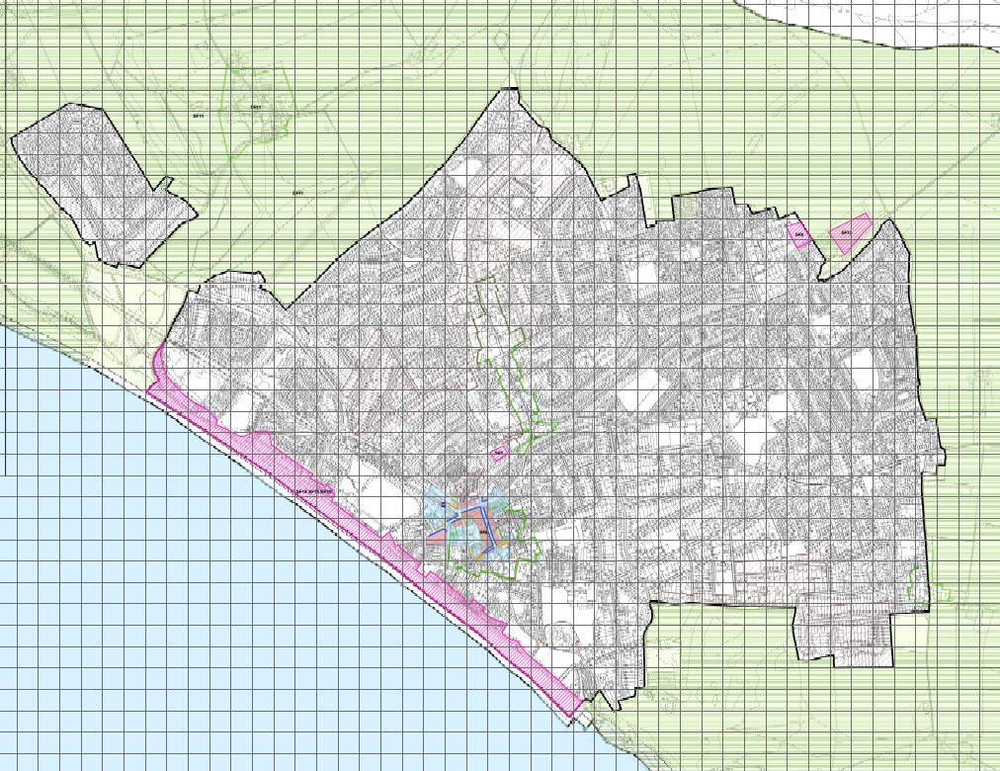
ANNEX B – Call for Sites –text of letter sent out

Seaford Town Neighbourhood Plan

CALL FOR DEVELOPMENT SITES

Seaford Town Council is preparing a Neighbourhood Plan for the Seaford area under the provisions of the Localism Act 2011.

The Steering Group aim to assess future housing and other development needs and is calling for Landowners agents/managers, developers, businesses and local interest groups within the Seaford area to submit expressions of interest for potential development sites to be considered for possible inclusion in the Neighbourhood Plan for future development.

At this stage, the Steering Group is not committed to allocate a proposed site to the Neighbourhood Plan. This exercise will not in itself decide whether a site would be allocated for development by the neighbourhood plan nor will it commit the proposer(s) to applying for planning consent, but it will enable the steering group to better understand the needs and wishes of the electors within its Parish area.

The site suggestions received by us will be used to guide and inform the preparation of the Allocations of Land and Site Development section of the Neighbourhood Plan.

If you want a site/s to be considered for development by the Neighbourhood Plan, we should like to hear from you. The sites need not be in your ownership if you have a responsibility for managing them and they can be proposals for a wide range of development uses.

Please supply the following information

- Location shown (supply map where possible showing site boundary)
- Current use of site
- Any known and anticipated constraints to developing site
- Proposed type and tenure of development (market, affordable, starter homes, downsizers, family homes, retail, office, etc.)
- The scale of proposed development (numbers)

If you would like a site to be considered, please send all relevant information including your name and full contact details no later than 29th July 2016 to
admin@seafordtowncouncil.gov.uk

Please head your submission
“Seaford Neighbourhood Plan Call for Sites”

Alternatively, you can submit by post to
Seaford Town Council, Seaford, East Sussex.
BN25 1HG

Thank you

The Call for Sites was then extended until 30th November 2016.

ANNEX C – Land and Site Assessment Schedules and Maps
Sourced from:

- The Lewes District Strategic Housing and Economic Land Availability Assessment (SHELAA)
- Neighbourhood Plan Survey Response
- List of Seaford Town Council owned sites – for sale or being considered for sale
- List of other Seaford Town Council owned sites
- List of Lewes District Council owned sites
- List of East Sussex County Council owned surplus sites
- Call for sites
- Brownfield sites
- Larger dwellings with the potential to be sub-divided into smaller units
- Local knowledge

Sites put forward by owners for consideration by the Neighbourhood Plan following the Call for Sites – received by the Focus Group by 6pm, 29th November 2016.
No | Site | Size - Hectares
1 | Old Dairy site, 51-53 Blatchington Road, Seaford | 0.11
2 | Brooklyn Hyundai, Claremont Road, Seaford | 0.14
3 | Land at the top of Crown Hill, Seaford | 0.3
4 | Land to the north east of Firle Road, Seaford (between the club house and Abundant Grace) | 0.6
5 | Land north of the railway track at Surrey Road, Seaford | 1.2
6 | Land at Florence House, Southdown Road, Seaford | 2.4
7 | Newlands School, Eastbourne Road, Seaford* | 6.35
8, 9 & 10 | 3 parcels of land off Grand Avenue, Seaford | Parcel 1 – 5.04  Parcel 2 – 4.21  Parcel 3 – 5.25
*According to Lewes District Council, Newlands cannot be counted towards Seaford’s allocation of 185 dwellings
These sites are shown on the map below.
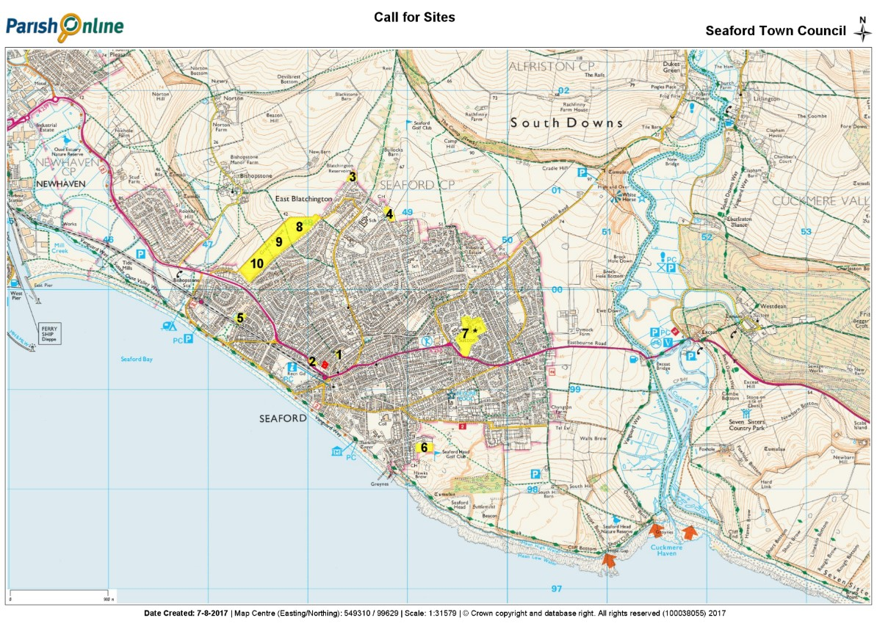

On 19th December 2016, Seaford Town Council submitted the following 25 sites:
Parcel of land on Newhaven Road
The Salts
Sunken Gardens, Seafront
Land adjacent to sunken gardens on Green Lane
Martello Fields (west)
Martello Fields (middle)
Martello Fields (east)
The Crouch
Allotment site, Sutton Drove
Corner of Southdown Road and Chyngton Road
Chyngton Way grassed road island
Seaford Head Golf Course
Sixth hole, Seaford Head Golf Course
Seaford Head Nature Reserve and open site including South Barn
Princess Drive land
Princess Drive open space, one half thereof
Blatchington Pond
Avondale War Memorial
Firle Close grassed island
High & Over car park area
Normansal Field (excluding tree area)
Normansal Field (half)
Land at Covers
Land at The Boundary

Map of sites put forward by Seaford Town Council
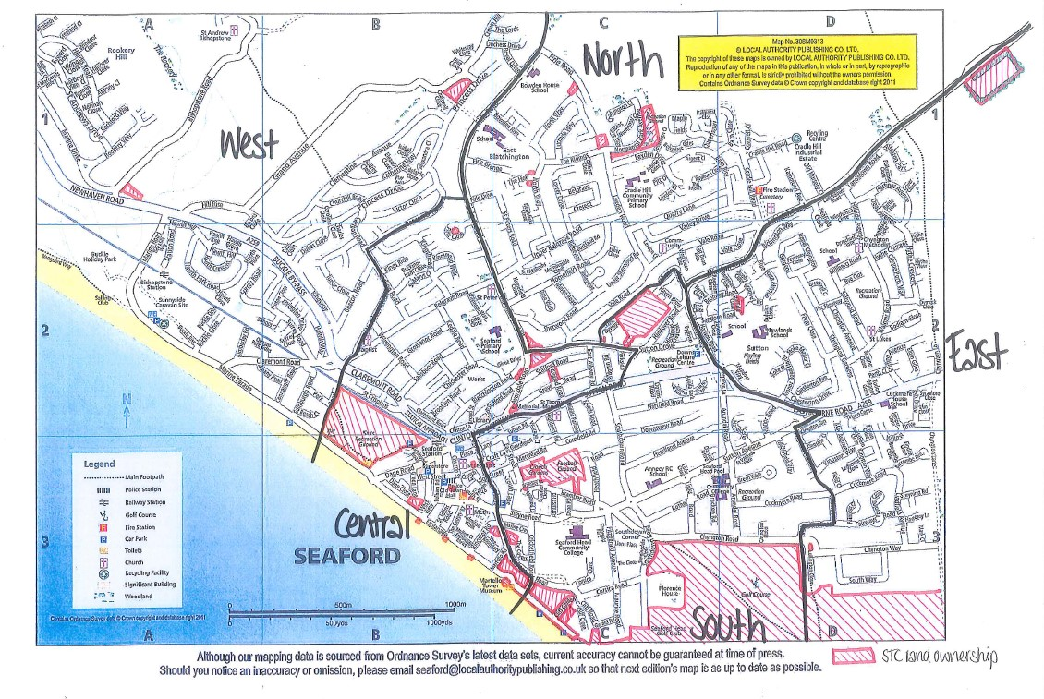
List of original 306 Sites showing those that may accommodate 6+ units, if recent planning permission has been obtained, availability and relevant planning policies

No | Site name/address | Planning already | Size | Available | Planning
 |  | Received | 6+ |  | Policy
1 | Alfriston Road – Malvern House B&B | N | Y | N | CP5
2 | Alfriston Road – Seaford cemetery and chapel | N | Y | N | CP7, CP8
3 | Alfriston Road – The Seven Sisters public house | N | Y | Y | CP4, CP7
4 | Alfriston Road north side | N | Y | N | SF12
5 | Alfriston Road south side – verge bordering Landsdown Road | N | Y | N | CP8
6 | Alfriston Road -woods to west adjoining Nursery Close | N | Y | N | CP8, CP10
7 | Alfriston Road, Seven Sisters pub | duplicated
8 | Annecy School and playing fields | N | Y | N | CP8, RE1
9 | Aquila Park | N | N | N | CP8, RE1
10 | Avondale Road – The Avondale Hotel | LW/17/0544 awaiting decision | Y | Y | CP5
11 | Avondale Road – War memorial | N | N | Y
12 | Badgers Copse – woodland | N | Y | N | CP8
13 | Barn Rise estate green space | N | N | N | CP8
14 | Barn Close – land to east | N | Y | Y | SDNP
15 | Beacon Road – Threeways Nursing Home | N | Y | N | CP4, CP7, H12
16 | Belgrave Road – Malton House care home | N | Y | N | CP4, CP7
17 | Belgrave Road – Nova House Residential Care Home | N | Y | N | CP4, CP7, H12
18 | Belgrave Road – Seaford Baptist church | N | Y | N | CP7
19 | Belgrave Road – St Peters Church and church hall | N | Y | N | CP7, H2, H4, H5
20 | Belgrave Road – Seaford tennis club | N | Y | N | CP8, RE1
21 | Bishopstone Downs | N | Y | N | SDNP, SF11
22 | Bishopstone Manor Farm | N | Y | N | SDNP, SF11
23 | Bishopstone Road – Rookery Shaw | duplicated
24 | Bishopstone Road/A259 – land to north and east | N | Y | Y | SDNP, SF11
25 | Bishopstone Station | N | Y | N | CP7, CP13
26 | Blatchington Hill / Sutton Drove trees opposite pond | N | N | Y | CP8, H4, H5
27 | Blatchington Pond, Sutton Drove | N | N | Y | CP8, RE1, H4, H5
28 | Blatchington Reservoirs | N | Y | N | SDNP, SF11
29 | Blatchington Road – Bowling Club | N | Y | N | CP8, RE1
30 | Blatchington Road – Elm Court site | LW/15/0946 | Y | N | -
31 | Blatchington Road – Industrial units 1-7 including Mend All Autos | N | Y | P | CP4
32 | Blatchington Road – 51-53 Old Dairy site/Brooklyn Motors | N | Y | Y | CP4, H12
33 | Blatchington Road - Old Gasworks | N | Y | Y | CP4, SF5
34 | Blatchington Road – St James’ Trust | LW/17/0501 | Y | N | CP7, H12
35 | Blatchington Road - The Archway | N | N | N | CP7, H12
36 | Blatchington Road – Trek club | LW/17/0369 awaiting decision | Y | Y | CP4
37 | Bodiam Close – green space | N | N | N | CP8
38 | Bowden House School playing fields | N | Y | N | CP8, RE1
39 | Bowden Rise green space | N | Y | N | CP8
40 | Bramber Lane – Martello Cottage | N | Y | N | H4
41 | Bramber Lane – open space behind 16 – 18 (Bramber Court) | N | N | N | H4, CP8
42 | Broad Street – No 10, Hurdis House | N | N | N | CP6, H5
43 | Broad Street – land at rear of No 29 (Boots chemists) | N | N | N | H4, H5, SF9
44 | Broad Street/High Street – land behind Grumpy Chef/Lucky House | N | N | N | CP6, H4, H5
45 | Brooklyn Road – Clanlu Site, Carrera Coachworks | N | N | P | CP4
46 | Brooklyn Road – Clanlu Site, Fixall unit 3 | N | N | P | CP4
47 | Brooklyn Road – Clanlu Site, Greve & Son | N | N | P | CP4
48 | Brooklyn Road – Claremont WI hall and car park | N | Y | N | CP7
49 | Brooklyn Road – 48, H Wilson Ltd & Swindells | N | N | P | CP4
50 | Brooklyn Road – Inklusion print works | N | N | N | CP4
51 | Brooklyn Road – 48A, B, C, Johnson’s Glass | N | Y | P | CP4
52 | Brooklyn Road – Pet Doctors vets | N | Y | N | CP4, CP7
53 | Brooklyn Road – 46, S J Hampton removals and storage | N | N | N | CP4
54 | Brooklyn Road – Able Autos | N | N | N | CP4
55 | Brooklyn Road – Saxby Motors | N | N | N | CP4
56 | Brooklyn Road – Southern Water pumping station | N | N | N | CP7
57 | Buckle car park | N | Y | N | CP7, SF14 - SF16
58 | Buckle lorry park | N | Y | N | CP7, SF14 - SF16
59 | Buckle Rise - Sunnyside Caravan Park | N | Y | N | CP5
60 | Bullocks Barn | N | N | N | SDNP, SF11
61 | Chalvington Close verge | N | N | N | CP8
62 | Chalvington Fields, Sovereign Close / Normansal Park Avenue | N | Y | N | SDNP
63 | Chichester Road - Lock-up garages | N | N | Y
64 | Chichester Road – land and Scout hut | N | Y | N | CP7, CP8
65 | Chichester Road – yard between 64 & 66 | N | Y | Y
66 | Church Lane – St Leonards church hall | N | Y | N | CP6, CP7, H4, H5
67 | Church Street - Crypt Gallery | N | N | N | CP6, CP7, H4, H5
68 | Church Street – No 37 Police Station / Town Hall | N | Y | N | CP6, CP7, H4, H5
69 | Church Street – Old School surgery and Hopscotch nursery | N | Y | N | CP4, CP6, CP7, H4, H5
70 | Church Street – Post Office | N | Y | N | CP4, CP6, CP7, H4, H5
71 | Church Street – St Leonard’s cemetery & church | N | Y | N | CP6, CP7, H2, H4, H5
72 | Church Street – The Crown Sports Pub | N | N | N | CP4, CP6, CP7, H4, H5
73 | Church Street – The Old Plough public house | N | Y | N | CP4, CP6, CP7, H4, H5
74 | Chyngton Farm | N | Y | N | SDNP
75 | Chyngton Lane – Chyngton House South (former B&B) | duplicated
76 | Chyngton Lane, Cuckmere Cottage | N | Y | N | CP10
77 | Chyngton Lane, Greenholm | N | Y | N
78 | Chyngton Lane, Little Chyngton | N | Y | N
79 | Chyngton Road – 6th hole | N | Y | Y | SDNP
80 | Chyngton Road – Brecon Guest House | N | N | N | CP5, H12
81 | Chyngton Road – Polruan B&B | N | N | N | CP5, H12
82 | Chyngton Road No 15 | N | N | N | H12
83 | Chyngton Road No 34 | N | N | N | H12
84 | Chyngton Road No 37 | N | N | N | H12
85 | Chyngton Road/Southdown Road (corner of) | N | Y | Y | SDNP
86 | Chyngton School playing fields | N | Y | N | CP8, RE1
87 | Chyngton Way – field to south of road | N | Y | Y | CT1, CP8, CP10, H5
88 | Chyngton Way roundabout | N | N | Y | CP7, CP8, H12
89 | Cinque Ports Way - lock-up garages | N | Y | N
90 | Claremont Road - Brooklyn Hyundai showroom and workshop | N | Y | Y | CP4
91 | Claremont Road – Claremont House Rest Home | N | Y | N | CP4, CP7
92 | Claremont Road – Clifden House Dementia Care Centre | N | Y | N | CP4, CP7
93 | Claremont Road – Holmes Lodge Guest House | N | Y | Y | CP5
94 | Claremont Road - Jermyn & Sons Ford dealership | N | Y | Y | CP4
95 | Claremont Road - Lambs Bridge car park and recycling centre | N | N | N | CP7
96 | Claremont Road – Mardon | N | Y | N | SF14 - SF16
97 | Claremont Road – Parade of small shop units | N | Y | N | CP4, CP7
98 | Claremont Road – Royal British Legion | N | Y | N | CP7
99 | Claremont Road – St Crispian’s estate | N | N | N | CP8
100 | Claremont Road – The White Lion public house | N | Y | N | CP4, CP7
101 | Cliff Road – The Gallery B&B | N | N | N | CP5
102 | Clinton Lane – South Coast Physiotherapy and Clinton Garage | N | Y | N | CP4, CP7
103 | Clinton Place – The Clinton Centre | N | Y | N | CP7
104 | College Road – Hillersdon Court Residential Care Home | N | Y | N | CP4, CP7
105 | College Road / The Covers open space | N | Y | Y | CP8, CP12
106 | College Road / Ringmer Road / The Boundary – open space | N | Y | Y | CP8, CP12
107 | Connaught Road – By The Sea B&B | N | N | N | CP5
108 | Cornfield Road – Cornfield House Residential Care | N | Y | N | CP4, CP7
109 | Corsica Close/Cliff Road, The Cottage | N | N | Y
110 | Corsica Hall and land | N | Y | N | H12
111 | Corsica Road – Seaside B&B | N | N | N | CP5
112 | Corsica Road – Westerleigh Nursing Home | N | Y | N | CP4, CP7
113 | Coxwell Close | N | Y | N | CP8
114 | Cradle Hill industrial area– wooded area to s of Civic Amenity site | N | Y | N | CP8
115 | Cradle Hill Road – Civic amenity site | N | Y | N | CP4, CP7, SF8
116 | Cradle Hill Road - Fire station | N | Y | N | CP4, CP7
117 | Cradle Hill Road – industrial units | N | Y | N | CP4, SF8
118 | Cradle Hill Road – Wynne’s Garden Centre | N | Y | N | CP4, SF8
119 | Cradle Hill School and playing fields | N | Y | N | CP8, RE1
120 | Cradle Valley | N | Y | N | SDNP
121 | Cricketfield Road – Beachside Residential Care Home | LW/17/0323 | Y | Y | CP4, CP7
122 | Cricketfield Road – Flint Beach House holiday rental | N | N | N | CP5
123 | Crouch Gardens and football ground | N | Y | Y | CP8, RE1
124 | Crouch Lane - Seaford & District Constitutional Club | LW/16/0124 | Y | Y | CP7, H5
125 | Crouch Lane – The Old Forge/garage | N | N | N | CP4, CP6, H4, H5
126 | Crown Hill – land behind No 10 | N | Y | Y | CP8
127 | Cuckmere Estuary – south of A259 and west of river to coast | N | Y | N | SDNP
128 | Cuckmere House School and playing fields | N | Y | N | CP8, RE1
129 | Cuckmere Road, Dolphins | N | N | N | H12
130 | Cuckmere Valley north of A259 and west of river to The Comp track | N | Y | N | SDNP
131 | Dane Close – The Lighthouse holiday rental | N | N | N | CP5
132 | Dane Road – Danemere care home | N | Y | N | CP4, CP7
133 | Dane Road – Freshford Cottage Nursing Home | N | Y | N | CP4, CP7
134 | Dane Road – Health Centre/Community Health Services | N | Y | N | CP4, CP7
135 | Dane Road – Morrison’s supermarket and roof space | N | Y | N | CP4, CP7, H5
136 | Dane Road – The Shore public house | N | Y | N | CP4, CP7, H4, H5
137 | Downs Road – Tower House | N | N | N
138 | Dymock Farm | N | Y | N | SDNP
139 | East Dean Rise/West Dean Rise | N | N | N | CP8
140 | East Street - Telephone exchange | N | Y | N | CP4, H5
141 | Eastbourne Road – Hill House B&B | N | Y | N | CP5
142 | Eastbourne Road – Texaco garage | N | Y | N | CP4
143 | Esplanade – sunken gardens to west of Hardwicke House | N | N | Y | CP8
144 | Esplanade – land adjacent to sunken gardens | N | Y | Y | CP8
145 | Esplanade - Martello Tower | N | Y | N | H2
146 | Etherton Way island | N | N | N | CP8
147 | Firle Close open space | N | N | N | CP8
148 | Firle Close, Robin Down | N | N | N | H12
149 | Firle Road – Abundant Grace Nursing Home | N | Y | N | CP4, CP7
150 | Firle Road – Blatchington House retirement home | LW/15/0427 | Y | N | CP4, CP7, H4, H5
151 | Firle Road No 1 | N | N | N | H4, H5
152 | Firle Road, Beacon Lodge | N | N | N | H12
153 | Firle Road, Crest Cottage | N | N | N | H12
154 | Firle Road, High Wood | N | N | N | H12
155 | Firle Road – land behind Keeper’s Cottage | N | Y | Y | H12, CP8, CP10, CT1
156 | Firle Road, Robins Post | N | N | N | H12
157 | Firle Road, Rosecroft | N | N | N | H12
158 | Firle Road, Turnstile Cottage | N | N | N | H12
159 | Firle Road – Wynford House care home | N | N | N | CP4, CP7
160 | Fitzgerald Avenue - Roman Sands B&B | N | N | N | CP5
161 | Fitzgerald Avenue – open space | N | Y | N | CP8
162 | Fitzgerald Park – open space | N | N | N | CP8
163 | Foster Close – open space | N | N | N | CP8
164 | Gildredge Road - verge | N | N | N | CP8
165 | Gleneagles Close - verge | N | N | N | CP8
166 | Grand Avenue – land to east | duplicated
167 | Grand Avenue Parcel 1 | N | Y | Y | SDNP, SF11
168 | Grand Avenue Parcel 2 | N | Y | Y | SDNP, SF11
169 | Grand Avenue Parcel 3 | N | Y | Y | SDNP, SF11
170 | Green Lane/Steyne Road – open space behind sunken garden | duplicated
171 | Green Walk – roundabout | N | N | N | CP8
172 | Grosvenor Road No 3a – care home | N | Y | N | CP4, CP7
173 | Hamsey Lane – Chyngton House B&B (closed) | N | Y | N | H4, H5
174 | Headland Avenue – Applewood Residential Home | N | Y | N | CP4, CP7
175 | High and Over car park | N | Y | Y | SDNP
176 | High Street - Golden Dragon building | N | N | N | CP6, H4, H5
177 | High Street – land behind Lucky House / Grumpy Chef | duplicated
178 | High Street – Talland Parade and land behind | LW/11/1321 | Y | N | CP4, CP6, H4, H5
179 | High Street – The Cinque Ports public house | N | N | N | CP4, CP6, CP7, H4, H5
180 | High Street – The Old Boot public house | N | Y | N | CP4, CP6, CP7, H4, H5
181 | Hillside Avenue – Chyngton Methodist Church | N | N | N | CP7
182 | Homefield Place No 10 (closed) | N | Y | Y | CP7
183 | Hurdis Road – open space | N | N | N | CP8
184 | Hythe Crescent – garages | LW/15/0426 | N | N
185 | Katherine Way / Clementine Avenue open space | N | Y | N | CP8
186 | Katherine Way / Princess Drive open space | N | Y | N | CP8, RE1
187 | Lexden Road – garages | N | N | N
188 | Lexden Road – parade of shops | N | Y | N | CP4
189 | Marine Drive/Rookery Way – roundabout | N | N | N | CP8
190 | Marine Parade – Beachlands Residential Care Home | N | Y | N | CP4, CP7, SF14 - SF16
191 | Marine Parade – Buckle car park and recycling centre | duplicated
192 | Marine Parade – By Buckle Court Nursing Home | N | Y | N | CP4, CP7, SF14 - SF16
193 | Marine Parade – Environment Agency depot | N | Y | N | CP7, SF14 - SF16
194 | Marine Parade – Newhaven and Seaford Sailing Club | N | Y | N | CP5
195 | Marine Parade – Old Brickfields | N | Y | N | CP8, CP10
196 | Marine Parade - Windy Gap | N | Y | N | SF14 - SF16
197 | Martello Fields east | N | Y | Y | CP8
198 | Martello Fields middle | N | Y | Y | CP8
199 | Martello Fields west | N | Y | Y | CP8
200 | Mercread Road – youth centre | N | N | N | CP7
201 | Micklefield Way – southern end open space | N | Y | N | CP8
202 | Millfield Close / Sandore Road – open space | N | N | N | CP8
203 | New Barn | N | Y | N | SDNP, SF11
204 | Newhaven Road, Newlands, Bishopstone | N | Y | Y | CP8, CP12
205 | Newhaven Road, corner of Bishopstone Road | duplicated
206 | Newlands School and playing fields | LW/16/0800 awaiting decision | Y | Y | CP8, RE1
207 | Normansal Park Avenue – open space | N | Y | Y | CP8
208 | North Way / Firle Road land | N | N | Y | CP8
209 | Northcliffe Close – roundabout | N | N | N | CP8
210 | Pelham Road – The Bay Tree Inn | N | N | N | CP4, CP6, CP7, H4, H5
211 | Pelham Yard – Antique shop and V Bar | LW/13/0444 | N | N | -
212 | Pelham Yard – Indigo Therapies building | N | N | N | CP6, H4, H5
213 | Place Lane – St John Ambulance HQ | LW/17/0240 | N | N | CP6, CP7, H4, H5
214 | Princess Drive/Grand Avenue open space | N | Y | Y | CP8
215 | Railway embankments | N | N | N | CP8
216 | Richmond Road – unmade car park next to railway | duplicated
217 | Richmond Road car park and recycling centre | N | Y | N | CP7
218 | Rookery Hill | N | Y | N | SDNP
219 | 76 Rookery Way land | N | Y | Y | SF11
220 | Rosemount Close – open space | N | N | N | CP8
221 | Salts – land either side of Rugby Clubhouse | N | Y | Y | CP8
222 | Salts recreation ground | N | Y | Y | CP8, RE1
223 | Saltwood Road – lock-up garages | N | N | N
224 | Sandore Road - northeast corner open space | duplicated
225 | Saxon Lane – Barn Theatre | N | Y | N | CP7, H4, H5
226 | Saxon Lane – behind Talland Parade | duplicated
227 | Saxon Lane – behind Toy Town | N | Y | N | CP6, H4, H5
228 | Saxon Lane – The Office Bar & Club | N | Y | N | CP4, CP6, CP7, H4, H5
229 | Saxon Lane car park between Saxon Lane and Crouch Lane | N | Y | N | CP6, CP7, H4, H5
230 | Seafield Close – open space | N | N | N | CP8
231 | Seaford County Primary School and playing fields | N | Y | N | CP7, CP8, RE1
232 | Seaford Golf Course – land NE of Firle Road | N | Y | Y | SDNP
233 | Seaford Golf Course and club house | N | Y | N | SDNP
234 | Seaford Head 6th Form Annexe | N | Y | N | CP7
235 | Seaford Head Community College and playing fields | N | Y | N | CP4, CP7, CP8, RE1
236 | Seaford Head Community College tennis courts and playing field | N | Y | N | CP7, CP8, RE1
237 | Seaford Head Golf Course and club house | N | Y | Y | SDNP
238 | Seaford Head Golf Course – 6th hole | N | Y | Y | SDNP
239 | Seaford Head Lower School and playing fields | N | Y | N | CP4, CP7, CP8, RE1
240 | Seaford Head Nature Reserve | N | Y | Y | SDNP
241 | Seaford Railway Station and car park | N | Y | N | CP6, CP7, CP13
242 | Sheep Pen Lane – Brian Huntley Builders | N | N | N | CP4
243 | Sheep Pen Lane – Ridley’s Sutton Corner Garage | LW/14/0640 | N | N | CP4
244 | Sherwood Road No 22 | N | N | N
245 | South Hill Barn | N | Y | Y | SDNP
246 | South Hill car park | N | Y | Y | SDNP
247 | South Street - Old Town Hall & Toilets | N | N | N | CP6, CP7, H4, H5
248 | South Street / Steyne Road – triangular land at the junction | duplicated
249 | South Way, Chyngton Rise– large corner plot SW | N | N | N | H12
250 | South Way No 36 – large corner plot SE | N | N | N | H12
251 | Southdown Road – Burdyke Lodge Residential Care Home | N | Y | N | CP4, CP7
252 | Southdown Road – Florence House | N | Y | Y | CT1, CP10
253 | Southdown Road – land adjacent to Florence House | N | Y | Y | SDNP
254 | Southdown Road – Southdown H a Nursing Home | N | Y | N | CP4, CP7
255 | St Andrews Drive – open space | N | N | N | CP8
256 | St Crispian’s / A259 green space | N | N | N | CP8
257 | St John’s School and playing fields | N | Y | N | CP8, RE1
258 | St Peter’s Road – Barclay House care home | N | Y | N | CP4, CP7
259 | St Peter’s Road – Blatchington Court Retirement Home | N | Y | N | CP4, CP7
260 | Station Approach – Flowers Furniture | N | Y | N | CP4, CP6, H5
261 | Station Approach - Morrison’s petrol station | N | Y | N | CP4
262 | Station Approach – space above Rowland Gorringe estate agents | N | Y | P | CP4, CP6, H5
263 | Station Road, Bishopstone – Ab Fab Rooms B&B | N | N | N | CP5
264 | Steyne Road – Cross Way church | N | Y | N | H4, H5
265 | Steyne Road – triangular green | N | N | N | CP8, H4, H5
266 | Steyne Road - Kemps Garage | N | Y | N | CP4, H5
267 | Steyne Road - Mardon Motors | N | N | N | CP4
268 | Steyne Road – Seaford Head Retirement Home | N | Y | N | CP4, CP7
269 | Steyne Road – Seaford Little Theatre | N | Y | N | CP7, H5
270 | Steyne Road – The Wellington Hotel public house | N | Y | N | CP7, H4, H5
271 | Steyne Road - Timber Requirements | N | N | N | CP4
272 | Steyne Road/West View – former Kennard’s site | LW/12/0693 | Y | N | H5
273 | Sunnyside Caravan Park | N | Y | N | CP5
274 | Surrey Road – land by 4 blocks of flats | N | Y | N | CP8
275 | Surrey Road / Railway line – woodland to north of railway | N | Y | Y | CP8, CP10
276 | Sussex Ouse Valley Way | N | Y | N | SDNP
277 | Sutton Avenue – Sussex Housing & Care Nursing Home | N | Y | N | CP4, CP7
278 | Sutton Croft Lane car park | N | Y | N | CP6, CP7, H4, H5
279 | Sutton Drove - Allotments | N | Y | Y | CP8
280 | Sutton Drove/East Albany Road | LW/15/0859 | N | N
281 | Sutton Road car park, junction with East Street | N | Y | N | CP6, CP7, H5
282 | Sutton Park Road – lock-up garages | N | N | N
283 | Sutton Park Road – The Silverdale Hotel (closed) | N | Y | N | H5
284 | Sutton Road - Downs Leisure Centre and playing fields | N | Y | N | CP4, CP8, RE1
285 | Sutton Road – Horder Healthcare Centre | N | Y | N | CP4, CP7
286 | Sutton Road – St Thomas More church and church hall | N | Y | N | CP7
287 | Sutton Road/East Street – block single-storey shop units | N | N | N | CP4, CP6, H5
288 | The Byeways (former Wynnes garden centre) off Sutton Drove | LW/15/0128 | N | N
289 | The Comp | N | Y | N | SDNP
290 | The Holt No 1– large garden on corner site | duplicated
291 | The Holt/North Way – 2 plots | LW/17/0064 | N | N
292 | The Peverells/Raymond Close Play Area | N | Y | N | CP8, RE1
293 | The Ridings/Lexden Road green space | N | N | Y | CP8, RE1
294 | Tide Mills | N | Y | N | SDNP
295 | Troon Close – verge | N | N | N | CP8
296 | Vale Close open space | N | N | N | CP8
297 | Vale Road - Lexden Court | N | N | N | CP8
298 | Walmer Road – open space/playing fields | N | Y | N | CP8, RE1
299 | Walmer Road – St Luke’s church & grounds | N | Y | N | CP7
300 | Warwick Road – 3 x lock-up garages | N | N | N
301 | Warwick Road – Cranleigh House B&B | N | N | N | CP5
302 | Warwick Road – Seaford Spirit | N | N | N | H5
303 | West Street – Car Park | N | Y | N | CP6, CP7, H4, H5
304 | West Street – Jehovah’s Witnesses | N | N | N | CP6, CP7, H4, H5
305 | Westdown Road No 27 | LW/17/0190 | N | N | H12
306 | Windsor Close - verge | N | N | N | CP8

List of 59 short listed sites

10 Homefield Place, Seaford BN25 3DG
46 Brooklyn Road | North of Rookery Hill
48 Brooklyn Road | Old Dairy, Blatchington Road
48A-C Brooklyn Road | Princess Drive land
6th Hole Seaford Head Golf Course | Royal British Legion, 70 Claremont Road
76 Rookery Way | Seaford Head Golf Course
Alfriston Road land | Seven Sisters pub, Alfriston Road
Allotment site, Sutton Drove | Station Approach/Dane Road
Blatchington pond | Surrey Road land
Blatchington Road industrial units | Sutton Road car park (Sutton Croft Lane)
Brooklyn Hyundai, Claremont Road | The Crouch
Buckle car park | The Ridings, North Way
Buckle lorry park | The Salts
Chalvington Field | The Trek, Blatchington Road
Clementine Ave, Katherine Way/Princess Dr AOS
Corner of Southdown Road/Chyngton Road
Downs Leisure Centre
East Street car park
Firle Close grassed island
Florence House, Southdown Road
Foster Close AOS
Gasworks, Blatchington Road
Grand Avenue field #4825
Grand Avenue field #7148
Grand Avenue field #9264
High & Over car park
Holmes Lodge, 72 Claremont Road
Industrial site at 50 Brooklyn Road
Jermyn Ford
Kemps Garage, Steyne Road
Land adj. 35 Brooklyn Road (part)
Land adj. to Florence House, Southdown Rd.
Land adjacent to sunken gardens
Land at the Boundary/College Road
Land East of Barn Close
Land north east of Firle Road
Land north of Crown Hill
Land north of South Hill Barn (Chyngton Field)
Land off Firle Road
Land rear of 64/66 Chichester Road
Martello Fields east
Martello Fields middle
Martello Fields west
Newhaven Road
Newlands, Bishopstone
Normansal Park Avenue land

Map of 59 short listed sites

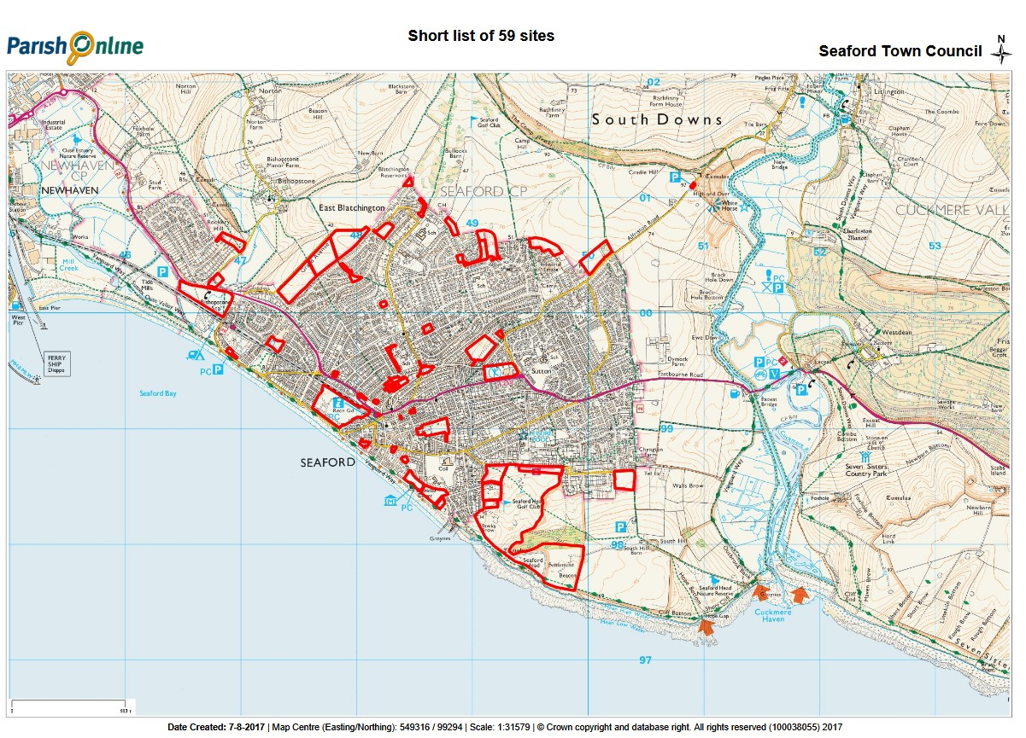
List of proposed development sites

NP Site No | Site name | Housing Yield per AiRS | Total | Of which, affordable | SHELAA reference
 | Sites identified by LDC in JCS
 | - Already Achieved
 | Old House Depository, Claremont Rd | 35 |  | 35
 | Sub-total | 35 |  | 35
 | - To be achieved
SC8 | 51-53 Blatchington Road | 10 |  | 0 | 21SF
SC16 | Holmes Lodge, Claremont Road | 12 |  | 4 | 20SF
SC21 | Station Approach, Dane Road | 12 |  | 0 | 24SF
 | Elmcourt, Blatchington Road | 9 |  | 0 | 25SF
 | Sub-total | 43 |  | 4
 |  |  | 78 | 39
 | New sites identified by NP
 | Dane Valley Project sites
SC1 | 48 Brooklyn Road | 2 |  | 0
SC2 | 48A-C Brooklyn Road | 14 |  | 5
SC3 | Industrial site at 50 Brooklyn Road | 13 |  | 5
SC4 | Blatchington Road industrial units | 14 |  | 5
SC6 | Land adj. 35 Brooklyn Road | 3 |  | 0
SC7 | Land rear of 64/66 Chichester Rd | 30 |  | 12 | 29SF
SC9 | The Trek, Blatchington Road | 12 |  | 5
SC12 | 46 Brooklyn Road | 2 |  | 0
 | Sub-total |  | 90 | 32
 | Potential large sites
SC13 | Brooklyn Hyundai, Claremont Rd | 13 |  | 5
SN5 | 10 Homefield Place, Seaford | 19 |  | 8
SS13 | Seven Sisters pub, Alfriston Road | 9 |  | 0
SS26 | Jermyn Ford, 10, Claremont Rd | 20 |  | 8
 | Sub-total |  | 61 | 21
 | Grand Total |  | 229 | 127

This table must be read in conjunction with Paras 2.5-2.13 of the main report.
The above programme achieves the 185 target with a wide contingency margin of 44 homes. This margin more than makes up for the shortfall of 22 homes within the 153 ‘Commitments’ target referred to in para 2.8 above. Thus, including the significant contribution made by Seaford to the District-wide target for windfall, and the exceeding of the District-wide target for ‘unidentified’ sites, the Focus Group is confident that Seaford is making a significant contribution to the JCS targets for new housing completions 2010-2030.

Map of proposed development sites

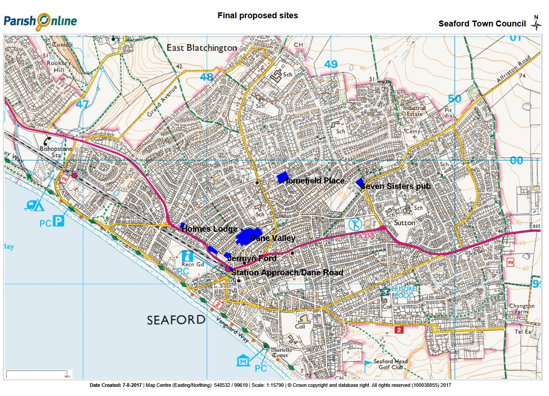
ANNEX D - Sources of Evidence
In addition to guidance from Action in rural Sussex, input from the Neighbourhood Plan Steering Group and Focus Groups, workshops and meetings with stakeholders, evidence was obtained from the following sources:

1 | 2011 Census
2 | http://www.altitude.nu/
3 | www.ancientmonuments.info/monuments/seaford-east-sussex
4 | Bishop V. and Prosser R. (2000) Landform Systems. Harper Collins
5 | Bishopstone Conservation Area Appraisal 2003 http://www.lewes.gov.uk/planning/1097.asp
6 | Brighton & Hove City Council Homelessness Strategy 2014 -2019
7 | Brighton University Town Planning MSc students
8 | www.britishlistedbuildings.co.uk
9 | Call for Sites by Seaford Town Council
10 | Chyngton Lane Conservation Area Appraisal 2003 http://www.lewes.gov.uk/planning/1097.asp
11 | http://www.compass-travel.co.uk/download/east-sussex-bus-services/119-120.pdf
12 | Council of Europe http://www.coe.int/en/web/landscape/the-european-landscape-convention Florence (2000)
13 | CPRE (2005) Unlocking the landscape. action pack: preparing a community landscape character assessment. http://www.cpre.org.uk/resources/countryside/landscapes
14 | DEFRA and Natural England 2014 https://www.gov.uk/guidance/landscape-and-seascape-character-assessments
15 | Design Council Building for Life 12.0 – The Sign of a Good Place to Live  http://www.designcouncil.org.uk/sites/default/files/asset/document/Building%20for%20Life%2012_0.pdf
16 | East Blatchington Conservation Area Appraisal reviewed 2005 http://www.lewes.gov.uk/planning/1097.asp
17 | www.eastsussexinfigures.org.uk managed by East Sussex County Council
18 | https://www.eastsussex.gov.uk/leisureandtourism/countryside/rightsofway/map/
19 | https://www.eastsussex.gov.uk/media/7143/urban-areas-32-to-34.pdf
20 | https://www.eastsussex.gov.uk/environment/conservation/coastaldiversity
21 | English Heritage Research Department Report Series 27/2011 Kitchener’s Camps at Seaford: A First World War Landscape on aerial photographs. Archaeological Report by Robert Skinner
22 | English National Parks and the Broads. UK Government Vision and Circular 2010 by DEFRA
23 | https://flood-warning-information.service.gov.uk
24 | https://www.google.co.uk/
25 | https://www.gridreferencefinder.com/
Guidance on the Implementation of Directive 2001/42 On the Assessment Of
The Effects Of Certain Plans And Programmes On The
Environment http://ec.europa.eu/environment/archives/eia/pdf/030923_sea_guidance.pdf

26 | http://www.heritagegateway.org.uk
27 | www.home.co.uk/
28 | Housing Needs Survey Report 2016 in Seaford, Lewes District by Action in rural Sussex
29 | Imperial College: http://www3.imperial.ac.uk/newsandeventspggrp/imperialcollege/newssummary/news_15-11-2016-10-50-32
30 | http://jncc.defra.gov.uk Joint Nature Conservation Committee
31 | www.legislation.gov.uk Natural Environment and Rural Communities Act 2006
32 | Lewes District Local Plan Part 1 Joint Core Strategy 2010 – 2030, May 2016 http://www.lewes.gov.uk/Files/plan_Adopted_JCS_with_front_cover.pdf
33 | Lewes District Council Authority Monitoring Reports http://www.lewes.gov.uk/planning/7194.asp
34 | Lewes District Council District Wide Saved Policies http://www.lewes.gov.uk/planning/savedpolicies.asp
35 | Lewes District Informal Recreational Space Study October 2005 and Appendices  http://www.lewes.gov.uk/Files/plan_recreational_space_study.pdf  http://www.lewes.gov.uk/Files/plan_recreational_space_appendices.pdf
36 | Lewes District Council Landscape Capacity Study 2012 http://www.lewes.gov.uk/Files/plan_LCS_2012.pdf
37 | Lewes District Outdoor Playing Space Review 2004 http://www.lewes.gov.uk/Files/plan_Outdoor_Playing_Space_Review_Full_Report_2004.pdf
38 | Lewes District Council Planning Application Documents http://www.lewes.gov.uk/planning/index.asp
39 | Lewes District Council and South Downs National Park Authority Strategic Housing and Economic Land Availability Assessment (SHELAA) and appendices http://www.lewes.gov.uk/planning/shlaa.asp
40 | https://www.lightpollutionmap.info
41 | www.magic.gov.uk managed by Natural England
42 | https://data.nbn.org.uk/ National Biodiversity Network's Gateway - Natural Environment and Rural Communities Act 2006 - Species of Principal Importance in England (sec: birds)
43 | Natural England Designated Sites of Scientific Interest https://designatedsites.naturalengland.org.uk/
44 | Natural England (2017) http://www.sssi.naturalengland.org.uk/citation/citation_photo/1002008.pd
45 | Neighbourhood Plan Survey Report 2016 carried out for Seaford Town Council by Action in rural Sussex
46 | Office of the Deputy Prime Minister’s Practical Guide to Strategic Environmental Assessment Directive  https://www.gov.uk/government/uploads/system/uploads/attachment_data/file/7657/practicalguidesea.pdf
47 | On Blatchington Beach by Rodney Castleden 2013
48 | Parish Online - http://gis.getmapping.com/parish-online
49 | Planning Aid – How to prepare a Character Assessment to support design policy within a neighbourhood plan - http://www.ourneighbourhoodplanning.org.uk/storage/resources/documents/How_to_prepare_a_character_assessment.pdf
50 | Planning for Walking, Chartered Institution of Highways and Transportation April 2015
51 | http://planningguidance.communities.gov.uk/ Planning Practice Guidance
52 | Providing for Journeys on Foot – The Institution of Highways and Transportation 2000
53 | Questionnaire to Young People and Heads of Household
54 | www.rightmove.co.uk
55 | http://www.rowmaps.com
56 | SAUER, C (1925) The Morphology of Landscape. University of California Publications in Geography. Number 22. Pages 19-53
57 | Seaford Historic Character Assessment Report from the Sussex Extensive Urban Survey by Roland B Harris
58 | Seaford Local Plan – February 1988
59 | Seaford Museum
60 | Seaford Town Centre Conservation Area Appraisal reviewed 2005 http://www.lewes.gov.uk/planning/1097.asp
61 | Seaford Town Council website http://www.seafordtowncouncil.gov.uk/
62 | South Downs Local Plan: Evidence and Supporting Documents, Viewshed Analysis https://www.southdowns.gov.uk/planning/planning-policy/national-park-local-plan/evidence-and-supporting-documents/viewshed-analysis/  https://www.southdowns.gov.uk/wp-content/uploads/2015/10/Viewshed-Study-Report.pdf
63 | South Downs Local Plan: Preferred Options Consultation September - September 2015  https://www.southdowns.gov.uk/wp-content/uploads/2015/08/Local_Plan_Master_240815_Whole_Document.pdf
64 | South Downs Local Plan: Preferred Options - Assessment of Site Allocations against Major  Development Considerations, Technical Report October 2015 https://www.southdowns.gov.uk/wp-content/uploads/2015/10/SDNP-Major-Sites-Assessment-Report.pdf
65 | South Downs National Park Dark Night Skies https://www.southdowns.gov.uk/enjoy/dark-night-skies/
66 | SDNPA Landscape planning advice:https://www.southdowns.gov.uk/planning/planning-advice/landscape/
67 | SDNPA Integrated Landscape Character Assessment 2005 (updated 2011)  https://www.southdowns.gov.uk/wp-content/uploads/2015/03/ILCA-2005-Introduction.pdf  http://www.southdowns.gov.uk/wp-content/uploads/2015/03/ILCA-Appendix-A-Open-Downland.pdf  http://www.southdowns.gov.uk/wp-content/uploads/2015/03/ILCA-Appendix-R-Shoreline.pdf
68 | Stonegate Homes Limited, Littleworth Properties Limited (Claimants) versus Horsham District Council and Henfield Parish Council  http://cornerstonebarristers.com/cmsAdmin/uploads/r-(stonegate)-v-horsham-dc-final.pdf
69 | Sussex Heritage Coast – A Strategy and Action Plan 2016 – 20  https://www.southdowns.gov.uk/wp-content/uploads/2016/08/Sussex-Heritage-Coast-A-strategy-and-action-plan-2016-20-FINAL-VERSION.pdf
70 | Sussex University:  http://www.sussex.ac.uk/geography/researchprojects/coastview/Rendels_postcards/seaford_head.htm
71 | The Sussex Biodiversity Record Centre http://sxbrc.org.uk/
72 | www.Sustrans.org.uk
73 | http://www.wildlifetrusts.org

ANNEX E – Existing Policy
The policies applicable to Housing & Development are:

1. The National Planning Policy Framework

2. Lewes District Local Plan Part 1 – Joint Core Strategy 2010 - 2030

3. Lewes District Council saved policies to retain:

Core Policy | ‘Saved’ 2003 Local Plan policies that the Core Policy replaces | ‘Saved’ 2003 Local Plan policies to retain
Spatial Strategy | RES2
CP1 – Affordable Housing | RES9 | RES10
CP2 – Housing Type, Mix and Density |  | ST3, ST4
CP3 – Gypsy and Traveller Accommodation | RES21, RES22
CP4 – Encouraging Economic Development and Regeneration | E1
CP5 – The Visitor Economy | E10, E11, E16 | E14, E15, E17
CP6 – Retail and Sustainable Town and Local Centres | E3, E4, E5, E6, E7, E8 | ST3
CP7 - Infrastructure | ST1, E8, RES20, RE2, RE9, RE10
CP8 – Green Infrastructure | RE9 | ST3, ST11, RES19, RE1, RE6, RE7,
CP9 – Air Quality |  | ST30
CP10 – Natural Environment and Landscape Character | CT2 | CT5, CT1, RE8
CP11 – Built and Historic Environment and High Quality Design |  | ST3, ST4, ST11, ST20, ST21, ST25, ST29, , RES8, RES13, RES14, RES18, H2, H3, H4, H5, H7, H12, H13, H14, RE8
CP12 – Flood Risk, Coastal Erosion and Sustainable Drainage
CP13 – Sustainable Travel | T1, T2, T7, T8, T9, T10, T13, T14 | T3, T4
CP14 – Renewable and Low Carbon Energy and Sustainable Use of Resources |  | ST14, ST20, ST21
Seaford | SF1, SF10 | SF5, SF8, SF9, SF11, SF12, SF14, SF15, SF16

4. South Downs National Park Preferred Options – September 2015 Policies as amended:

SD1 - Sustainable Development in the South Downs National Park
SD2 - Ecosystems Services
SD3: Major Development in the South Downs National Park
SD4/ DS - The Dip Slope
SD5 - Landscape Character
SD6 - Design
SD7 - Safeguarding Views
SD8 - Relative Tranquillity
SD9 - Dark Night Skies
SD10 - The Open Coast
SD11 - Historic Environment
SD12 - Biodiversity and Geodiversity
SD14 - Green Infrastructure
SD16 - Rivers and Watercourses
SD17 - Flood Risk Management
SD18 - Transport and accessibility
SD19 - Walking, Cycling and Equestrian Routes
SD20 - Sustainable Tourism
SD21 -Development Strategy
SD22 -Housing
SD23 - Affordable Housing Provision
SD30: Climate Change and Sustainable Construction
SD34: Provision and Protection of Open Space
SD36: Trees, Woodland and Hedgerows
SD38: Conservation Areas
SD41: Archaeology
SD42: Sustainable Drainage
SD43: Public Realm and Highway Design
SD44: Car and Cycle Parking Provision
SD53: New and Existing Community Infrastructure
SD54: Supporting Infrastructure for New Development
SD56: Renewable Energy

ANNEX F – Site Assessment Criteria

A thorough and fair assessment of all sites was undertaken to ensure the most sustainable options were identified.
The sites were assessed initially against the Sustainability Objectives set out in the Scoping Report.
The site assessments focused on the four elements below:
- Suitability - an objective assessment against clearly identified criteria (see Suitability Assessment below and Annex H)
- Achievability - an assessment of the viability of development
- Availability – confirmation of the availability of the site for development
- Acceptability - a more subjective element factoring in community feedback
We followed the Site Assessment Template in Annex G.
Suitability Assessment
Clearly Identified Criteria
An assessment of the suitability of individual sites was undertaken. The National Planning Practice Guidance states that this assessment should be done against clearly identified criteria. An example of these criteria is set out in Annex H.
Weighting
In some instances, it may be appropriate for certain criteria to be weighted such as Acceptability criteria based on community feedback.
Consultation
Consultation with the community and key statutory consultees has been carried out on individual sites prior to the final selection being decided. This evidence has been fed into the site assessments.

ANNEX G – Site Assessment Template
Site Name
Background Information | This section can include background information to add context to the site assessment. For example:  - Site location  - Site Area (Ha)  - Existing use  - Proposal
Suitability | This section forms an objective assessment of social, environmental and economic criteria. This should form a summary of the Suitability Assessment Table (Annex H)  If any issues are identified, an explanation must be given of how could they be overcome
Achievability | A summary on whether development of the site is likely to be viable. Information provided by landowners/site proponents and consultees should feed into this section.  If any issues are identified, an explanation must be given of how could they be overcome
Availability | Confirmation of the availability of the land and may include the following information:  - the intention of the landowner/site proponent to develop  - when the site is available  - any legal or ownership problems  If any issues are identified, an explanation must be given of how could they be overcome
Acceptability | This section will feed community aspirations into the site assessment provided there is clear evidence in support
Strategic Environmental Assessment | A Strategic Environmental Assessment (SEA) is required for all neighbourhood plans allocating development sites
Conclusion | This section will form a balanced conclusion of whether the site should be developed based on the criteria above.

ANNEX H – Suitability Assessment Table
Suitability Assessment
Criteria |  | Questions to Consider | Outcome
Social | Housing | - Would development provide affordable housing provision?
 | Transport/accessibility | - How would developing the site impact on the highway network?  - Is a suitable access point achievable?  - Would it exacerbate congestion?  - Is the site in walking distance (800m) of community services and facilities?  - Can safe pedestrian access be provided to and from the site?
 | Communities | - Could development bring about additional/improved community facilities?
Environmental | Brownfield / Greenfield | - Is the site located on Brownfield or Greenfield land?
 | Vacant Land | - Would the site bring vacant units back into use?
 | Biodiversity | - Is development likely to impact on biodiversity designations?  - Is development likely to impact on Ancient Woodland?
 | Landscape | - Would development of the site have a detrimental impact on a valued landscape?
 | Historic Environment | - Could development of the site have a detrimental impact on listed buildings or conservation areas, including their setting?
 | Flood Risk | - Is the site located in Flood Zone 2 or 3?  - Is the site prone to surface water flood risk?
 | Infrastructure | - Is there sufficient local infrastructure capacity to accommodate development on the site (utilities, highway etc)? If not, is there evidence to say that additional/new provision can come forward?
Economic | Local business | - Would development of the site support local businesses?  - Is the site within walking distance of local businesses?  - Would development involve the loss of business premises?  - Would development facilitate the provision of additional/new/upgraded business premises?

ANNEX I – Strategic Environmental Assessment (SEA) Criteria

In line with recent planning guidance, Lewes District Council now require a Strategic Environmental Assessment to be prepared for all neighbourhood plans allocating development sites.

A SEA ensures that a neighbourhood plan identifies likely environmental implications of options considered for the plan, as well as the plan itself. In turn it will help to identify potential mitigation measures if any negative environment impacts are identified. It will assess the various options (for policies and development sites) against a set of environmental objectives to ensure that there are no consequential significant environmental effects. The outcomes of the appraisals will feed into the neighbourhood plan.

There are a number of stages to the SEA process – see diagram below.
The SEA Regulations require plan-makers to assess ‘reasonable alternatives’. Therefore, various options for development in the neighbourhood plan (including sites considered for housing allocations) will be appraised through the SEA. The findings of these appraisals will help to inform the sites allocated.

Sustainability Appraisal

A Sustainability Appraisal is wider in scope and includes an assessment of social and economic objectives in addition to environmental. Although not a legal requirement for a neighbourhood plan, it is a useful way to demonstrate to an examiner that the plan “contributes to the achievement of sustainable development”.

SEA Process Diagram

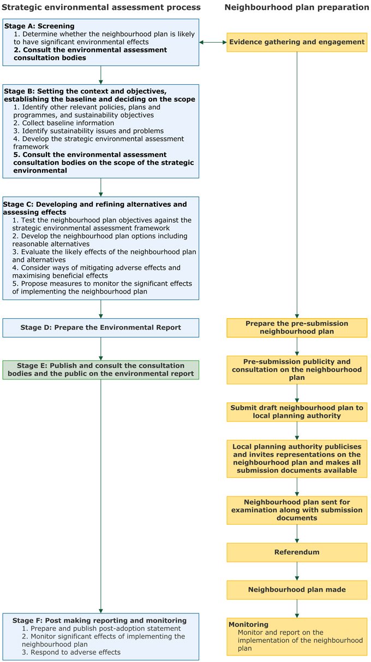
ANNEX J - Consultees
1 | British Telecom
2 | East Sussex County Council – Archaeology Department
3 | East Sussex County Council – Highways Department
4 | East Sussex County Council – Rights of Way
5 | East Sussex County Council – Sustainable Drainage
6 | East Sussex Fire & Rescue Service
7 | Environmental Health
8 | Environment Agency
9 | Lewes District Council
10 | National Trust
11 | Natural England
12 | Seaford Residents – via workshops, press, social media and formal public consultations
13 | Seaford Town Council
14 | South Downs Society
15 | Southern Gas Networks
16 | Southern Water
17 | South East Water
18 | South Downs National Park Authority
19 | Sussex Police
20 | Sussex Wildlife Trust

ANNEX K - Young People’s Survey for people age 16 -35
- Do you want to continue living in Seaford when you leave school / leave home OR if you have left Seaford, do you want to move back?

No – please explain why. Then continue to question 5.

Yes – please explain why. Then continue to question 2.

- What type of accommodation/property would you be looking for?
Type | 1 bed | 2 bed | 3 bed | 4 bed | 5+ bed
Flat/Bedsit/Maisonette
House
Bungalow
Caravan/Mobile Home/Temporary structure
Other (please specify)

- Which ownership would you prefer and expect to achieve (if different)?

 | Renting from a Housing Association or Local Authority | Shared Ownership (Part own/part rent) | Renting from a private landlord | Buying on the open market
Prefer
Expect to achieve

- When do you think you would need to move to this accommodation?

Within the next 2 years | Between 2 and 5 years from now | In 5 or more years

- What is your age range?

Age 16 to 21 | Age 22 to 35

Neighbourhood Plan Housing Survey for Heads of Household
This questionnaire is being distributed through your child’s school. If you receive more than 1 copy because you have more than one child at school, please indicate in the ‘additional comments’ box the number of copies received, but only return one completed form.
- Do you want to continue living in Seaford for the foreseeable future OR if you have left Seaford, do you want to move back?

If No – please explain why in comment box below, leave questions 2, 3 & 4 blank and go to 5.
If Yes – please explain why in comment box below, and then complete the questionnaire.

Comments

- What type of accommodation/property would you be looking for?
Type | 1 bed | 2 bed | 3 bed | 4 bed | 5+ bed
Flat/Bedsit/Maisonette
House
Bungalow
Caravan/Mobile Home/Temporary structure
Other (please specify)

- Which ownership would you prefer and expect to achieve (if different)?

 | Renting from a Housing Association or Local Authority | Shared Ownership (Part own/part rent) | Renting from a private landlord | Buying on the open market
Prefer
Expect to achieve

- When do you think you would need to move to this accommodation?

Within the next 2 years | Between 2 and 5 years from now | In 5 or more years

- What is your age range?

Age 22-35 | Age 35 upwards

Please make any further comments below and return the completed form to your child’s teacher.

Additional Comments

 | ANNEX L – Seaford Sports, Recreation and Play facilities
Site name |  |  |  |  | LDC Ward | Category |  |  |  | Seaford NP site list No. |  |  |  | size (ha) |  | sub total | Category sub total |  |  |  | total |  | percentage of total
Bowden House School (SEN boarding school) |  |  |  |  | SN | Schools |  |  |  |  |  |  |  | 3.025
St John's School, (SEN Boarding School) |  |  |  |  | SN | Schools |  |  |  |  |  |  |  | 2.281
Cradle Hill Primary School (LEA School) |  |  |  |  | SN | Schools |  |  |  |  |  |  |  | 1.454 |  | 6.76
Chyngton Primary School (LEA School) |  |  |  |  | SE | Schools |  |  |  |  |  |  |  | 0.835
Cuckmere House (SEN Boarding School) |  |  |  |  | SE | Schools |  |  |  |  |  |  |  | 0.301
Newlands School (est Sports facilities area) |  |  |  |  | SE | Schools |  |  |  | SE3 |  |  |  | 1.75 |  | 2.886
Seaford Head upper & playing fields (LEA Sch) |  |  |  |  | SS | Schools |  |  |  |  |  |  |  | 1.617
Seaford Head Lower School (LEA School) |  |  |  |  | SS | Schools |  |  |  |  |  |  |  | 3.893
Annecy Primary School (RC School) |  |  |  |  | SS | Schools |  |  |  |  |  |  |  | 1.021 |  | 6.531
Seaford Primary School (LEA School) |  |  |  |  | SC | Schools |  |  |  |  |  |  |  | 1.249 |  | 1.249 | 17.426 |  |  |  |  |  | 33.8%
The Crouch Gardens |  |  |  |  | SS | Sports Facilities |  |  |  | SS15 |  |  |  | 2.78
Downs Leisure Centre |  |  |  |  | SS | Sports Facilities |  |  |  | SS4 |  |  |  | 2.016 |  | 4.796
The Salts |  |  |  |  | SC | Sports Facilities |  |  |  | SC23 |  |  |  | 8.813
Blatchington Bowls Club |  |  |  |  | SC | Sports Facilities |  |  |  |  |  |  |  | 0.228
Seaford Tennis Club |  |  |  |  | SC | Sports Facilities |  |  |  |  |  |  |  | 0.502 |  | 9.543
Walmer Road |  |  |  |  | SE | Sports Facilities |  |  |  |  |  |  |  | 2.444 |  | 2.444 | 16.783 |  |  |  |  |  | 32.5%
Alfriston Road/ Lansdown Road strip |  |  |  |  | SN | Public AOS |  |  |  |  |  |  |  | 0.58
Bowden Rise AOS |  |  |  |  | SN | Public AOS |  |  |  |  |  |  |  | 0.221
Chalvington Fields play area |  |  |  |  | SN | Public AOS |  |  |  | SN4 |  |  |  | 1.896
Coxwell Close playground |  |  |  |  | SN | Public AOS |  |  |  |  |  |  |  | 0.092
Normansal Park Avenue |  |  |  |  | SN | Public AOS |  |  |  | SN3 |  |  |  | 1.693
The Ridings, Lexden Road |  |  |  |  | SN | Public AOS |  |  |  | SN2 |  |  |  | 0.291
Vale Close AOS |  |  |  |  | SN | Public AOS |  |  |  |  |  |  |  | 0.067
Argent Close/The Peverells Playground |  |  |  |  | SN | Public AOS |  |  |  |  |  |  |  | 0.285 |  | 5.125
Bodiam Close |  |  |  |  | SE | Public AOS |  |  |  |  |  |  |  | 0.137
Sandore/Millfield AOS |  |  |  |  | SE | Public AOS |  |  |  |  |  |  |  | 0.195
Seafield Close |  |  |  |  | SE | Public AOS |  |  |  |  |  |  |  | 0.127 |  | 0.459
Micklefield Way AOS |  |  |  |  | SS | Public AOS |  |  |  |  |  |  |  | 0.709
Aquila Park playground |  |  |  |  | SS | Public AOS |  |  |  |  |  |  |  | 0.071
Bramber Lane/Crooked Lane AOS |  |  |  |  | SS | Public AOS |  |  |  |  |  |  |  | 0.038
Etherton Way AOS |  |  |  |  | SS | Public AOS |  |  |  |  |  |  |  | 0.11
Martello Fields Centre |  |  |  |  | SS | Public AOS |  |  |  | SS11 |  |  |  | 1.952
Martello Fields East |  |  |  |  | SS | Public AOS |  |  |  | SS10 |  |  |  | 0.389
The Boundary |  |  |  |  | SS | Public AOS |  |  |  | SS8 |  |  |  | 0.334 |  | 3.603
Blatchington Pond |  |  |  |  | SC | Public AOS |  |  |  | SC11 |  |  |  | 0.371
Esplanade Gardens |  |  |  |  | SC | Public AOS |  |  |  | SC18, SC22 |  |  |  | 0.383
Martello Fields West |  |  |  |  | SC | Public AOS |  |  |  | SC20 |  |  |  | 1.204
The Covers |  |  |  |  | SC | Public AOS |  |  |  | SC19 |  |  |  | 0.218
St Crispians AOS |  |  |  |  | SC | Public AOS |  |  |  |  |  |  |  | 0.179
Steyne Road Drinking Fountain garden |  |  |  |  | SC | Public AOS |  |  |  |  |  |  |  | 0.025
Foster Close AOS |  |  |  |  | SC | Public AOS |  |  |  | SC24 |  |  |  | 0.383
Firle Close AOS |  |  |  |  | SC | Public AOS |  |  |  | SC15 |  |  |  | 0.212 |  | 2.975
Bishopstone Village green |  |  |  |  | SW | Public AOS |  |  |  |  |  |  |  | 0.54
St Andrew's Drive |  |  |  |  | SW | Public AOS |  |  |  |  |  |  |  | 0.069
Windsor Close strip |  |  |  |  | SW | Public AOS |  |  |  |  |  |  |  | 0.047
Edinburgh Road verge |  |  |  |  | SW | Public AOS |  |  |  |  |  |  |  | 0.447
Katherine Way 2 sites, 1 incl. play equipment |  |  |  |  | SW | Public AOS |  |  |  | SW4 |  |  |  | 0.632
Princess Drive |  |  |  |  | SW | Public AOS |  |  |  | SW11 |  |  |  | 1.293
The Brickfield |  |  |  |  | SW | Public AOS |  |  |  | SW1 |  |  |  | 2.169 |  | 5.197 | 17.359 |  |  |  | 51.568 |  | 33.7%
 |  |  |  |  |  |  |  |  |  |  |  |  |  | 51.568
Private sites of 'open land, with NP aspiration as AOS
Chyngton Way field |  |  |  |  | SE | Private OS |  |  |  | SE2 |  |  |  | 2.75 |  | 2.75
Land adj. Hillhead, Firle Road |  |  |  |  | SW | Private OS |  |  |  | SW9 |  |  |  | 0.68
land adj 47 Surrey Road |  |  |  |  | SW | Private OS |  |  |  | SW12 |  |  |  | 1.012 |  | 1.692 | 4.442 |  |  |  | 4.442 |  | 100.0%
 |  |  |  |  |  | Requirement (Ha) |  |  |  |  |  | Provision (Ha) * |  |  |  |  | Difference (Ha)
Requirement per LDC Policy RE1
outdoor sports, Inc.' pitches courts& greens |  |  |  |  |  | 41.375 |  |  |  |  |  | 34.209 |  |  |  |  | -7.166
children's play equipped & casual |  |  |  |  |  | 17.037 |  |  |  |  |  | 17.359 |  |  |  |  | 0.322
total |  |  |  |  |  | 58.411 |  |  |  |  |  | 51.568 |  |  |  |  | -6.843
Seaford pop. (2015 census projection) |  |  |  |  |  | 24,338
* note Private OS excluded as not available.
schools do not include buildings or car parks or access roads.
Seaford Population 2015 |  | Households | Population |  |  | Average |  |  | No 0-15 yr. olds |  |  |  |  |  | % 0-15 |  | No. 65+ |  | % 65+
Seaford Central |  | 2446 | 5,016 |  |  | 2.1 |  |  | 642 |  |  |  |  |  | 12.8 |  | 1,499 |  | 29.9 |  |  |  | 42.7
Seaford East |  | 2131 | 4,805 |  |  | 2.3 |  |  | 681 |  |  |  |  |  | 14.2 |  | 1,756 |  | 36.5 |  |  |  | 50.7
Seaford North |  | 2194 | 5,315 |  |  | 2.4 |  |  | 977 |  |  |  |  |  | 18.4 |  | 1,514 |  | 28.5 |  |  |  | 46.9
Seaford South |  | 1916 | 4,517 |  |  | 2.4 |  |  | 623 |  |  |  |  |  | 13.8 |  | 1,510 |  | 33.4 |  |  |  | 47.2
Seaford West |  | 2107 | 4,685 |  |  | 2.2 |  |  | 507 |  |  |  |  |  | 10.8 |  | 1,807 |  | 38.6 |  |  |  | 49.4
total |  | 10794 | 24,338 |  |  | 2.3 |  |  | 3,430 |  |  |  |  |  | 14.1 |  | 8,086 |  | 33.2 |  |  |  | 47.3

http://www.eastsussexinfigures.org.uk
http://planningguidance.communities.gov.uk/blog/guidance/neighbourhood-planning/what-is-neighbourhood-planning/
Para 185 of the National Planning Policy Framework https://www.gov.uk/government/uploads/system/uploads/attachment_data/file/6077/2116950.pdf
http://www.rightmove.co.uk/house-prices-in-East-Sussex.html and
http://www.home.co.uk/guides/house_prices_menu.htm?location=seaford
https://www.gov.uk/government/uploads/system/uploads/attachment_data/file/6077/2116950.pdf
http://www.lewes.gov.uk/Files/plan_Adopted_JCS_with_front_cover.pdf
http://www.lewes.gov.uk/coun/planning/lewes_local_plan/contents_written.htm
https://www.gov.uk/government/uploads/system/uploads/attachment_data/file/6077/2116950.pdf
https://www.southdowns.gov.uk/wp-content/uploads/2015/10/SDNP-Major-Sites-Assessment-Report.pdf
http://www.lewes.gov.uk/Files/plan_Adopted_JCS_with_front_cover.pdf
http://www.lewes.gov.uk/coun/planning/lewes_local_plan/written/written_frame.htm?cpt14.htm&top
http://cornerstonebarristers.com/cmsAdmin/uploads/r-(stonegate)-v-horsham-dc-final.pdf
http://ec.europa.eu/environment/archives/eia/pdf/030923_sea_guidance.pdf
http://www.lewes.gov.uk/Files/plan_recreational_space_appendices.pdf
http://www.lewes.gov.uk/Files/plan_Outdoor_Playing_Space_Review_Full_Report_2004.pdf
http://www.lewes.gov.uk/coun/planning/lewes_local_plan/written/written_frame.htm?cpt14.htm&sf12
http://www.eastsussexinfigures.org.uk
https://www.brighton-hove.gov.uk/sites/brighton-hove.gov.uk/files/Homeless%20Strategy%202014.pdf
http://www.lewes.gov.uk/Files/plan_Affordable_Housing_Needs_Assessment.pdf
By infrastructure this Focus Group means the economic and physical infrastructure and facilities to promote sustainable development. We aim to align ourselves to the work of the Local Economy & Facilities Focus Group.
http://www.britishlistedbuildings.co.uk/england/east+sussex/seaford
http://www.lewes.gov.uk/Files/plan_CAA_SeafordTownCentre.pdf
By amenity open space this Focus Group means open green space, play, recreation and sport that is important to the community as a result of its recreational, historic, beauty, wildlife or tranquillity qualities. We aim to align ourselves to the work of the Environment & Countryside Focus Group.
By amenity open space this Focus Group means open green space, play, recreation and sport that is important to the community as a result of its recreational, historic, beauty, wildlife or tranquillity qualities. We aim to align ourselves to the work of the Environment & Countryside Focus Group.
https://www.gov.uk/government/uploads/system/uploads/attachment_data/file/6077/2116950.pdf
http://www.lewes.gov.uk/Files/plan_Adopted_JCS_with_front_cover.pdf
https://www.southdowns.gov.uk/wp-content/uploads/2015/08/Local_Plan_Master_240815_Whole_Document.pdf
http://planningguidance.communities.gov.uk/blog/guidance/neighbourhood-planning/preparing-a-neighbourhood-plan-or-order/

