Seaford Refreshment Concessions
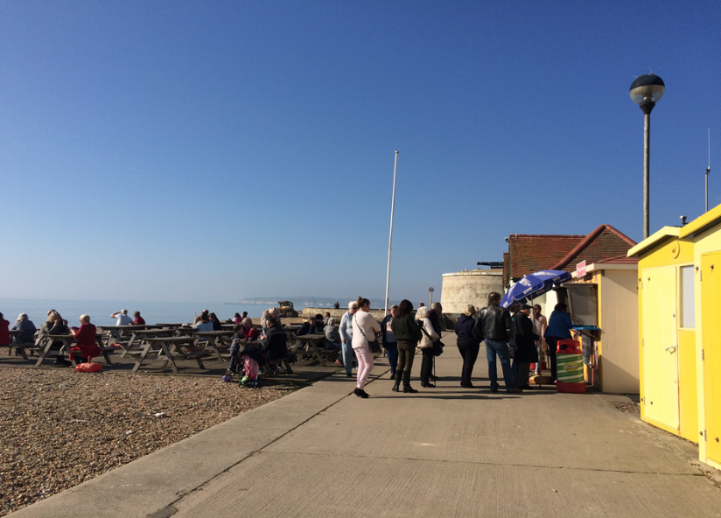
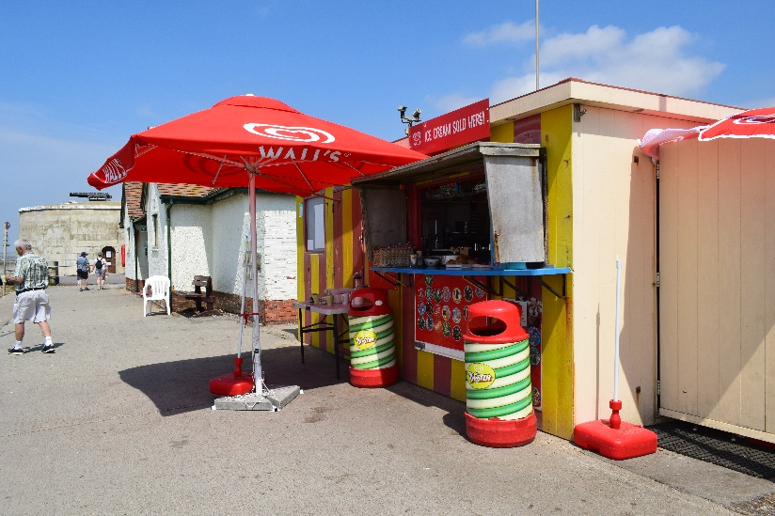
Martello Kiosk

Situated on the promenade of a popular visitor destination which experiences all year-round visitors. Benefitting from its favourable seafront location and free parking, the area experiences a significant footfall both in and out of season.
Encompassed by the striking presence of Seaford Head and the cliffs, it is popular with walkers, families, anglers and water sport enthusiasts. There is already a flourishing and stable market in place but room for scope for the right trader to enhance the loyal customer base.
The kiosk itself is of glass reinforced plastic construction with a floor area of approximately 94 square feet. The kiosk has the supply of mains electricity, water and drainage. Toilets are adjacent to the kiosk and there is plenty of public seating on a decked area of the beach opposite.
Seaford Town Council invites tender proposals from operators able to demonstrate how they will provide additional aspects to enhance and improve the visitor experience and compliment the location.
If you or someone you know is interested in being a part of Seaford’s exciting future and running a successful business in these idyllic locations,
we invite you to find out more and download an application pack via:
https://www.seafordtowncouncil.gov.uk/contracts-and-tenders/

