Seaford Refreshment Concessions
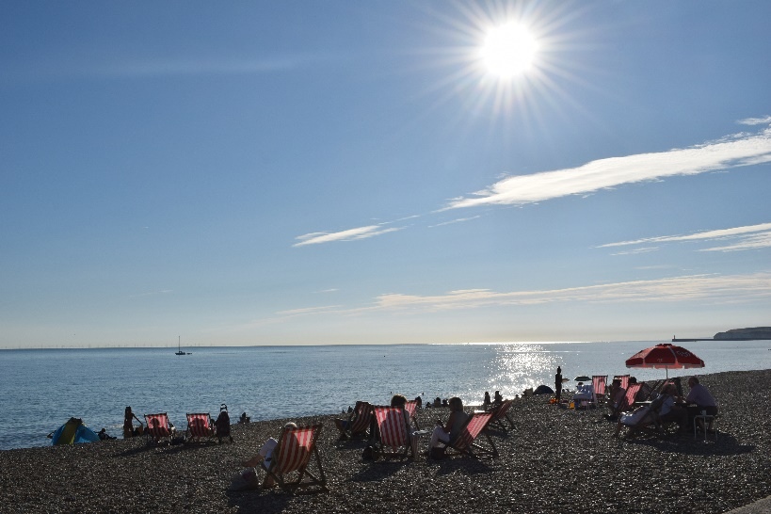
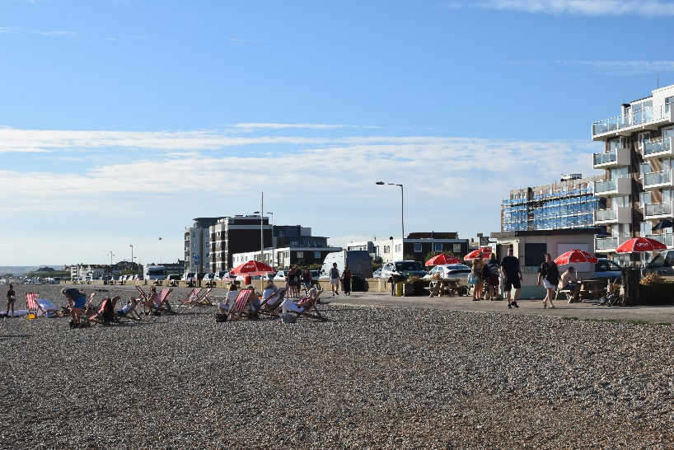
West View Kiosk

Situated on the promenade of a popular visitor destination which experiences all year-round visitors. Benefitting from its favourable seafront location and free parking, the area experiences a significant footfall both in and out of season.
Encompassed by the striking presence of Seaford Head and the cliffs, it is popular with walkers, families, anglers and water sport enthusiasts. There is already a flourishing and stable market in place but room for scope for the right trader to enhance the loyal customer base.
The kiosk is of brick construction with a floor area of approximately 50 square feet. Electricity supply and mains water supply are available in the kiosk, but there are no drainage previsions. Throughout the summer season the site benefits from increased business and footfall from the adjacent eight short term rental beach huts, four concession huts and three portable toilets, one of which is for sole use by the kiosk’s customers.
Seaford Town Council invite tender proposals from operators able to demonstrate how they will provide additional aspects to enhance and improve the visitor experience and compliment the location.
If you or someone you know is interested in being a part of Seaford’s exciting future and running a successful business in these idyllic locations,
we invite you to find out more and download an application pack via:
https://www.seafordtowncouncil.gov.uk/contracts-and-tenders/

