INTRODUCTION TO SEAFORD
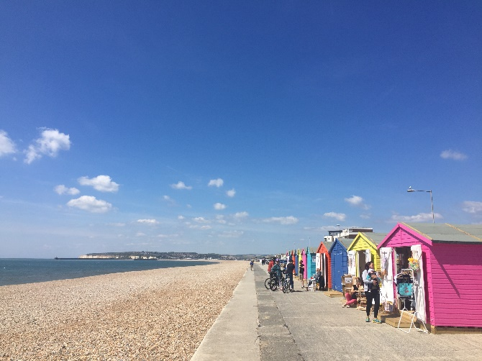
Seaford serves a population of around 27,000 and a further 67,000 within the Lewes District. It is well known for its convenient parking, easy to access town centre, countryside, beach front and arguably the most memorable coastal views to be found in the region.
Seaford is a favoured alternative for visitors seeking an uncomplicated seaside and coastal countryside destination. The town is situated in a beautiful location presiding over the wide sweep of Seaford Bay under the distinctive chalk landmark of Seaford Head. Seaford beach is just a short walk from the train station with a fun and vibrant yet relaxed feel.
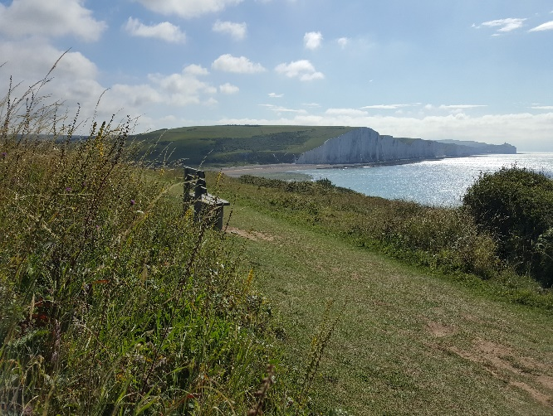
To the North, the town faces the chalk down land of the South Downs National Park; and along the coast to the East are the Seven Sisters chalk cliffs.
Seaford Town Council is developing regeneration projects for Seaford in order to support a vibrant and active town with lots to do and plenty to see and enjoy. A recent success being the forward thinking and positively received disabled access right on to the beach close to the Martello Tower and the Shoal.
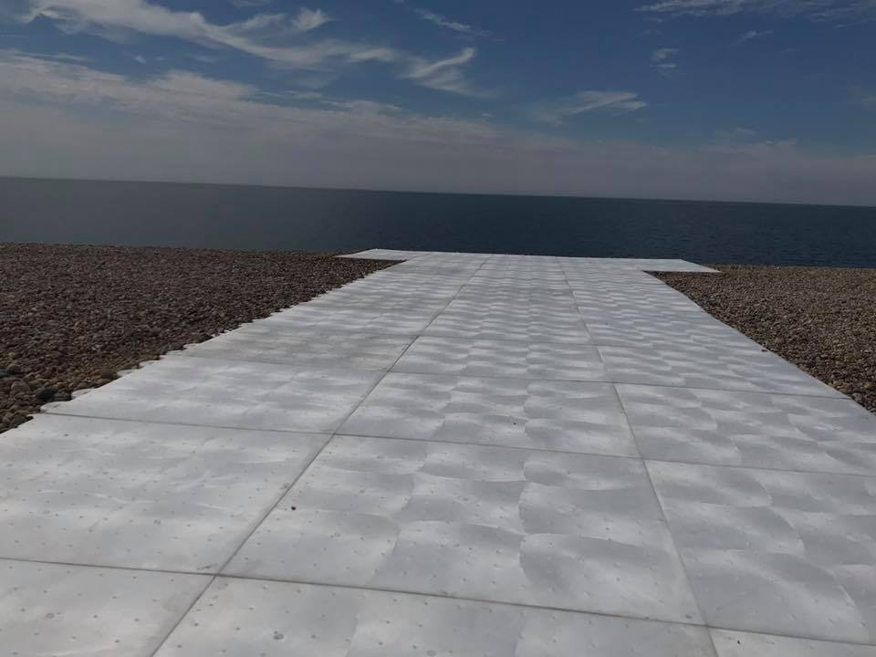
Seaford Town Council is inviting applications for two of its trading concessions on the seafront in two of Seaford’s most prominent and favoured visitor destination viewpoints.
If you or someone you know is interested in being a part of Seaford’s exciting future and running a successful business in these idyllic locations,
we invite you to find out more and download an application pack via:
https://www.seafordtowncouncil.gov.uk/contracts-and-tenders/

