Taking Part in a Zoom Meeting
Please note that the following instructions are for joining a meeting using a laptop, computer or tablet device. Accessing with a smartphone may differ.
Index
- Joining
1a If this is your first time
1b If you have already downloaded the Zoom app
6 Settings
6a Screen View
6b Mute / Unmute
6c Technical Run Through -Chat Function
8 Participation
8a Public Participation
8b Councillor Discussions / Participation
8c Voting
9 Leaving the Meeting
9a Exclusion of Press & Public
9b Declaration of Interest

1 – Joining
Follow the link provided by email/on the agenda.
1a – If this your first time, you will probably see the screen below. Click the Zoom icon at the bottom to open the desktop app.
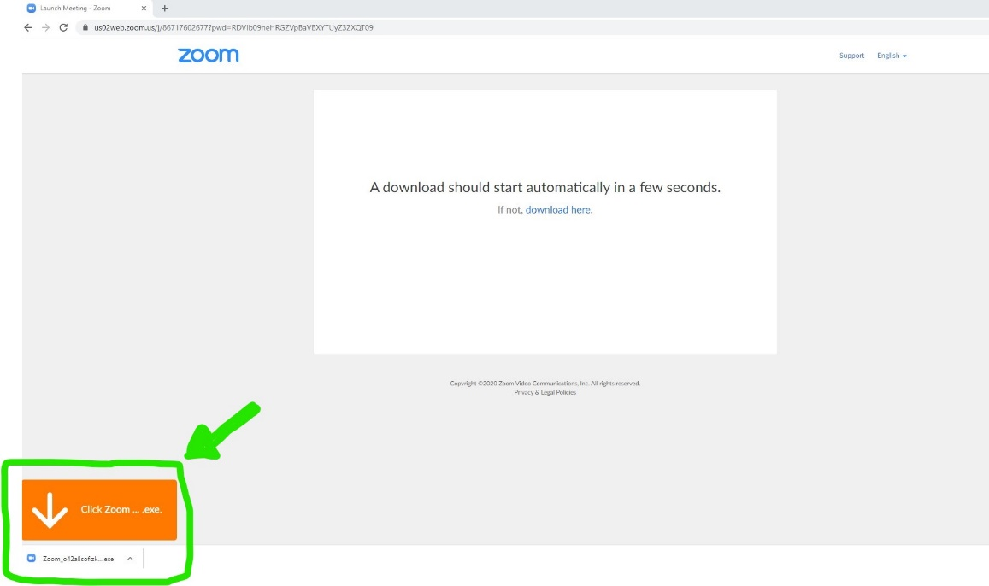
The you will be prompted to enter the meeting id and your name (note, this will be visible by all meeting participants). The meeting id can be found on the agenda, Council’s website or circulated email.
- For councillors, please do not choose to not connect your audio or turn off your video with the tick boxes.
- Members of the public will need audio as a minimum and whilst video is preferred, it is optional.
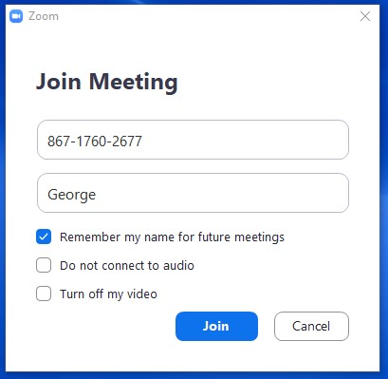

You will then be prompted to enter the meeting password, on the agenda, Council’s website or circulated email. Enter this and click to ‘join meeting’ (skip 1b and go to 2).
1b - If you have already downloaded the Zoom app, you can either:
- Follow the link and you should see the screen below. Click the button to ‘open Zoom’ (go to 2)
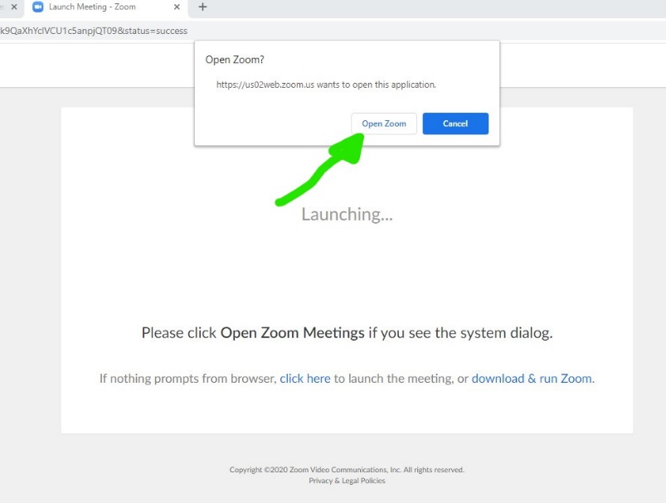

- Open the Zoom desktop app and click ‘join’ (blue arrow) and then enter the meeting details (green arrow) (go to 2)
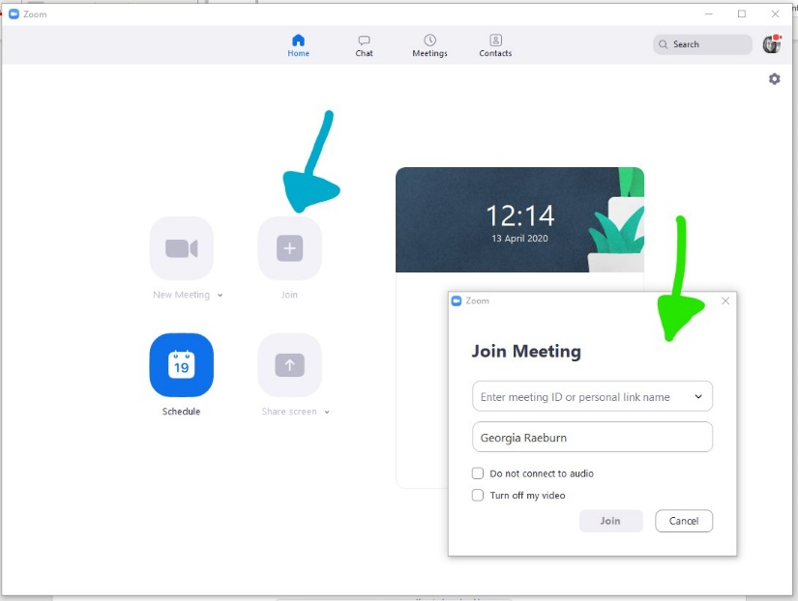

2 – Once in the desktop app, if the meeting has not yet started, you may see this below. If you wait, the host of the meeting just needs to start the meeting.
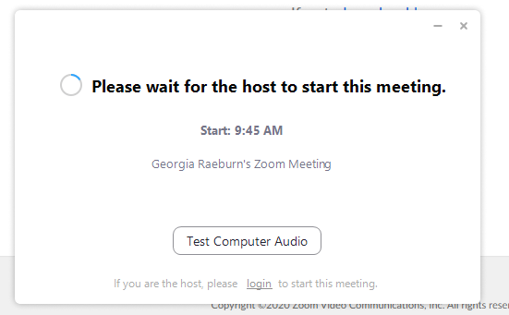

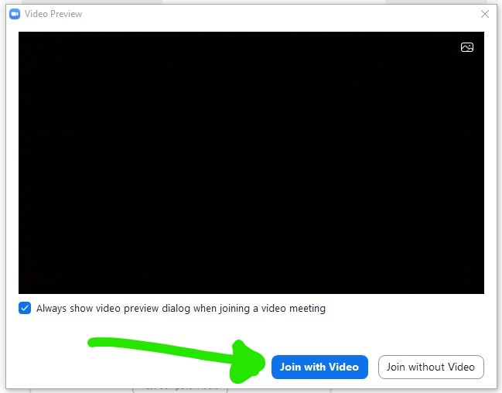
3 – Once the host starts the meeting, you will see the pop up below in your desktop app. Click the button to ‘join with video’.

4 – You will then join the ‘waiting room’ and the host will have to approve you entering. Your screen will probably show the below.

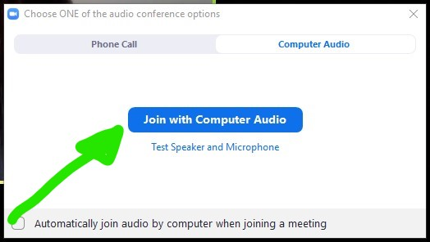
5 – Once admitted entry by the host, you will see the screen below. Click to ‘join with computer audio’.

6 – Settings
6a - Screen View
Once in, you will see all participants in the meeting so far. More participants may join and the screens will get smaller/move around to accommodate this. If you can just see one big person and the rest are fitted around, you are on ‘speaker view’ change this by pressing where the blue arrow shows below; try out ‘gallery view’ and see which you prefer!
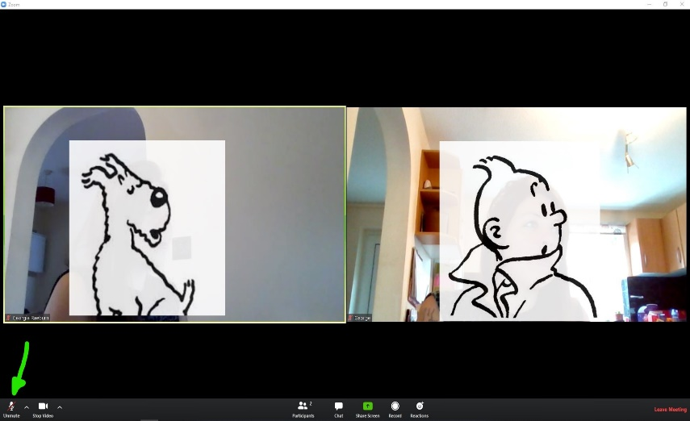

6b - Mute / Unmute
Check to see if you are muted (where the green arrow is):
If it says ‘unmute’ with a red line this means you are muted and can’t be heard
If it says ‘mute’ you can be heard
It will be best to remain muted until you want to speak – this prevents too much background noise and will make it easier for everyone to hear the speaker.
6c - Technical Run Through – Chat Function
We will go through the meeting at the start to make sure everyone can hear and see and be heard and seen. If you have any problems with the audio and can’t heard, we can use the ‘chat’ function to try to resolve this.
Click on ‘chat’ as per the green arrow below. Type your issue where the purple arrow is and hit ‘enter’. It will then appear where the blue arrow is. The host will respond to try and help.

7 – Once everyone is up and running, the Chair will conduct the meeting in the usual manner; going through the agenda. The Host (an officer) will monitor the IT/technical side of the meeting.
8 – Participation
Please remember to keep yourself on mute unless you are speaking (save for the Chair and host, who will need to be able to speak freely). It is imperative that all participants are able to clearly hear the speakers without lots of background noise.
8a – Public Participation
- The Chair will introduce public participation and invite any members of the public wishing to speak to raise their hands clearly in the video.
- The host will note down those wishing to speak (using the name/id shown by the person’s screen).
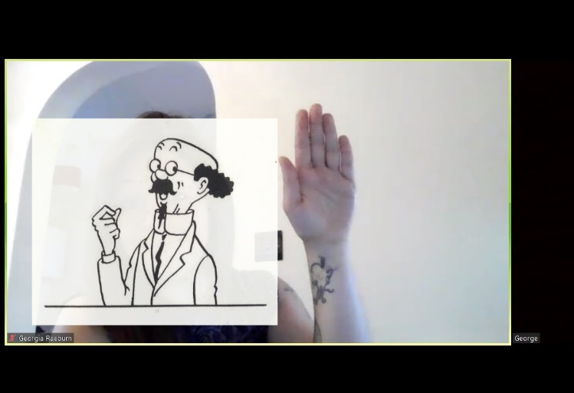

- The host will inform the Chair in turn who is next to participate.
- Once at the end of the list, the Chair will check if any other members of the public were wishing to speak.
- The Chair, or an officer and other councillor if invited to do so, will respond where relevant to the member of public.
- The public statement and any response will be recorded for the minutes in the usual manner.
- If a member of public does not have video feed, when the Chair is asking who would like to participate, the member of public should unmute themselves and state their name and that they wish to speak. They will be noted down in the list by the host and they will be invited to participate at the relevant stage by the Chair.
8b – Councillor Discussion/Participation
To try and prevent councillors from speaking over each other, it is encouraged that councillors keep their video/audio ‘muted’ until invited to speak by the Chair.
- Councillors wishing to speak should raise their hand clearly in the video (as above) and the host will note the hands raised. All hands then go down, when prompted.
- The host will inform the Chair who is to speak, and the Chair will invite that councillor.
- The councillor speaking first should ‘unmute’ themselves and make their statement; then ‘mute’ their video/audio again.
- The Chair will either respond or ask an officer to reply, where necessary.
- The Chair will then ask if any other councillors are wishing to respond to the councillor’s statement by show of hands. The host will note the hands raised and prompt the Chair as to who to invite to speak.
- Then follow the above steps ii-iv and work through the list of councillors wishing to respond.
- Then return to the list of councillors who had originally wanted to speak and follow the above steps again.
- If councillors do not have video feed, when the Chair is asking which councillors would like to speak or respond to another councillor’s statement, the councillor should unmute themselves and state their name. They will be noted down in the list by the host and they will be invited to participate at the relevant stage by the Chair.
This may feel over the top but is trying to ensure that all councillors have a fair chance to partake in discussions. Hopefully when we are all more accustomed to this way of ‘meeting’, this will all become more second nature.
8c – Voting
The Chair/an officer will clearly read out what it is that is being voted on, in the usual manner.
The host will then read through councillor’s names asking for their vote, whether ‘for’, ‘against’ or ‘abstain’. This is to ensure that votes are marked down correctly and remove any error of doubt.
The host will confirm verbally whether or not the resolution was carried.
Please note, this does not mean they are recorded votes and individual votes will not be shown in the minutes; a councillor would still have to specifically request a recorded vote if one was wanted.
9 – Leaving the Meeting
To leave the meeting, you can click on the ‘leave meeting’ in red text at the bottom right hand of the screen. You will be prompted to confirm you want to leave.
If you leave by accident, please follow the above steps in section 2 to re-join the meeting.
9a – Exclusion of Press & Public
Where an exclusion of press & public is resolved, all members of press and public will need to leave the meeting. They can do this themselves or the host does also have the ability to remove them.
The host will then ‘lock’ the meeting so no new attendees can join and interrupt the confidential session.
9b – Declaration of Interest
If a councillor has declared an interest in an item on the agenda and it is deemed best that they ‘leave the meeting’ for that item. They should leave following the meeting in the usual manner but keep their Zoom desktop app open. The host will then ‘invite’ them to return once the item has concluded.
When invited to return, a pop up will appear that the councillor should then ‘accept’ and they will re-join the meeting.

