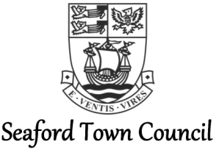

General Catering Assistant –
The View at Seaford Head

JOB DESCRIPTION

Responsible to: General Manager (The View)

Job purpose:
To assist in the operation of The View’s kitchen services, catering and bar facilities.
Duties to include, but not limited to:
- Assisting the kitchen staff with any tasks required to ensure the smooth running of the kitchen and catering facilities within the venue.
- Assist the Head Chef with communications between the kitchen staff and front of house staff.
- Assist in stock control, ordering and menu planning, as required.
- Ensure all Health & Safety and Hygiene requirements and standards are being upheld at all times.
- Ensure a degree of flexibility regarding your working hours, depending upon the needs of the business.
- To assist with evening and weekend events, including weddings as and when required, helping to ensure the event runs smoothly.
- To wait on tables, wash up and clean the venue as and when required.
- Be proactive in driving the business forward.
- To undertake any other tasks as required of you by your line manager.

