

Coat of Arms Policy

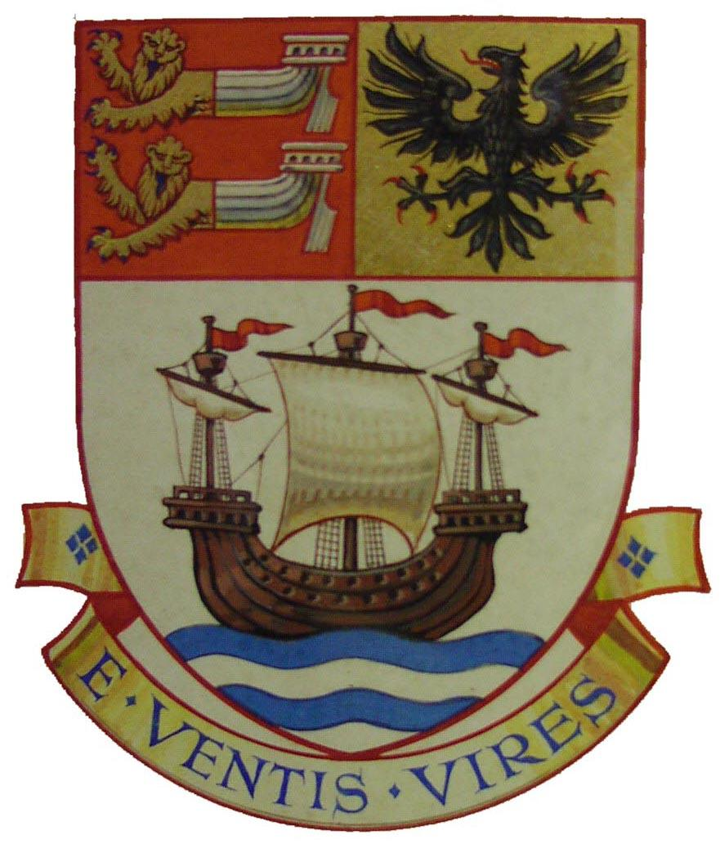
- Policy Statement
The Town Council (‘the Council’) has the license and authority to bear and use the Coat of Arms (‘the Arms’) of the former Seaford Urban District Council (pictured right).
‘The Council’ refers to all functions of the Town Council including but not limited to; voluntary appointees, such as the Town Crier; Councillors on Council business, and; Council-appointed working groups, such as the Neighbourhood Plan Steering Group.
In addition to this, the Council has registered the Arms as a trademark and therefore has protection over the Arms under Intellectual Property Rights for a ten-year period to 3rd May 2027.
The Council does not wish to deter local groups and organisations from using the Arms in and around the local community; recognising the Arms as a symbol of ‘Seaford’. It does however need to maintain a degree of control and available options if the Arms were used in such a way that the Council was not comfortable with or was potentially damaging to the Council.
This policy sets out the process that should be followed by others wishing to use the Arms.
- Use of the Arms
Having been granted the Arms, the Council may decide to grant permission to others to bear and use the Arms. This includes all formats that the Arms may be used in; PDF, Jpeg, Png, Colour, Black & White, embroidered, hand drawn and any other portrayal of the Arms.
As a registered trademark, in addition to the above, the Council will issue a Licence of Agreement (‘Licence’) surrounding the terms of the use of its trademark.
- Process Granting Use
  - There is an application form that should be submitted applying for use of the Arms; this form will clearly set out the intended use for the Arms.
  - The application will be considered by Full Council at its next available meeting.
  - Where an applicant is successful, a licence will be issued clearly identifying (not an exhaustive list):
    - The details of the licensee;
    - The granted use of the Arms and the limitations;
    - The ‘look’ of the Arms and any permitted alterations;
    - The status of the licence;
    - The duration of the licence;
    - The performance expectations;
    - Any fees due;
    - Termination arrangements and breaches of agreement.
  - Where an applicant is not successful, they will be informed in writing of the decision and reasons for permission being withheld.

  - Re-applications will only be considered where amendments have been made to the original application i.e. addressing issues identified in the reasons for permission being withheld. Where permission is being sought for a different use to the original application, it would be treated as a separate application and considered on its own merit.
  - Not-for-profit and voluntary organisations granted use prior to the adoption of this policy need not re-apply as the permission previously given will be honoured, providing the permission can be evidenced if requested to do so by the Council.
  - Appendix A to this policy details the permissions granted and shall be updated by officers as required.
- Fees for Use of Arms
  - The Town Council does not wish to deter local groups and organisations from using the Arms in and around the local community; recognising the Arms as a symbol of ‘Seaford’.
  - Not-for-profit and voluntary organisations or community groups will usually be granted a license free of charge, subject to documentary evidence submitted at application stage.
  - Commercial organisations will be required to pay a fee of £300.00 for a three-year licence period plus the difference between the licence start date and the following 1st April (the amount of which will be calculated pro-rata and added to the £300.00).
  - Organisations may apply for a licence period longer than three years if they wish to; there would be an extra £100 fee for each additional year requested.
  - The only exception to the above commercial fee is if the Council had required the organisation to display the Arms for any said reason, for example in the case of sponsorship or financial support being given to said organisation or partnership working on a project.
  - Any fees due will be invoiced upon permission being granted and where a licence renewal is requested, an invoice will be raised alongside the licence agreement renewal paperwork, with payment due by the renewal date.
- Renewal and Termination of a Licence
  - Licences for not-for-profit and voluntary organisations will be granted indefinitely, subject to specific changes as set out in the licence. The licensee will have responsibility to notify the Council of any of the specified changes taking effect.
  - Licenses for commercial organisations will be granted on a three-yearly basis. If the organisation wishes to apply for a longer licence it may do so but will be required to pay for the entire duration of the licence upfront.
  - If a commercial organisation does not submit payment for the fee by the renewal date, it will be assumed that the organisation is not looking to renew the licence and two months’ notice will be given to cease all use of the Arms.
  - Upon two months’ notice being given, the organisation must ensure all use of the Arms is ceased by the date specified. Failure to cease unlicensed use may result in the Council seeking legal action, as per section 6 below.
  - A breach of terms of the agreement, including use of the Arms that may be potentially damaging to the Council, will result in notice of termination of agreement being given.
  - Refunds will not be given for termination of an agreement partway through the agreement period.

- Unlicensed Use of Arms
Where the Council becomes aware of unlicensed use of the Arms, the Council will make contact with the user regarding entering in to a licence.
After a reasonable period of time and attempts, if the approaches to enter in to a licence are not successful and use of the Arms continues, the Town Clerk will issue a cease and desist letter. If use continues and a licence has not been agreed, the Town Clerk will notify the Council at its next scheduled meeting and the Council will decide the next course of action, which may be starting legal proceedings for trademark infringement.
Note; Infringement includes not only the Arms as depicted above but also trademarks similar in look and style.
- Notification
The Council will publicise a list on its website of Licences granted for use of the Arms.
Anyone with any queries or concerns regarding use of Arms should in the first instance contact the Council on 01323 894 870 or by email to admin@seafordtowncouncil.gov.uk

Coat of Arms Policy – Appendix A

A record of those organisations granted permission to use the Seaford Town Council Coat of Arms.

Licence No. | Organisation | Type | Date Permission Given | Expiry Date | Terms of Use | Notes
n/a | Seaford Silver Band | Not-for-profit | pre-1999 | n/a | Used as basis for Band's logo | Granted by SUDC
n/a | Seaford Head Golf Club | Not-for-profit | pre-2000 | n/a | Used as basis for Club's logo
n/a | Seaford Kurlers | Not-for-profit | 2011 | n/a | Used on tournament award shields
n/a | Seaford Twinning Association / Friends of Bonningstedt | Not-for-profit | pre-2013 (tbc) | n/a | None specified - includes a flag bearing the Arms | STC can use this flag on request
n/a | Seacroft Arts | Not-for-profit | 2019 | n/a | Used in printed poetry book | Currently reviewing whether wishing to use Arms (Jan-20)

Updated: January 2020

