Community Nursing in Seaford, Report to Seaford Town Council June 2020
Thanks to the donation of £2,000 towards Community Nursing Visits we have been able to continue to provide a vital community nursing service to residents of Seaford. In 2019-20 we supported 53 patients with community nursing in Seaford through 204 visits to patients. Our nurses’ support is wide ranging and includes the administration of medicine, practical support around dealing with aspects of their illness and helping patients and their family/carers to deal with the emotional effects of their illness, providing much needed comfort and reassurance.
Our Community Nursing Service has been continuing to operate in Seaford and across our catchment area during Covid-19 with face to face visits continuing in a safe manner. Extensive PPE is worn by all our nurses visiting patients we are able to continue visiting patients whilst other services in the area are only operating digitally. We have been keeping in touch with our patients regularly through video and phonecalls when visits have not been possible. This has included patients who usually attend our wellbeing sessions as we are aware these may not be possible at the hospice for many months to come due to social distancing measures. This ongoing support has not only been benefiting patients but their family members and carers too during this difficult time.
Our Associate Nurse Practitioner Ali talks about some of the patients she has recently supported in Seaford as well as what it has been like working during Covid-19.
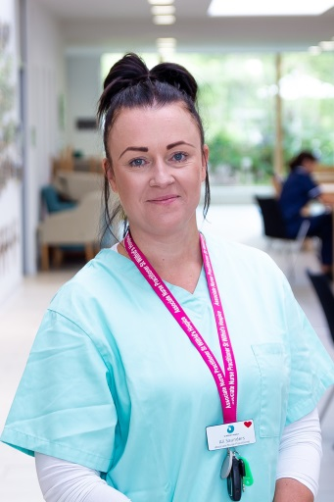
‘Throughout the Covid-19 pandemic I have been continuing to support patients face to face at home in Seaford fully protected wearing full PPE of course! Several of our patients in Seaford are close to death and I am making sure that they feel as supported and comfortable as possible as they plan for their final days.
One of the patients I am currently supporting has set up a room in their house similar to the hospice with a hospital bed, their favourite photos on the wall and access out into his wonderful garden. He is content that when his time comes to die he will be comfortable and surrounded by those he loves. I am continuing to visit once a week to check his symptoms and offer symptom management if needed. I am also offering comfort to his wife who is struggling with the upcoming death of her partner.
I am also visiting some patients in Seaford who have only recently been referred to us. Many of these patients are not seeing anyone at the moment except the immediate people they live with so our nurses visit are something they look forward to. It is good to be able continue to provide this reassurance and comfort when things are quite frightening for many people at this time. My regular visits help people to feel listened to and supported. Some of the patients we support also live on their own so our care offers a vital lifeline and company.’ Thanks again to Seaford Town Council for supporting our community nursing service. If you or a loved one is interested in receiving support from our community nurses please visit our website – www.stwhospice.org or call 01323 434200.

