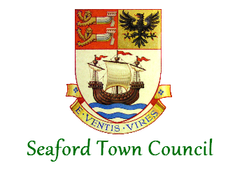

Noticeboard Policy
Seaford Town Council currently owns four noticeboards within the town that are open to general public use. If you would like to use any of them to display information we ask that you follow the given rules.
The main purpose of the boards is to display community events and activities, public services and council business.
Locations: (as shown on map – see other side)
- Buckle Car Park 2. Blatchington Pond 3. East Street
- Seaford Cemetery 5. South Hill Barn* 6. Southdown Road*
* = installed post policy adoption

Rules of Use:
- The above mentioned noticeboards are free to use for anyone that would like to display information providing it does not contain offensive material and is relevant to community events and activities within Seaford.
- Please be considerate of documents already on the board. We ask that you only remove documents/posters that are out of date. Events can only be advertised a maximum of 4 weeks in advance.
- Community matters have priority over businesses and for profit activities and therefore have the right to remove a document/poster displayed by a business and replace it with their own if there is no space.
- If you do remove out of date documents please dispose of them responsibly and where possible remove and dispose of any redundant pins and staples.
If you observe any misuse, vandalism or other
damage to the noticeboards please report this to:
Seaford Town Council, 37 Church Street, Seaford
Tel: 01323 894870 Email: admin@seafordtowncouncil.gov.uk

The noticeboards are checked every first day of the month
and cleared of any remaining old posters, pins and staples.
