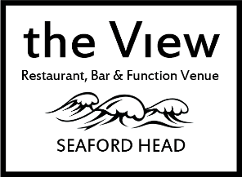

**The View Staff Structure**

**General Manager**

Craig Nicol

(Full Time)

**Kitchen Support**

(Casual Workers)

**General Catering Assistant**

*(vacant)*

(Vacant)

**Chef de Partie**

*vacant*

(Full Time)

**Sous Chef**

Seth Cage-Kaey

(Full Time)

**Kitchen**

**Head Chef**

Oliver Pink   
(Full Time)

**Waiting Staff**

(Casual Workers)

**Bar Staff**

(Casual Workers)

**Bar**

**Supervisors**

Candice Gay & Sophie Powell

(Full Time)

**Assistant Manager**

Kelly Powell

(Full Time)

**Finance & Events Coordinator**

Rebecca Sandalls

(Part Time 22hrs/pw)

Updated August 2021