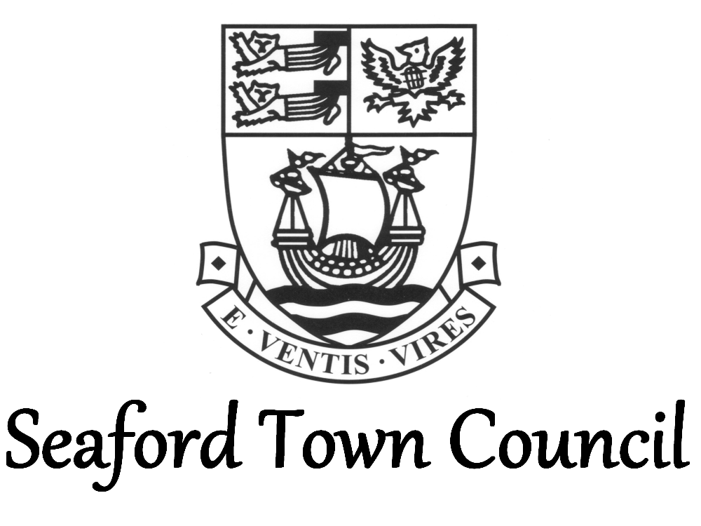

Public Participation Policy

Public participation is welcomed at Full Council and Committee meetings. Set out below is guidance, reflecting the Town Council’s Standing Orders, surrounding participation by members of the public at meetings:

- Public participation will be included in all Town Council agendas except for Personnel, Grievance, Disciplinary and Appeals Committees (/Sub-Committees); it is at this time in the meeting where members of the public may speak;
- Questions or statements made at Committees must be related to an item on the agenda and not general matters. Questions or statements at Full Council meetings can be on any reasonable matter.
- Members of the public wishing to make comments on a specific planning application being considered by the Planning & Highways Committee will be invited to do so immediately before each application is considered, rather than during the public participation agenda item.
- Members of the public will be given a maximum of four minutes each to speak. Public participation shall ideally take no longer than 20 minutes in total.
- Only one person is permitted to speak at any time. The member of public should raise their hand when wishing to speak; the Chair will decide the order in which members of the public speak. When speaking they should stand (unless they have mobility issues or are likely to suffer discomfort from doing so).
- To take part in public participation you must be present at the meeting to ask your question or make your statement.
- Any comments made or questions asked should be directed at the Chair. You should state which agenda item (where relevant) your question is regarding.
- Every effort will be made to give a response at the meeting, where required; a summary of any response given will be included in the minutes of the meeting, which will be published on the Town Council’s website.
- A verbal response may be provided to you by the Chair, a councillor or Town Council officer, through the Chair.
- The public question should not start a discussion.
- Members of the public will not have an automatic right to reply to the response given; the Chair may consider a request to reply if made, however this is likely to only be granted if new information is being provided.
- A request for the Town Council to pursue a public services matter with a public sector body will only be pursued if the requestor can evidence they have attempted to do this themselves first.
- Where it is necessary to exclude the press and public from a meeting, this shall be done by resolution with a reason for the exclusion given.
- The Chair has the ultimate say at meetings and anyone felt to be behaving inappropriately or acting disrespectfully towards others in the meeting, will be excluded from the meeting in accordance with Town Council Standing Orders.

Please note that audio and video recording of Town Council meetings is welcomed providing that the Town Council’s guidelines are observed. Said guidelines can be found in the public gallery at meetings or on the Town Council’s website.

Any member of public wishing to submit a petition should refer to the Town Council’s Petition Policy, which is available on the Town Council’s website.

Standing Orders 3 sets out the Town Council’s rules regarding public participation at meetings; this policy is a reflection of these rules.

Only in the event of unexpected / enforced changes to meeting formats (such as having to hold remote/virtual meetings or Government restrictions that prevent members of the public attending meetings physically), the Proper Officer shall consult with the Committee Chair’s Management Group to agree how public participation can be accommodated at meetings. Any change in public participation format will be clearly identified on agendas and other meeting communications.

Ultimately, the Chair controls and has order over the meeting in accordance with Town Council policy.

Adopted: October 2021
Revise: October 2024 or earlier if legislation/best practice changes

