**Response to NALC’s Questions on the ‘Local Nature Recovery Strategies’ consultation**

Seaford Town Council considered NALC’s briefing note on the Local Nature Recovery Strategies consultation AT ITS Full Council meeting on 13th October 2021 **(full details can be found within the Full Council Agenda for 13th October 2021 pages 48-54 –** [**click here**](https://www.seafordtowncouncil.gov.uk/wp-content/uploads/2021/01/13.10.21-Full-Council-Agenda-Reports-FINAL.pdf)**)** and has responded to the questions highlighted by NALC as set out below.

RESPONSE: All of the groups listed.

RESPONSE: No

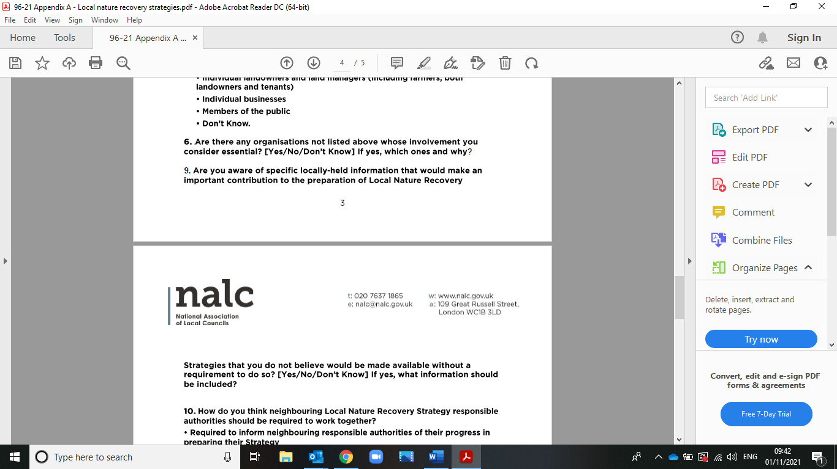

RESPONSE: No

RESPONSE: All of the suggestions, except other and don't know.

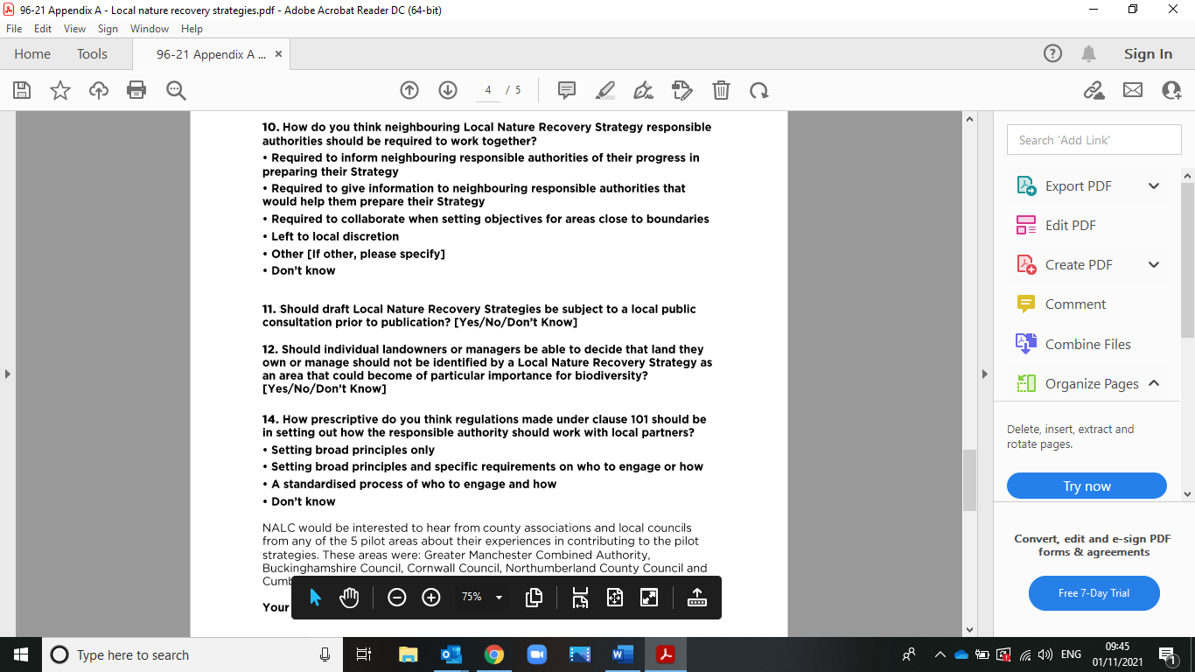

RESPONSE:Yes, but with time restraints, and contact local environment groups.

RESPONSE: The Town Council thinks that this will have to be determined by the individual owners, this question is vague to give a clear answer as to what individual landowners and managers should do to their land.

RESPONSE:Setting broad principles and specific requirements on who to engage or how.

Standardised process of who to engage and how.