Events & Facilities Officer
Job Description – November 2021

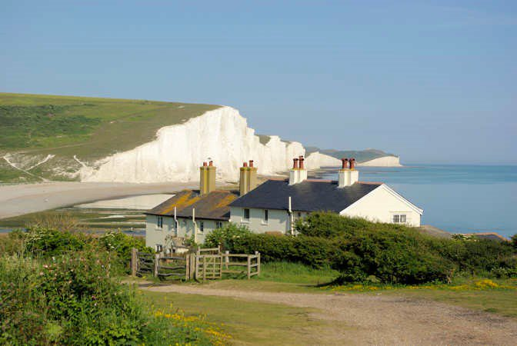
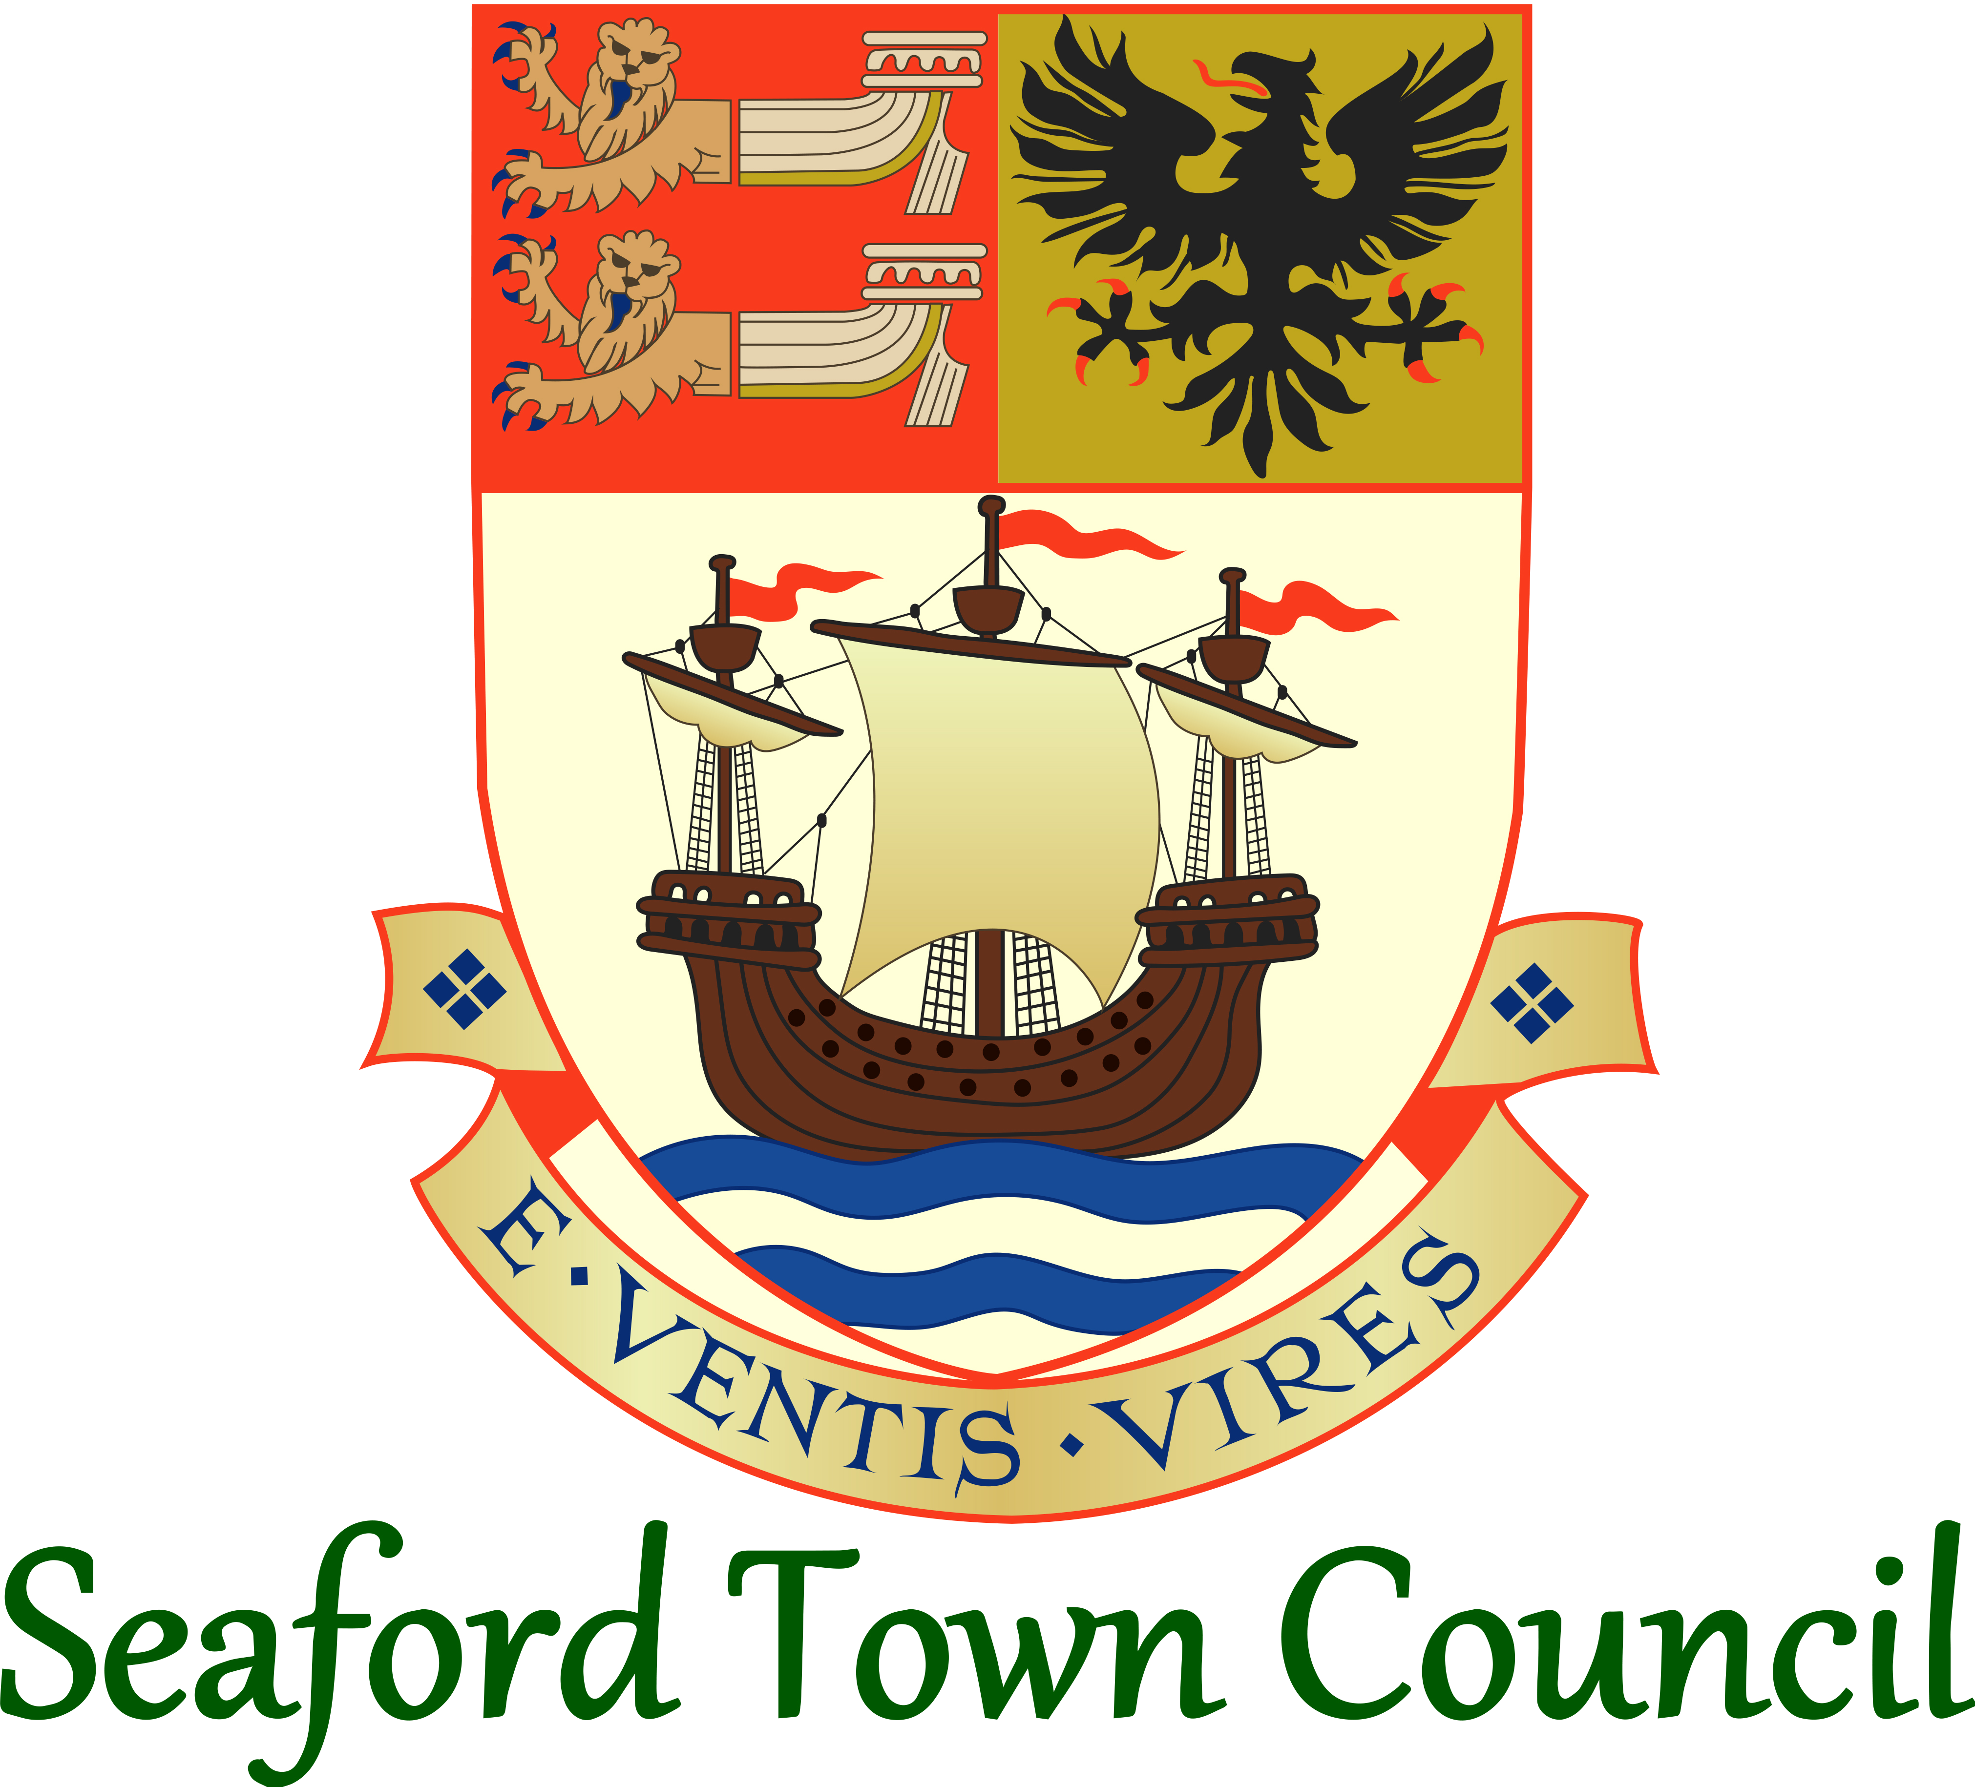

Responsible to: Projects & Facilities Manager
Hours: 28 hours per week
Grade: SCP 13-17

1. Job purpose
To provide day-to-day management of the Town Council’s events, concessions and street trading, external events and hirers, including communications as required surrounding these.
2. Areas of Day-to-Day Responsibility
Town Council Events (not including Civic)
Non-Town Council Events
Concession, Street Trading & Open Space Hire
Publicity/Marketing/Communications (of above areas)
3. Line Management
- There is no line management responsibility with this post.
- You will report directly to the Assistant Town Clerk.
4. Duties
Town Council Events
- Responsible for the day-to-day management of the Town Council events, including; being the main point of contact for Town Council events, the planning and preparations (with consideration of health & safety factors, equipment required, publicity, volunteers and other tasks in line with the event planner for each individual event), delivery of the event, administration and record-keeping as required, sourcing and applying for external funding opportunities, liaising with third parties and external contractors, supervising any volunteers and/or third parties assisting/taking part in the event, public and internal relations relating to events and handling incoming enquiries regarding events.
- Maintain and continue to develop excellent partnership working with other agencies and the community and new community initiatives, as a working representative for the Town Council.
Non-Town Council Events:
- To be the main point of contact for non-Town Council events on Town Council land and premises, where relevant, and process enquiries accordingly.
- To coordinate the process through which the event application is assessed for suitability, liaising with all parties as required and informing of the outcome of the application.
- To liaise with external event organisers to manage the event preparations internally within the Town Council, including; reviewing with other relevant officers the event management plan, ensuring all requirements are met and pursuing where these aren’t, administration and record-keeping as required, continued liaison with the organisers up to the event taking place, public and internal relations relating to events and handling incoming enquiries and/or complaints regarding events.
- Maintain and continue to develop relationships and partnership working with external event organisers and local community groups where community events are concerned.
Concessions, Street Trading & Open Space Hire:
- Day-to-day responsibility for the management of all current and new Town Council concessions in the town; managing the process from start to finish and ongoing management of relationships with concession holders.
- Day-to-day responsibility for managing processing requests under street trading arrangements (as delegated by Lewes District Council), coordinating the implementation of new street traders and maintaining relationships with traders.
- Ensure continued assessment of the nature and number of the Town Council’s concessions and street trading licences to ensure suitability and effectiveness for the town and its needs, and identify any areas for improvement.
- To coordinate and deliver the Town Council’s tendering procedure, in line with the Town Council’s Financial Regulations, on relevant areas and projects within remit.
- Responsible for the management of the Town Council’s concession hut scheme on an annual basis, including coordination of the trading arrangements and selection of traders.
- To maintain adequate records and document control for all concessions, street trading licenses and tendering processes undertaken, as relevant, in line with Town Council policy.
- To liaise with the Film & Liaison Officer as required regarding filming enquiries on Town Council land/properties.
- Main point of contact and day-to-day responsibility for the hire of open spaces by external parties.
- To arrange, where required, site visits and inspections on an ad hoc/responsive basis.
Publicity, Marketing &Communications:
- Responsible for coordinating press releases, publicity and other marketing regarding Town Council facilities, events or projects. Including keeping the relevant social media & website details up-to-date.
- Dealing with public queries and those from third parties or external organisations/agencies, face-to-face, over the phone or by email. Including handling and resolving more challenging queries and/or complaints, where relevant. To prepare reports to relevant Committee meetings monitoring the facilities and assets and any other relevant matters. To attend and support relevant Committee meeting to action and discuss reports.

- To assist in monitoring the performance of the Projects & Facilities team against financial and personal targets, individually and as a team. Contributing to the strategic planning of the team, particularly within areas of remit, but also showing awareness of cross-team impact and considerations.
- To act as one of the official representatives of the Projects & Facilities team in the absence of the departmental manager.
- To undertake any other duties as required consistent with the level and scope of the post.

