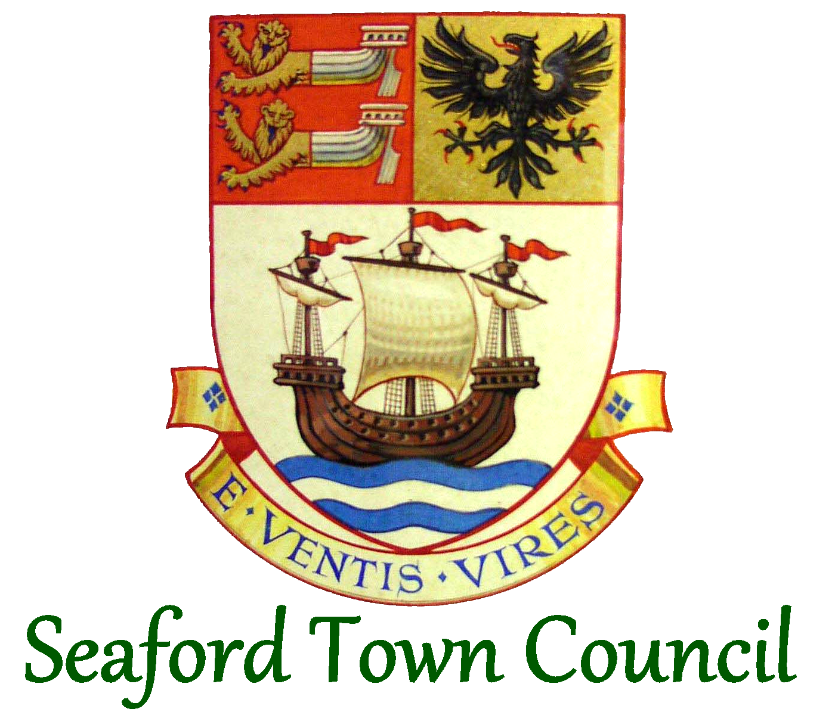

Events Policy

1. Introduction
Seaford Town Council fully recognises that outdoor events are of great value to the town, improving community well-being and visitor enjoyment. As such, the Town Council is pleased to allow, in principle and subject to the conditions of this policy, organised events to be held in open spaces owned by the Town Council, whether organised by the Town Council itself or external organisations.
This policy outlines the responsibility of the Town Council in organising and managing its own events and also the hiring of its open spaces and/or other assets (not including The View or Seaford Head Golf Course).
This policy ensures that the management and regulation of events organised and held in open spaces is for the mutual benefit of all.
2. General Bookings and Use of Seaford Town Council’s Open Spaces Available for Hire
- Crouch Gardens
- Martello Fields
- The Salts Recreation Ground
- South Hill Barn
- Seaford Promenade
- All applications for events in the Town Council-owned open spaces that are available for hire, as listed above, must be made on the Town Council’s application form to ensure the request can be recorded and monitored.
- This ensures that officers have the necessary information to satisfy themselves that the event will comply with the Health & Safety Executive, Guide HSG 195 The Event Safety Guide (second edition): A guide to health, safety and welfare at music and similar events. This guide is available from www.hse.gov.uk . Professional firework displays must comply with Health & Safety Executive Guide HSG 123.
- All event requests will be considered, with approval subject to open space availability and the event delivery supporting the Town Council’s strategic objectives.
- The size of the event determines how to apply:
Size | Audience capacity * | How to apply
Mini | Under 100, subject to conditions ** | Submit an Application for Hire Form
Small | Under 500 | Submit an Application for Hire Form
Medium | 500 – 3,000 | Submit an Application for Hire Form
Large | Over 3,000 | Submit an Application for Hire Form &  Event Management Plan
* Audience capacity is the maximum number of people expected at the event at any one time, including any staff or volunteers.
** To be classed as a mini event there must be no infrastructure or licensing requirement and very little, if any, impact to the local area and residents. Failing that, this would likely be classed as a small event.
- The type of the event determines the fees payable – please see section 8 below.
3. Mini, Small & Medium Events
- For small and medium events, the event organiser submits an Application for Hire Form (‘application form’) a minimum of 3 months before event set up on site begins.
- For mini events, the event organiser submits an application form ideally a minimum of 6 weeks before the event takes place. However, officers may consider a shorter lead time depending on the type of event and officer workload.
- Where an event is considered to have significant impact on an area, site or residents, or requires a considerable emergency services operation, it may be considered a large event regardless of estimated audience size.
- The application form is assessed by the Projects & Facilities team and consent will be issued by form of an email if permission is granted.
- The application form questions will need to be completed in full before submission. Depending on the nature of the event, the hirer may need to plan for some of the areas listed below under ‘large events’.
- A risk assessment is required for all events and the application form contains a template.
4. Large Events
- Following an application being submitted and an initial discussion with the Projects & Facilities team, an Event Management Plan must be submitted at least 6 months before event set up on site begins.
- If further development of the plan is necessary, a timescale greater than 6 months is likely to be required. If the timescale for event planning is not met, the Town Council’s consent may be withdrawn.
5. Event Management Plan
- Organisers of large events will need to produce a plan that will be subject to the approval of the Projects & Facilities team. The plan will include but not be limited to:
  - Access Provision
  - Cancellation procedure including adverse weather conditions
  - Child and vulnerable adult protection
  - Complaints procedure
  - Concessions and caterers
  - Crowd management
  - Emergency control
  - Entertainment
  - Environmental / Sustainability impact
  - Event communication plan including named contacts
  - Fire safety and evacuation
  - First aid / medical
  - Food safety
  - Infrastructure
  - Licensing requirements
  - Lost children and property procedures
  - Marketing
  - Noise management
  - Public liability insurance
  - Risk assessments
  - Sanitary provision
  - Security and stewarding provision
  - Site plans
  - Statement of intent
  - Production and event timetable
  - Traffic management
  - Transport management
  - Waste management
- Where the applicant is looking to seek permission for alcohol sales at an event, they must inform the Town Council of this on the application form and set out the necessary risk and impact assessments specific to an event with alcohol on sale.
- Upon reviewing the assessment documentation, Town Council officers in consultation with the Chair of Community Services may determine whether or not permission is given for the event organisers to apply to Lewes District Council for a Temporary Event Notice/permit to sell alcohol. Event organisers should look on the District Council’s website for more details on the application process and timescales and fees involved.
- It is the applicants’ responsibility to notify appropriate authorities with details of the event as required.
- It is the applicants’ responsibility to arrange licenses as required, in order to ensure the event complies with the most up to date legislation. Once licenses have been obtained, copies need to be provided to the Town Council to support the application.
- It remains the responsibility of the applicant to notify the Town Council in writing of any change of address or contact details. If required for whatever reason, the Town Council will only make contact with the applicant via the last address supplied by them.
- The Town Council will support the marketing of the event, where possible, by sharing details on the Town Council’s website, social media, notice boards and staff email banners, once the application form and deposit have been received and hire provisionally agreed.
6. Plastic Free Events Charter
Those organising events on Town Council land or taking part in Town Council events, are informed that Seaford is a plastic free town and therefore not to:
- use plastic for their takeaways
The Town Council has committed to work towards also including not to:
- use plastic bags
- use balloons both plastic and helium, or
- use plastic cutlery.
In addition to the above, they are also asked to:
- reduce the amount of plastic bottled drinks sold, and
- encourage reusable cups for drinks (hot drinks and pint glasses) during 2021 with a view to becoming compliant by 2022.
Officers carry out unannounced spot checks to assess adherence to the above measures. Where it is found that the plastic free events charter is not being adhered to, officers will assess what steps can be taken to address this/prevent recurrence.
Actively reminding events organisers/partners of these aims for events within the town sends a strong message about the kind of town Seaford is aspiring to be and the kind of environment the town wants to hold.
7. Deposits & Cancellations
- It is at the Town Council’s discretion to ask for a non-refundable deposit, if an open space booking is made more than three months in advance.
- Full payment will be invoiced one month in advance of the booking date, with payment to be made no later than two weeks before the booking date.
- Cancellation fees will apply to all open space bookings.
- Cancellations fees will be charged as follows:
  - within 28 days of the event or set up date (whichever sooner), 25% of the total booking fee
  - within 10 days of the event or set up date (whichever sooner), 50% of the total booking fee
  - within 48 hours of the event or set up date (whichever sooner), 100% of the total booking fee
- Cancellation of an event due to weather conditions –If an event is cancelled due to bad weather conditions, the Town Council is unable to offer a refund, however, can look at re-arranging the event on an alternative date in the calendar year for the existing price charged.
- Refundable security deposits can be requested should the event place the open space at risk of damage. refundable within 10 working days of the open space passing inspection successfully after the event. Security deposits can be refunded via BACS.
- The Town Council reserves the right to cancel a scheduled event, where it is required to do so, and will notify the applicant in this circumstance. Where the Town Council cancels an event booking, the hirer will receive a full refund of any payments they have made.
8. Hire Charges
Hire charges for all outdoor spaces for commercial and not-for-profit/ voluntary groups according to hire location:
Crouch Ornamental Gardens – lends itself to open-air style theatre productions due to the great acoustics.
 | Commercial | Not-for-Profit / Voluntary Groups
Day | £176.50 | £34.50
Set-Up / Close Down | £86.00 | £17.50
Hourly | £29.00 | £7.00

Martello East Fields – for larger and community events.
 | Commercial | Not-for-Profit / Voluntary Groups
Day | £437.00 | £175.00
Set-Up / Close Down | £196.00 | £88.00
Hourly | £109.50 | £44.00

Martello West Field – for larger and community events.
 | Commercial | Not-for-Profit / Voluntary Groups
Day | £284.50 | £44.00
Set-Up / Close Down | £98.50 | £22.00
Hourly | £55.00 | £14.50

Salts Recreation Ground – Large grounds, close proximity to the train station, seafront and town centre.
 | Commercial | Not-for-Profit / Voluntary Groups
Day | £459.00 | £184.00
Set-Up / Close Down | £207.00 | £89.00
Hourly | £109.50 | £92.00

South Hill Barn – ideal for showcasing exhibitions or holding talks.
 | Commercial | Not-for-Profit / Voluntary Groups
Day | £220.80 | £36.60
Set-Up / Close Down | £110.40 | £18.60
Hourly | £55.20 | £8.40

Seaford Promenade - stretching from Splash Point to Seaford & Newhaven Sailing Club, great for sponsored walks/runs.
 | Commercial | Not-for-Profit / Voluntary Groups
Flat Fee | £110.63 | £46.00

Hire charges will be reviewed by officers on an annual basis, to complement the budget setting process. Where changes are recommended, these will be presented to the Community Services Committee and/or Full Council for consideration.
9. Town Council Events
  - Sussex Day
- Sussex Day is arranged by the Town Council’s Projects & Facilities team and is held on the closest Saturday to 16th June each year, at 12noon.
- The Town Council welcomes the Town Crier to, as the master of ceremonies, to deliver the Sussex charter at 12noon.
- The Town Council arranges for the Mayor to raise the blue Sussex flag at the Martello Kiosk location.
- The Town Council arranges for ‘Sussex by the Sea’ to be sung following the raising of the flag and will provide printed copies of the song for all to join in the singing.
- The Town Council invites the Freemen of the Town and Town Councillors to attend and join in at the event.
- The Town Council arranges event support and funding in line with the budget agreed annually by Full Council.
- Changes from the above event format would be discussed with Mayor and Chair of Community Services Committee.
9.2 Armed Forces Day
- Armed Forces Day is arranged with a standalone non-Town Council committee including Town Council officers, Seaford Town Councillors, the Royal British Legion and Royal Society of St. George, as well as others approved by the committee.
- Armed Forces Day is held on the last Saturday in June, unless otherwise specified and agreed by the Armed Forces Day Committee.
- The committee agrees on an annual basis which military charity funds raised from the Armed Forces Day are to be donated to. The committee creates the programme of events, approves marketing materials used, and assists with fundraising activities.
- The Town Council arranges road closure applications to allow a military parade to be held between the hours of 11.30am and 1pm on the day, as agreed by the committee.
- The Town Council arranges event support, entertainment, marketing materials and funding, in line with the budget agreed annually by Full Council.
- Changes from the above event format would initially be discussed by the Armed Forces Day Committee and then with the Mayor and Chair of Community Services Committee.
9.3 Remembrance Sunday
- The Town Council supports the annual Remembrance Sunday celebration/commemoration activities with the Royal British Legion.
- The Town Council arranges installation of the wreath frame, event management and road closure for the Remembrance Sunday parade, in line with the budget agreed annually by Full Council.
- The Town Council arranges road closure applications to allow the wreath laying and parade to be held, between the hours of 10am and 11.30am on the Sunday after 11th November. This includes arranging a LANTRA to close the main A259 road.
- The Mayor’s Secretary arranges wreaths as appropriate for the Mayor and Young Mayor.
- Changes from the above event format would initially be discussed with the Royal British Legion and then with the Mayor and Chair of Community Services Committee.
9.4 Seaford Christmas Magic
- Seaford Christmas Magic is arranged with a standalone non-Town Council committee including Town Council officers, local traders, working partners and other volunteers as approved by the committee.
- With the support of the committee, the Town Council arranges an annual festive celebration for residents, visitors and traders, usually on the first Saturday of December.
- The Town Council arranges road closure applications for the day before the event, between the hours of 4pm – 12 midnight, to allow for set-up of structures and also the day of the Seaford Christmas Magic event, from 6am – 10pm.
- The Town Council arranges road closures, event support, entertainment, marketing materials, and funding in line with the budget agreed annually by Full Council.
- The Town Council will advise and work with residents living within the town centre, traders and other organisation who need to have access during the road closures, for smooth running during the event.
- Seaford Bonfire Society works with the Town Council to manage the road closures during the Seaford Christmas Magic event.
- The Town Council works with the event management company to look at the layout of the event on the closed roads, to include health and safety factors, access points and flow of large numbers of visitors to the event. Also booking first aid support to be available throughout the day.
- The Town Council provides a full risk assessment for the event.
- The Town Council will advertise for local stallholders, arranging bookings and payments from traders in the run up to the event. This will include various enquiries from stallholders regarding the event and also set-up information to be produced by the Town Council for access, set-up and close down for the event.
- The Town Council will work with the Christmas Magic Committee to seek sponsorship of the event and coordinate any advertising in exchange for sponsorship. This includes contacting local businesses and asking if they would like to support and sponsor the Christmas Magic event.
- The Town Council seeks to provide a free lantern making activity for the children, where lanterns and products to decorate will be sourced and packs made to provide to each child. This includes organisation of the hall, working with partner businesses and arranging volunteers on the day of the event.
- The Town Council works with the Christmas Magic Committee and business partners to arrange for a stage and entertainment to be provided throughout the day, with a list of the entertainment provided to the community through advertising.
- The Town Council works with local community groups and partner businesses to provide a Christmas grotto, with Father Christmas and presents for each child attending the grotto.
- The Town Council works with the Christmas lights contractor, the Mayor and Seaford Rotary Club to organise a countdown and switching on of the Christmas lights as part of the Christmas Magic event.
- The Town Council and Christmas Magic Committee look at and provide contingency plans for all aspects of the event.
- The Town Council runs the event with the help of the Christmas Magic Committee and other voluntary groups. Briefing sessions are required on the build up to the event and also on the day of event and the Town Council provides a work rota for all volunteers.
- The Town Council works with the Chamber of Commerce in judging the ‘Best Dressed Window’ competition, which the Mayor of Seaford announces before the Christmas lights are switched on.
- The Town Council will issue a press release on the build up to the event. Along with updating the Town Council’s website and social media applications with this information. A press release is also completed after the Christmas Magic event and distributed in the same way.
- The Town Council also looks at various grant and sponsorship options which may be available to help support the event for the community.
- The Town Council provides a feedback questionnaire to all traders and residents regarding the Christmas Magic event to analyse and see where the event can be improved on each year for all.
- Changes from the above event format would initially be discussed with the Christmas Magic Committee and then with the Mayor and Chair of Community Services Committee.

Adopted: July 2022
Review: January 2025

