
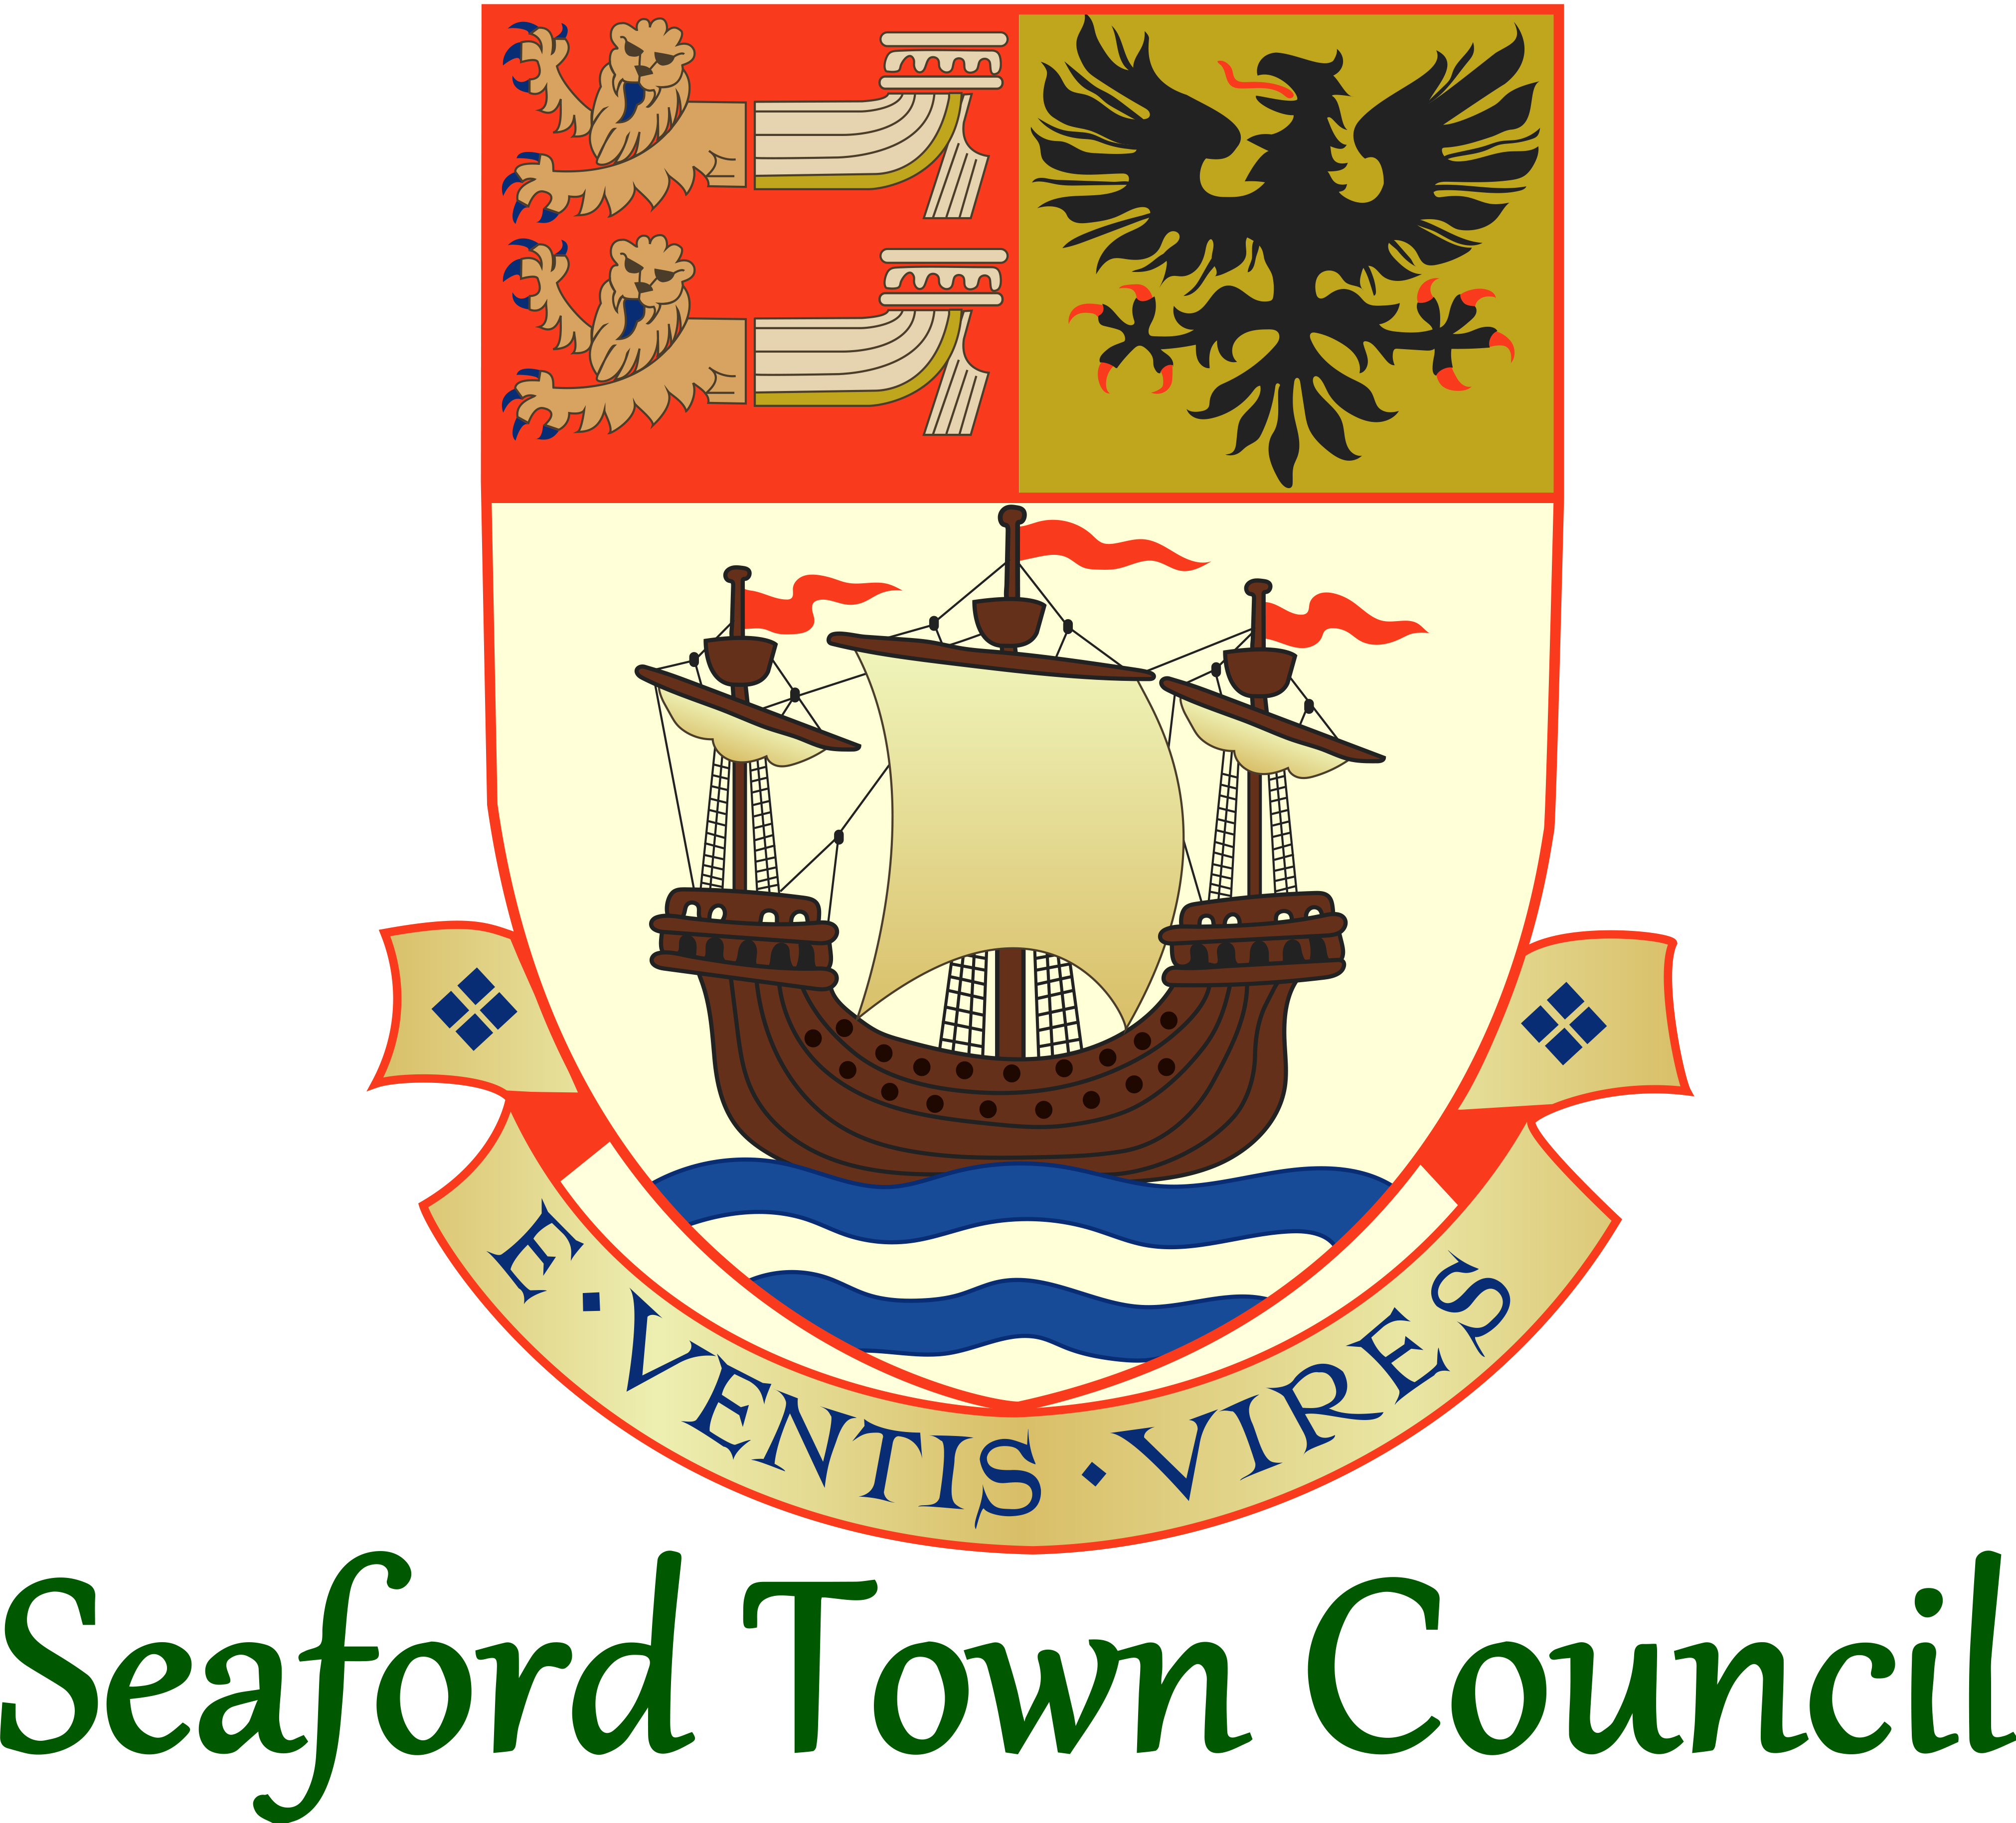

Admin Assistant
Job Description – October 2021

HR & Governance Assistant
Job Description – June 2022

Hours: 18 hours per week
Grade: SCP 6-11

JOB DESCRIPTION
- Job Purpose
To provide vital support to the HR & Governance Manager ensuring the smooth running of a number of core back office/support functions of the Town Council.
- Areas of Day-to-Day Responsibility
HR
Meetings
Data Protection
Policies
General support to the HR & Governance Manager
- Line Reporting
  - Reports to the HR & Governance Manager.
  - No direct line reports with responsibility for.
- Specific Responsibilities
HR
Administrative support to the HR and training functions of the Town Council, including:
  - Maintaining the personnel files and database.
  - Assisting with recruitment process; advertising and interviews preparations and onboarding and induction processes.
  - Drafting letters for staff on a variety of topics (pay awards, offer letters, performance management processes and others as needed).
  - Updating HR documentation, templates and other resources.
  - Assisting with the staff training functions; sourcing and booking training and maintaining the training log.
  - Updating the Town Council’s vacancies and staff pages, as appropriate.
  - Assisting with the annual appraisal process.
  - Any other support for the HR and training functions relevant to the scope of the role.
Meetings
Administrative support to facilitate the Town Council’s meeting cycle, including:
  - Monitoring the meeting timetable key dates and providing managers with reminders in accordance with this.
  - Assisting in the creation and issue of public agendas for meetings.
  - Drafting minutes for the meetings from a template.
  - Assisting with the preparation for meetings (room and equipment set up etc).
  - Assisting with the record keeping for meetings, updating membership lists, meeting timetables, master copies of document, document templates and other similar records.
  - Editing meeting videos and uploading to YouTube.
  - Maintaining the meetings pages of the Town Council’s website.
  - If required, occasional attendance at evening meetings (to assist with understanding of meeting procedures and/or assist with the smooth running of the meeting).
  - Any other support for the meeting functions relevant to the scope of the role.
Data Protection
Administrative support to help ensure the Town Council’s continued compliance with data protection legislation, including:
  - Appropriate to the scope of the role, assisting the HR & Governance Manager as required with reviewing practices to ensure compliance with data protection legislation.
Policies
Administrative support with the upkeep of the Town Council’s policies, including:
  - Assisting with the process of creating, reviewing and issuing adopted Town Council policies.
  - Maintaining the policy database.
  - Any other support with the Town Council’s suite of policies relevant to the scope of the role.
Others
  - Any other tasks relevant to the scope and grade of the role.
  - General support for the HR & Governance Manager as required.
  - Ad hoc support to help cover in the absence of other members of staff (such as the Town Council office Administration Assistant).

