Assistant Town Clerk
Job Description – January 2023

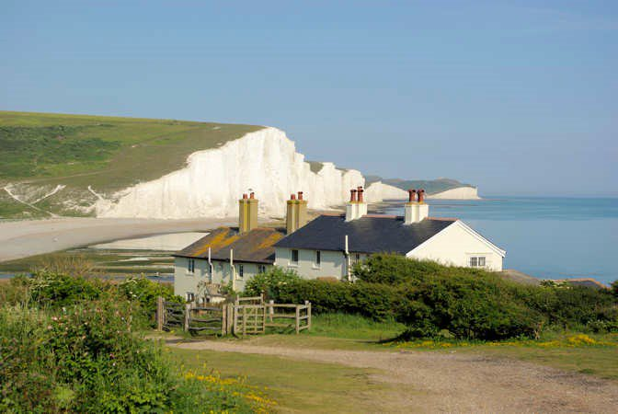
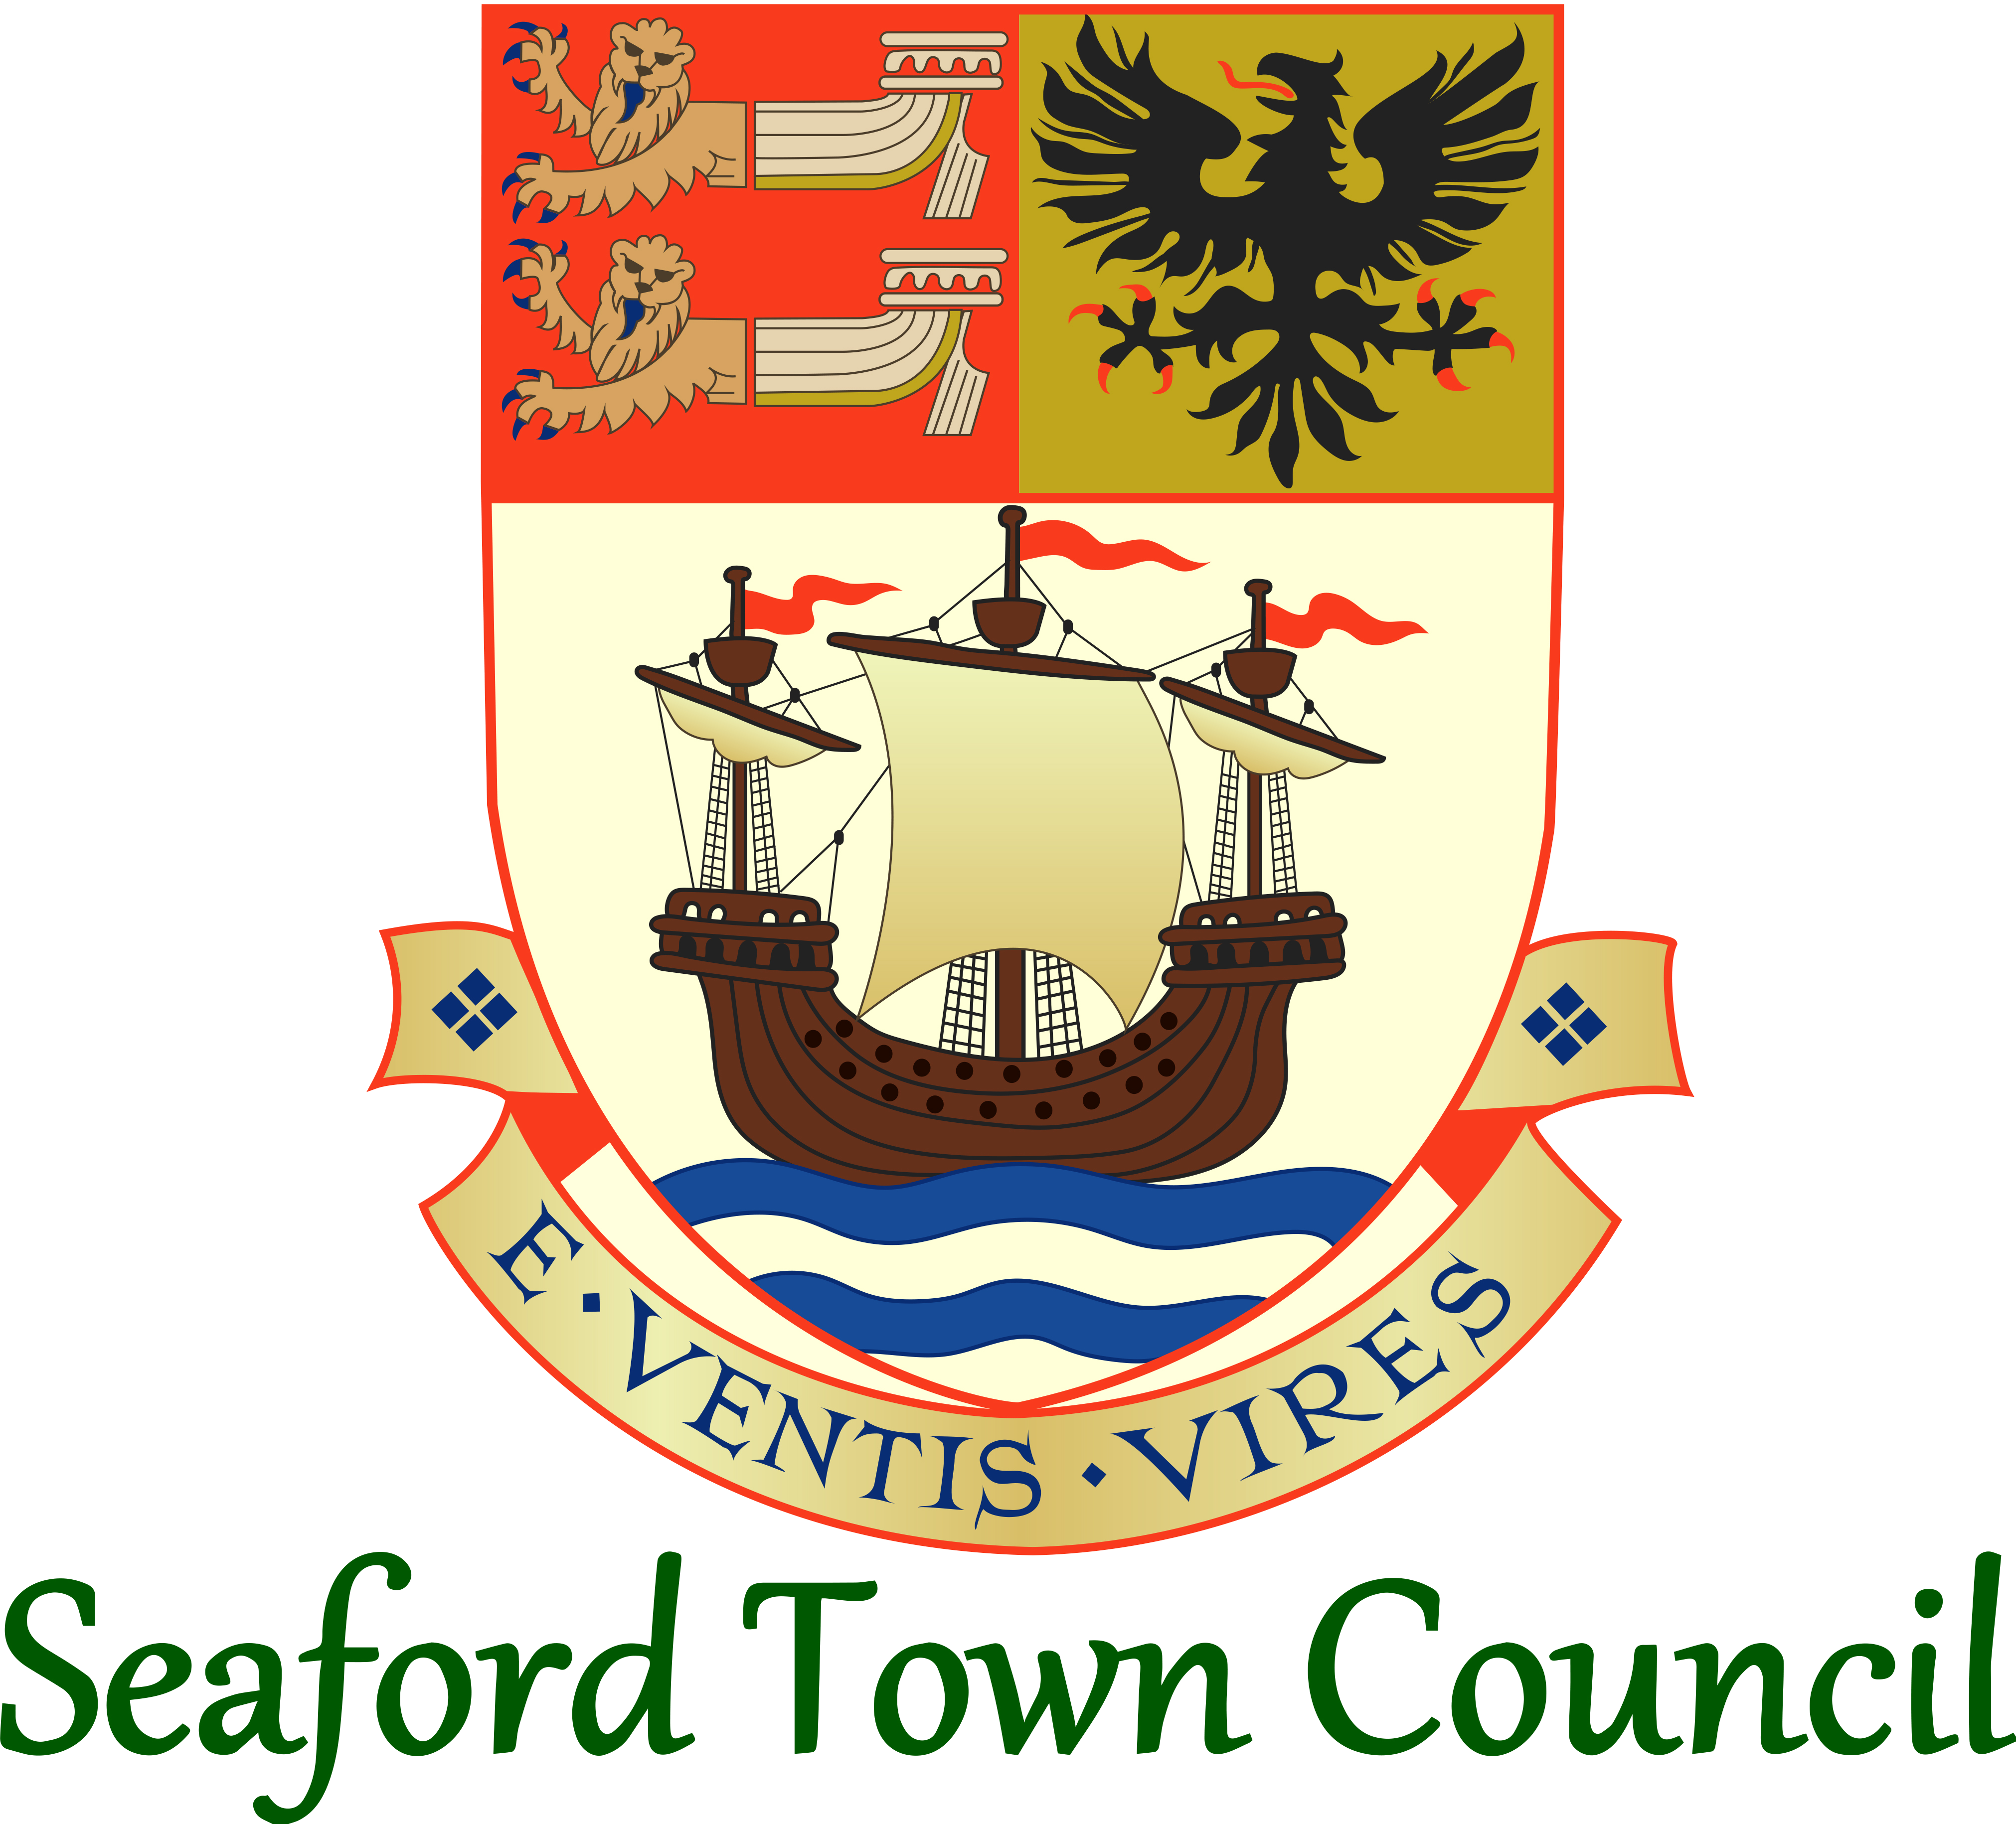

Responsible to: Town Clerk
Hours: 28 hours per week
Grade: SCP 23-29

- Job Purpose

The post of Assistant Town Clerk helps deliver and maintain the framework to help the Town Council succeed.

You will be responsible for the delivery and effectiveness of the areas of your day-to-day responsibility, whilst leading, motivating and developing your team members.

The Town Clerk is responsible overall for ensuring that the instructions of the Town Council in connection with its function as a local council are carried out, and you will be pivotal in supporting them to achieve this.

- Areas of Day-to-Day Responsibility

Communications (Websites, Social Media, Publications, Marketing, Council Branding)
Democratic Services (Councillor Details, Outside Bodies, Elections)
Civic Services (Mayor & Young Mayor Offices, Civic Events, Civic Regalia & Protocol)
Corporate Governance (Freedom of Information)
Public Engagement and Consultations
Office Management (Office Facilities & Equipment, IT Services, Telephones)

- Line Management

  - Two direct reports; the Civic Officer and Administration Assistant.
  - Reports to the Town Clerk.

- Specific Responsibilities

Communications
  - Responsibility for the Town Council’s website, Facebook page and any future social media accounts. To ensure that information on these sites is up to date and accurate, meeting the legal requirements for data transparency. To act as point of call on website related queries.
  - Assist with the creation of Town Council press releases and publicity of the Town Council’s activities and authorising such releases.
  - Responsibility for the Town Council’s Annual Report, annual Council Tax Leaflet and other such publications as requested.
  - Responsibility for reviewing, planning and managing any marketing relating to the activities of the Town Council.
  - Responsibility for managing and overseeing the overall branding of the Town Council.
Democratic Services
  - Provide assistance where possible during local and general elections and the induction of any subsequent Town Councillors.
  - Coordination of the Town Council’s Outside Bodies, liaising with the external organisations, advising Councillors where needed and related administration activities.
  - Maintain information regarding Councillors; Council records and publicly available documents and information.
Civic Services
  - To oversee and manage the civic services of the Town Council.
  - Line management of the Civic & Grants Officer and supporting them with their activities coordinating the offices of both Mayor and Young Mayor.
  - Ensure Civic Protocol is upheld.
  - Responsible for arrangement of the Annual Town Meeting (Town Forum).
  - Oversee the Freedom of the Town process.
Corporate Governance
  - Responsibility for handling Freedom of Information Act requests received by the Town Council in accordance with Town Council policy and relevant legislation.
  - Drafting of reports to Full Council or Committee meetings as required, regarding activities within remit.
Public Engagement and Consultations
  - To oversee and manage public engagement activities of the Town Council; working with other teams to create, collate and analyse engagement activities and responses.
  - To bring to the attention of the Town Clerk any consultations that the Town Council could or should be responding to. To assist with draft and submitting responses and publicising the response on the Town Council’s website.
Office Management
  - Information provision and support to the Town Clerk, Councillors and other members of staff as and when required.
  - Ensure the office is running effectively and efficiently, working with the Administration Assistant regarding the general office administration activities.
  - Responsible for the Town Council’s IT function and telephone systems (including those at The View and Golf Course).
  - Part of the Corporate Management Team; responsible for providing administrative support to the team, arranging meetings, note-taking and overseeing follow up actions.
  - Staying up to date with matters effecting the Town Council and bringing these to the Town Clerk’s attention as and where relevant.
  - Ensuring published Town Council documents and information are accurate and up to date (hard copies and online) and the Office and Councillor Information Packs.
  - To undertake any other duties required by the Town Council consistent with the level and scope of the post.
Continuity Planning
  - In the absence of the Town Clerk/Proper Officer, and providing such matters cannot wait until the return of the Town Clerk/Proper Officer, shall be responsible for:
    - Those responsibilities bestowed upon the Proper Officer according to Standing Orders and any other Town Council Policy.
    - Decision making regarding the areas of responsibility in the job description.
  - Where necessary, such decisions should be discussed with other relevant members of management team and a written record made to be reported back to the Town Clerk/Proper Officer at the earliest possible convenience.

