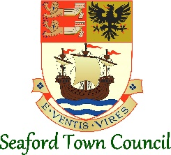

Contact: Admin
admin@seafordtowncouncil.gov.uk

IMMEDIATE RELEASE
Date 20th December 2023

Seaford Town Council’s Festive Wrap Up
Seaford Town Council is delighted to reveal the total number of gifts received for the Seaford Secret Santa Gift Campaign and share the success of the largest lantern parade in Seaford Christmas Magic history and enjoyment had at the Mayor’s Carol Service.

SEAFORD, 20th DECEMBER 2023 – As the Town Council approaches the festive break, it reflects on the whole host of community successes enjoyed this December.
One of the most notable successes has been the wonderful Seaford community coming together and helping to raise an incredible 208 gifts for local families in need through this year’s Seaford Secret Santa Gift Giving Campaign. The Town Council would like to thank everyone who took part and helped to exceed the 150 gifts target.
With the support of the endlessly helpful team at the Seaford Tourist Information Centre and the guidance of Family Support Work, this generosity will support hundreds of local families to place presents under the tree this year. Gifts are already being distributed and the organisers are thrilled with the variety and quality of the gifts received.
“It has been so wonderful working with Seaford Town Council, the generosity of residents in the town has been incredibly heartwarming. With hundreds of families benefiting from the gifts received and donations made at the incredible Christmas Grotto in early December, this is a real example of community spirit and working together to achieve a little Christmas Magic.” Martin Auton-Lloyd, CEO, Family Support Works.
This year’s Seaford Christmas Magic saw one of the town’s largest parades to date, with schools, organisations, families, and individuals lining the streets for the Positivity Parade.
Image One – Seaford Christmas Magic Positivity Parade Lanterns.
The Seaford Christmas Magic event on Saturday 2nd December was home to a variety of free activities to get everyone into the festive spirit. St Leonard’s Church was buzzing as the over 60’s choir filled the space with joyful song, whilst families and groups also gathered at the Seaford Climate Hub and Seaford Library to enjoy rhyme and story time, and take part in the sustainable gift exchange.
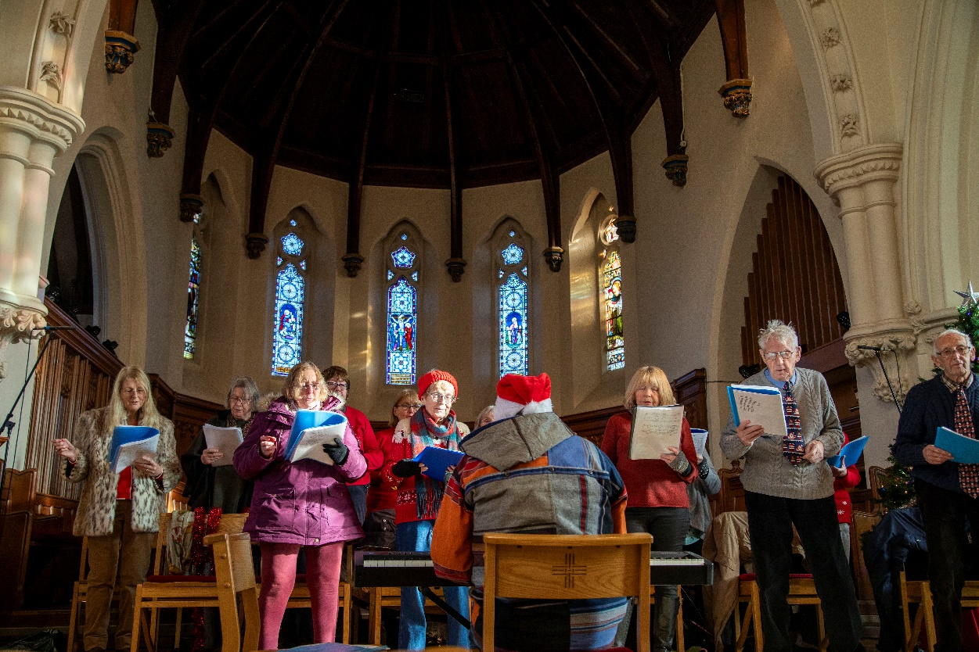
Image Two – St Leonard’s Church Over 60’s Choir.

Seaford Town Council’s officers and volunteers welcomed many residents and visitors to sneak a peek at the merry Christmas grotto in the Old Town Hall and Sussex Contemporary Illustrators and Printmakers (SCIP) got everyone in the mood with a lively lantern making workshop at The Mercread Youth Centre.
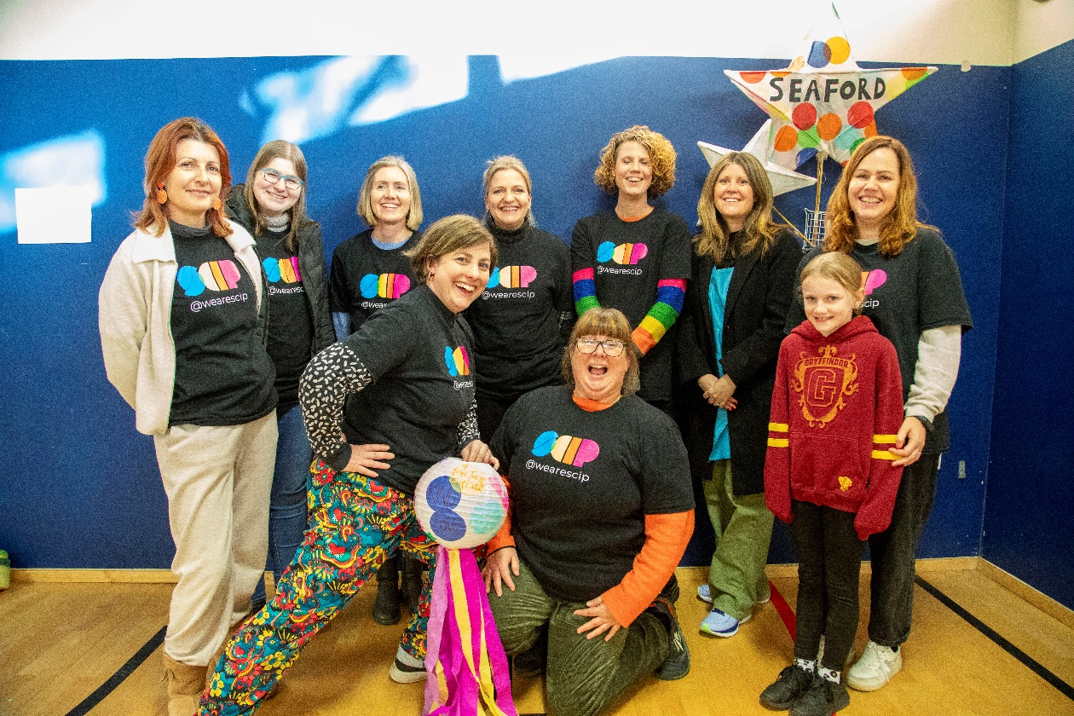
Image Three – Sussex Contemporary Illustrators and Printmakers lantern workshop.
The whole event was a wonderful reminder of the community the town has created, and the Town Council looks forward to planning next year’s event early with the input of local businesses, organisations, residents and partners. Keep an eye on our website and social media for more information or to be involved in the 2024 event.
“A magical day was had by all, meeting Santa, listening to rhymes at Seaford Library, learning about an environmentally friendly Christmas at the Seaford Climate Hub, visiting the Mercread Youth Centre for the lantern making sessions run by SCIP. Joining in the fun at St Leonard’s Church, it was great to see the town of Seaford so busy. Well done to all involved.” Councillor Olivia Honeyman, the Mayor of Seaford.

###

