Concessions Policy

January 2024

Policy Ref. | FS13
Date Last Adopted | January 2024
Date of Next Review | 2028 - 2029
Possible Prompts for Earlier Review | - Change in best practice or legislation
Previous Adoption Dates | n/a
Author | Events & Sponsorship Officer

Concessions Policy
The purpose of this policy is to propose a comprehensive Concessions Policy for Seaford Town Council (STC) that aligns with STC’s commitment to fostering a vibrant, accessible, and inclusive community within our town.
The mission of this policy is to promote economic development, enhance public spaces, and provide residents and visitors with diverse and high-quality concession offerings throughout STC assets.
By implementing a transparent and equitable matrix system, footprint evaluation and concessions policy we aim to create an environment that supports local businesses, contributes to the overall well-being of our community, whilst also building our commercial viability.
Please note the below covers all STC fixed and non-fixed assets. The Community Services Committee controls the number and type of concessions.
Mission Statement
Create a diverse commercial offering for the residents and visitors of Seaford. Providing local sustainably operated businesses the chance to launch and explore viability in affordable, accessible, and influential town spaces.
The mission statement will be shared in all tender application information to ensure full transparency for potential applicants.
Matrix System
To ensure a fair and objective evaluation process for concession applicants, a matrix system has been implemented. This system considers various factors which officers will use to assess the suitability and potential contribution of each applicant. The following criteria will be included in the matrix:
Experience & Business Proposal – assessing applicants business plan, experience, and references.
Financial Viability – assessing the financial stability and capability of the application.
Community Impact – assessing the positive community impact of the application.
Environmental Sustainability – assessing the sustainability approach, credentials, and commitment to sustainable practices of the application.
Accessibility & Inclusion – assessing how the applicant serves a diverse audience and provides accessible options to serve all members of the community.
Variety & Site Ownership – assessing the offering and current business status of applicants to ensure the town maintains a range of business owners and business types across STC’s portfolio of assets. STC will strive to have different concession owners for all our fixed and non-fixed assets.
Locality & Portfolio – assessing the business location and any other commercial ventures.
Health & Wellbeing – assessing the applicant’s commitment to create spaces which support the physical and mental wellbeing of Seaford residents and visitors.
Each criterion will be assigned a weighted value between 1-5, and all applicants will be scored accordingly. This matrix system will ensure a thorough, impartial, and consistent evaluation process for all concession applications.
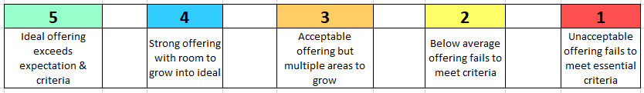
Officers will continue to evaluate the efficiency and relevance of the matrix and have delegated powers to amend in accordance with the needs of the town and STC. See below sample of the type of matrix used.

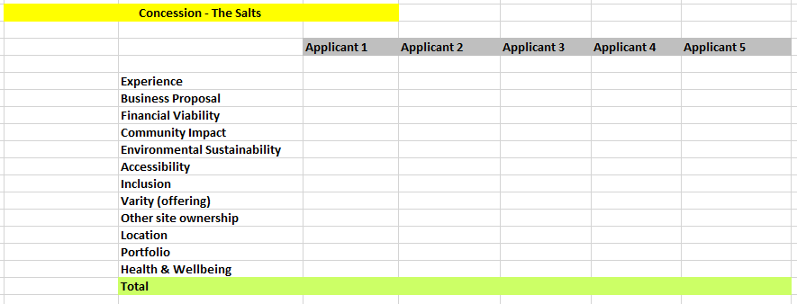

Footprint Evaluation
As part of this work, STC is introducing a footprint evaluation which looks at each assets physical space and introduces a charge for those looking to extend out of their agreed concessionary footprint.
This would be considered should concessions look to extend beyond their concession unit with tables, chairs etc. This would also be required should a concession wish to put on an event or activities which falls outside of their agreed space. Any such extension would need to first be approved by STC and would then be assessed on a case-by-case basis to confirm the cost. This will depend on duration, size, and purpose.
The above matrix will be consulted when looking at this charge and should the extension be deemed as supporting STC’s mission statement, officers have the power to waive the fee.
Concessions License updates
The below additional sections will be added to the existing legal document signed during the concession selection and approval process.
The proposed framework will set the standards and expectations for all concessions working within STC consent streets and land assets. These will be required to be adopted by all existing and new concessions.
Licensing, Events, and Health & Safety documentation – all documentation will be provided and reviewed annually and will be required to be completed by the concession within the agreed Council timeframe. If additional licenses are required for the concession, they will notify STC ahead of application and send details upon completion. Any TENS license applications will require review by the Chair or Vice Chair of the Community Services Committee ahead of being obtained and used. All elements of the application process will need to be completed by the concession, should STC officer time be involved this would need prior approval and would be chargeable to the concession.
Operating times - all concessions will comply to the agreed operating times within their contract, failure to do so will result in formal notification. Should no reason or evidence be provided by the concession STC reserves the right to terminate a concessions operating license and agreement within 7 days’ written notice.
Duration of concession agreement – standard term for all concessions will be 3 years with the potential to extend by 2 years based on performance evaluations and revaluation of the matrix criteria at the time.
Revenue transparency - a transparent revenue model must be adopted by all existing and new concessions. Providing STC with declared income via professional accounts. This ensures STC have an accurate picture of the viability and success of assets at each given site. This contributes to the financial sustainability of STC’s assets and ensuring the tender process continues to be inclusive, competitive, and informed.
Check ins, annual review & evaluation – comprehensive concession communication will be introduced which allows STC to maintain healthy relationships with concessions, ensure ongoing compliance, evaluate concessions performance across the scaled matrix and address any emerging issues or concerns. Should STC have any unaddressed concerns regarding a concession they reserve the right to terminate a concessions operating license within 7 days’ written notice. Officers will provide regular reviews to the Community Services Committee.
Repair, condition & cleanliness – concessions will support STC by maintaining a clean, clear, and accessible area around their concession and will maintain the footprint associated to their concession agreement to the highest standard. This includes supporting with shingle clearance for seafront concessions and any other waste management within the agreed footprint and immediate vicinity of their site. All concessions will be required to provide sustainable waste management at their site and must have their own waste bins, including provisions for recycling where possible.
Public access - concessions will support STC by maintaining clear and accessible areas around their concession and in the immediate vicinity. This includes providing clear signage for queuing and training staff to consistently consider and work to always ensure accessible access around the concession. Should STC have any unaddressed concerns regarding access or infringement on public access they reserve the right to terminate within 7 days’ written notice.
Nature, product, and goods sold – concessions will not be able to produce or sell anything other than the agreed items within their contract. Sub-letting or change of purpose or product must be first approved by STC. Failure to do so will result in termination within 7 days’ written notice.
Plastics – concessions will comply with the single-use plastics ban enforced by the UK government on 1st October 2023. Should STC have any unaddressed concerns regarding infringement on this public policy they reserve the right to terminate within 7 days’ written notice.

