
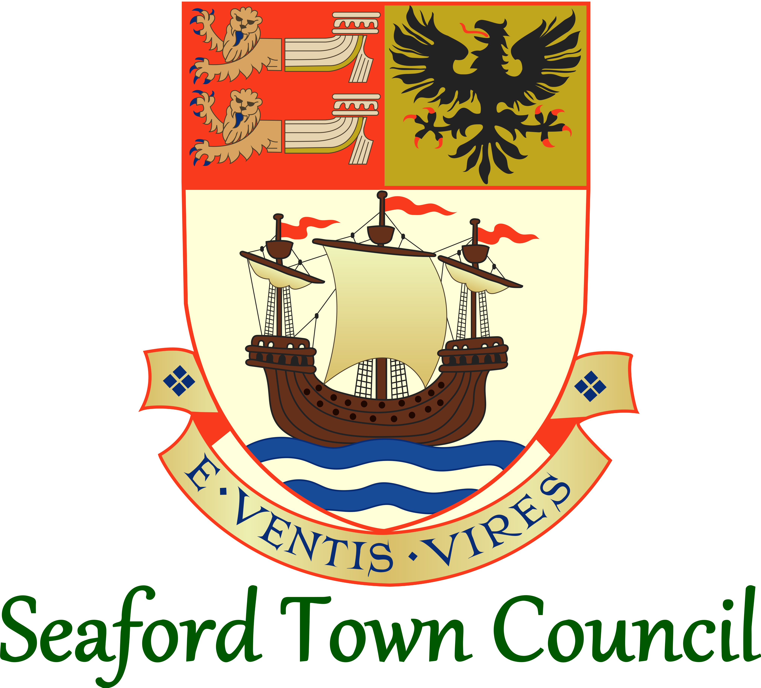

Admin Assistant
Job Description – October 2021

HR & Governance Manager
Job Description – October 2021

Responsible to: Town Clerk
Hours: 37 hours per week
Grade: SCP 23 -29

JOB DESCRIPTION
*JANUARY 2024 - temporary amendment:
Temporary HR Manager in situ January 2024 to June 2024. For this period this postholder shall be Governance Manager and have the temporary HR Manager reporting to them*

- Job Purpose
To provide efficient and effective support to the Corporate Management functions of the Council and the Town Clerk.
- Areas of Day-to-Day Responsibility
Human Resources (incl. Training)
Corporate Governance (Council Policies & Accreditation)
Council & Committee Meeting Paperwork & Administration
- Duties
General / Administration
- Information provision and support to the Town Clerk, Councillors and other members of staff as and when required.
- Staying up to date with matters effecting the Council and bringing these to the Town Clerk’s attention as and where relevant.
- Managing the post of HR & Governance Assistant.
- To undertake any other duties required by the Council consistent with the level and scope of the post.
Human Resources
- Day-to-day responsibility for all Human Resources functions of the Council, including advising and administration.
- Working closely with the Town Clerk to ensure the Council is complying with Employment Law and its own policies.
- Handling performance management processes and grievances in line with Council policy.
- Overseeing the training and development of staff members and councillors. Including record keeping, arranging of training and other related duties.
- Responsibility for arranging work experience placements and liaising with all necessary parties.
- Providing support to line managers and other members of staff on Human Resources queries or issues.
Corporate Governance (Policies & Accreditation)
- Leading on the monitoring and review of the Council’s policies and procedures.
- Providing advice to staff members and councillors on corporate governance matters and adherence with Council policies.
- Overseeing the Council’s membership of the Local Council Award Scheme, monitoring and managing adherence to the necessary criteria.
- Overseeing the process of any further accreditations the Council seeks (Local Council Awards, Star Council etc).
Council & Committee Meeting Paperwork & Administration
- Administration and support for Council and Committee meetings; including report writing, agendas, minutes, follow up actions and dealing with queries on meetings.
- Confidential support for the Personnel, Appeals, Disciplinary and Grievance Committees/Sub-Committees.
- Continuity Planning
In the absence of the Town Clerk/Proper Officer, and providing such matters cannot wait until the return of the Clerk/Proper Officer, shall be responsible for:
- Responsibilities bestowed upon the Town Clerk within Personnel Policies of the Council and/or relating to personnel/employment matters.
- Urgent line management duties for staff usually reporting to Town Clerk i.e. holiday requests, sickness notification, performance management etc.
- Decision making regarding the areas of responsibility in the job description.
Written: October 2013 / Reviewed: October 2021 / Temporary Update: January 2024

