Seaford Annual Town Meeting
Seaford Town Council is pleased to announce the details of this year’s Annual Town Meeting that it is facilitating.
Date: Tuesday 30th April 2024
Time: 7.00pm (arrival from 6.30pm)
Venue: Cross Way Church, Clinton Place, Seaford, BN25 1NP
AGENDA
- Welcome and Introductions by the Mayor of Seaford
- Minutes
To adopt the minutes of the Annual Town Meeting held 23rd May 2023 (available on the Town Council’s website).
- Seaford Town Council Update
The Town Clerk will present an update on the Town Council’s activities over the past year, including the adoption and implementation of its Strategic Plan 2023-2027, and the Town Council’s plans to mark its 25th Anniversary during the 2024 – 2025 municipal year.
- Presentations by Recipients of Large Grants
To receive brief presentations from the recipients of the large grants in 2023 – 2024.
- Young Mayor Update and Award
- The 2023 – 2024 Young Mayor, Nia Waite will present an update of her year in office and present her award.
- The Town Clerk will provide an update on the future of the Young Mayor role.
- Mayor’s Awards
The 2023 – 2024 Mayor of Seaford will present the following awards:
- Coastal Environment Champion
- Sporting Achievement Award
- Community Charity Champion
- Don Mabey MBE Award
- Question & Answer Time
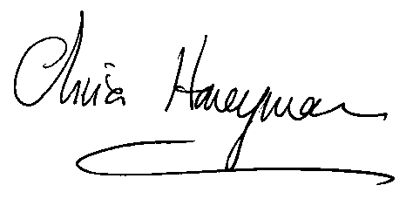
Residents have the opportunity to raise questions of local interest.

