Crouch Stakeholder Group Meeting
Seaford Town Council, 37 Church Street, Seaford, BN25 1HG
Wednesday 3rd April 2024 at 5pm

Seaford Town Council (STC) Officers:

Louise Lawrence, Head of Assets, Projects & Services, Seaford Town Council (STC)
Sharan Brydon, Assets & Projects Manager, STC
Contact email: projectsandfacilities@seafordtowncouncil.gov.uk
STC Councillors:
Cllr Christina Bristow, Seaford Town Council
Cllr Rod Buchanan, Seaford Town Council
Cllr Sally Markwell, Seaford Town Council
Cllr Maggie Wearmouth, Seaford Town Council
Cllr Stephanie Dubas, Seaford Town Council
Group representatives:
Crouch Concerns – Andy Shields
Crouch Concerns – Bob Downing
Peace Garden – Lindsay Thomas
Seaford Bowls Club – Peter Evans
Seaford Community Garden – Lesley Drew
Seaford Community Garden – Gillian Davey
Seaford Natural History Society – Mike Vingoe
Seaford Town Football Club – Sarah Scott
Seaford Town Football Club – Mike Greve
Trees for Seaford – Margery Diamond

Minute Taker: Louise Dickson, Projects & Facilities Assistant, STC

MINUTES
- Introduction
Introductions around the room.
- Updates
- Bowls Club
Still waiting on the path lights, which has taken a very long time and permission to place the purchased memorial bench (this has been no cost to STC). STC confirmed that they have been liaising with LDC on numerous occasions concerning the lights.
Action: Email projectsandfacilities@seafordtowncouncil.gov.uk and Cllr Oliver Honeyman cllr.olivia.honeyman@seafordtowncouncil.gov.uk (mentioning Christine Brett) on the placement of the bench.
- Football Club
Disappointment with the working group lack of meet with STFC. The club is failing ground rating as it is not meeting FA requirements this includes having access to two female toilets on the ground.
The public is playing golf on the football pitch and dog fouling is still a problem with bags being issued so that they can clean up the pitch before games. Involvement of young children to design a poster, ‘scoop the poop’.
Concerns over the contractor’s maintenance on the mini-pitch, nails etc had been left behind. Have spoken to the council about taking on maintenance. On Sunday 5th May tournament/presentation of trophies with a BBQ.
Action: Email admin@seafordtowncouncil.gov.uk for publicising upcoming events on STC Facebook page.
- Peace Gardens
Thanked STC for the compost. Dog fouling is ongoing.
STC Action: Check with Mercread Youth Centre about the defibrillator and coding for access to the community defibrillator.
- Community Garden
The wall is to be done as soon as possible, due to an increase in the footfall as the weather improves. An open invite to the Community Garden open day on 13th July 2024, 10:00 AM-3:00 PM. Also looking into the possibility of hosting garden therapy sessions. A Memorial tree is available. Peace Gardens are happy to have it, but STC will need to be included in the emails for the placement of tree.
Action: Community Garden to email admin@seafordtowncouncil.gov.uk. For publicising upcoming events on STC Facebook page. Seaford Allotment email: sec.seaford.allot@gmail.com
- Crouch Concerns
Concerns about the working group and lack of action. Reports of people not getting into the ground on match days. Issues with match day notices as a mixture of old ones and new ones, along with the permanent display of adverts on the pitch. Health & Safety issues with the rubbish by pitch. Questions about the missing Public toilet and discussion about CCTV compliance.
- Trees for Seaford
Annual pruning of trees has been happening. East Sussex Country Council are planting trees in local roads with protective tree cages on Walmer Road.
Vandalised apple trees in northeast corner of the Crouch still to be looked at.
- On the Verge
Great to see 70 wide flowers growing in edges around the Crouch. Unfortunately, the grass has now been cut at the edges. Requested for the edges not to be mowed and unclear on who did mow.
- Councillors
- Positive news about the Gates now open. Concerns over anti socialising behaviour, with the vandalism of certain parts in the Crouch, empty bottles being left and use of drugs. The Police have been asked to do more patrols down towards the crouch.
- Cornfield House lights are to be dimmed after complaints of the bright lights.
- Ongoing dog fouling problems.
Action: Report any incidents to the police.
- STC Updates
- STC propose to have regular meetings and a yearly walk around with Idverde. A council working party will be set up in 2025 for end of contract discussions.
- The working groups findings will be going to full council in July.
- The crouch will be getting one of the compostable toilets which are in use at the seafront. Toilet will be maintained by STC. Looking at position of toilet and open to views. Email suggestions to projectsandfacilities@seafordtowncouncil.gov.uk.
- Dual Use Bins to replace current bins.
- Bike racks are not being considered at the moment. Mercread has bike racks in its current bid to LDC.
- The request for signage to the crouch was turned down.
STC Action: Idverde to meet with stakeholders to discuss greens and pitches.
STC Actions: Share dimensions of toilets, please see attachment. Additionally, Lindsey Stirton and Olivia Honeyman are to be included in placement toilets at The Crouch. STC Actions: Map to be attached of the Crouch area, please see attachment.
Crouch Plans
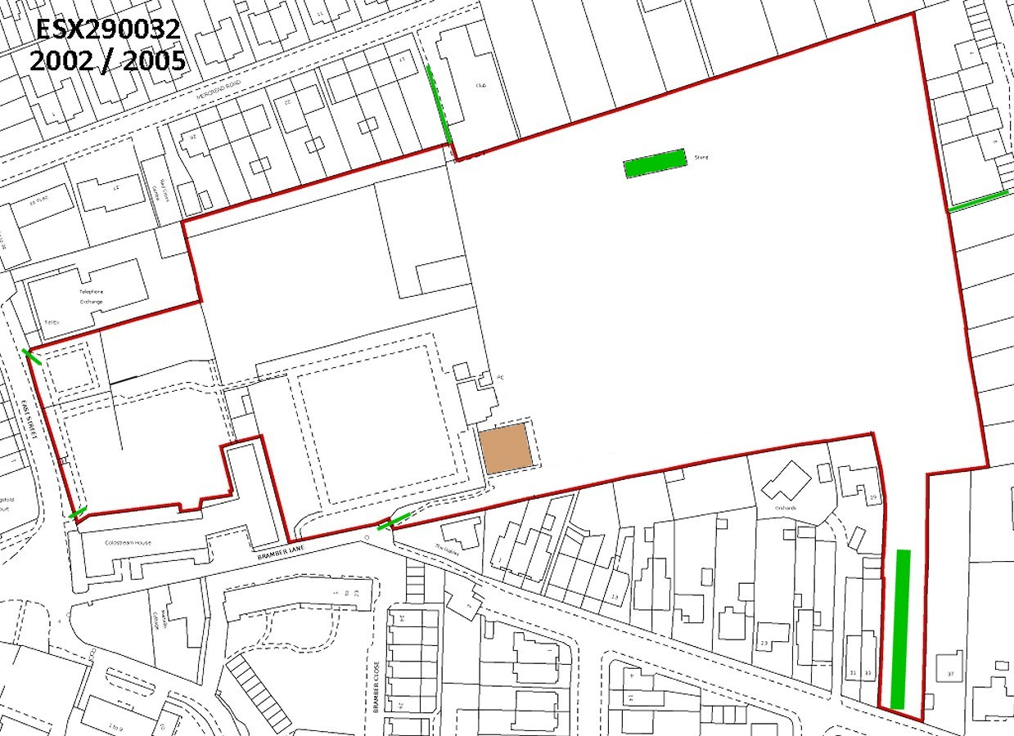
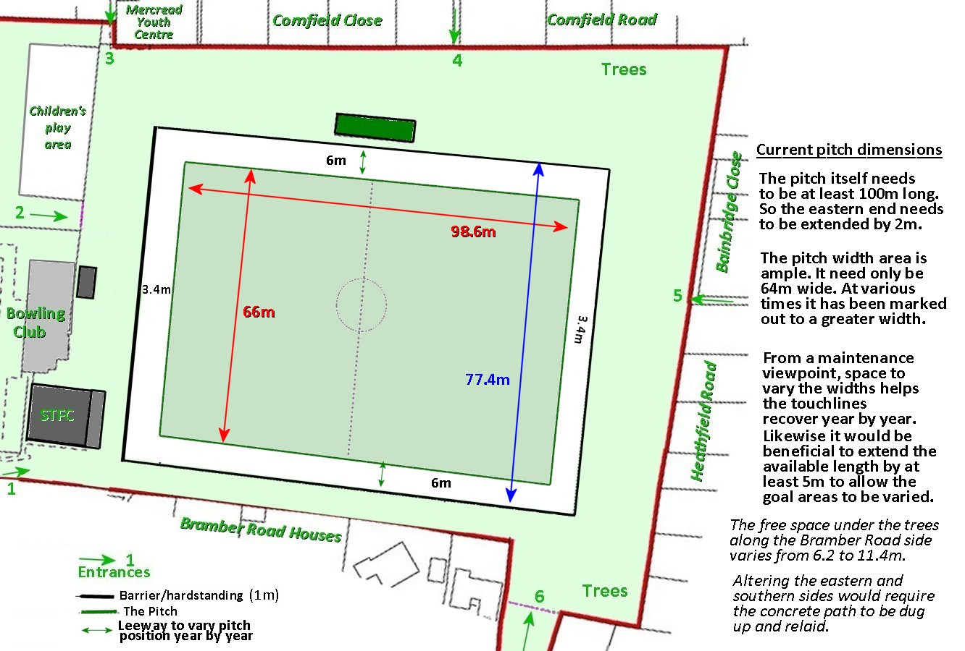
Compostable Toilet Plans

Flat
Landing
1.2
m
m
1.2
Bin
Access
Hatch
1.6
m
m
0.75
Tank
Access
Hatch
Sliding
Door
two fixed
handrails and
one folding
handrail
m
2.4
2.4
m
1.2
m

0.6
m
Tank
Access
Hatch
2.4
m

