

**In order to ensure the high quality of this service, it is necessary to report any damage or hygiene issues to Seaford Town Council immediately on**

**01323 894870**

**Email:changingplaces@seafordtowncouncil.gov.uk**

# Guidelines of Use

Anyone wishing to use this Changing Places Facility should be appropriately trained in the use of specialist equipment including hoists and changing benches. If the person is in any doubt of how to use the equipment, they should not use the facility.

It is for the person(s) using the facility to satisfy themselves regarding compatibility of their slings with the hoist. Seaford Town Council does not supply slings for health and safety reasons If there is any doubt whether a person’s sling is compatible with the hoist, they should not use the hoist.

Before use of the changing bench please ensure that a protective paper sheet is placed on the bench and removed after use.

All soiled/disposable material should be placed in the sanitary bins provided. **DO NOT FLUSH DOWN THE TOILET.**

Please take all soiled clothing away and under no circumstances should clothing be washed on the premises, as this will cause contamination.

It is the carer’s responsibility to ensure the safety of the user at all times including use of the hoist and under no circumstances should the weight limit of the equipment be exceeded. For the hoist maximum weight is 31.5 stone (200kg) and for the changing bench maximum weight is 30 stone (190kg).

The facility **must** be left clean (in the condition you’d expect to find it) and locked after use. Keys are not transferable between users. Misuse of the facility may lead to access being denied.

**Changing**

**Places Facility**

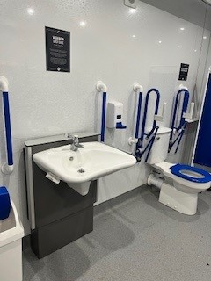

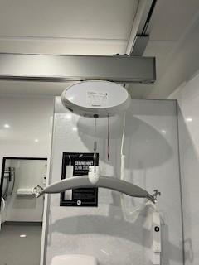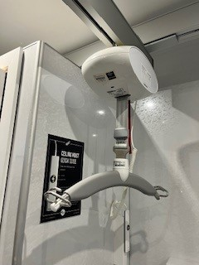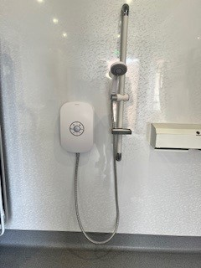

**Please contact**

**Seaford Town Council**

37 Church Street, Seaford, BN25 1HG

changingplaces@seafordtowncouncil.gov.uk

https://www.seafordtowncouncil.gov.uk

Changing places toilets DO NOT supply slings, so you will need to bring your own.

There are different slings with different attachments.

* Sling with clip attachment
* sling with loop attachment
* Sling with dual attachment (compatible

with all)

It is not allowed to lift more than 200kg (440lbs).

The hoist can be used for the following transfers:

* From a (wheel)chair to a bed & vice-versa
* From a (wheel)chair to a toilet & vice-versa
* From a (wheel)chair to a shower-bath-toilet chair & vice-versa

The user can be lifted from sitting or lying position and will hang in a (semi) sitting position.

The hoist can be used in combination with wheelchairs, without having to remove foot, leg or arm supports.

Emergency stop pull cord.

**More about the hoist**

The Seaford Town facility is intended for use by disabled people who require assistance of a carer or need extra facilities.

Access can be gained by contacting Seaford Town Council. You will be required to fill out a membership form for the access code to be sent to you. You will need to purchase your own radar key; this will not be provided by Seaford Town Council.

Evidence of top/mid-rate Disabled Living Allowance, Personal Independence Payment or Diagnosis Letter must be provided for the code to be issued (you will only have to show this once). Carers must also provide proof of ID.

**Martello Changing Places**

**How do they differ from a disabled toilet?**

Unlike standard disabled toilets, the Changing Places has extra specialist equipment and plenty of space for the user and more than one carer.

**Changing Bench**

Wall mounted and height adjustable enabling the bench level to be lowered to a suitable height for self-transfer from a wheelchair or assisted transfer using the hoist, and then raised to a working height for one or more assistants.

**The Hoist**

The hoist eliminates the need to lift a person manually, thus reducing the strain on carer’s backs and the risk of injury to the person being transferred. It aids access to the changing bench and toilet.

**The Toilet**

A peninsular toilet at least a metre away from the walls on either side. This means there is space on both sides of the toilet, allowing wheelchair transfers or assistance from carers.

**Wash Basin**

Height adjustable enabling the basin to be adjusted to suit the user with clear knee space below the bowl, to allow a wheelchair used to comfortably use.

**Also available**

A Shower is also available.

Changing places toilets are somewhere private and clean with the correct equipment for disabled adults and children to use when out and about.

**Equipment Available**

**What is a changing places toilet?**