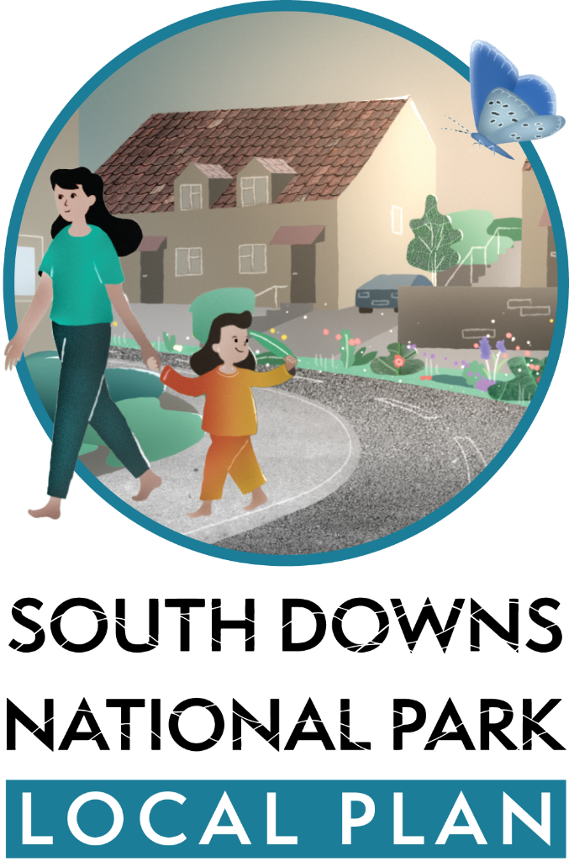

**Seaford Town Council’s responses in Red.**

**Key issues for the Local Plan to address**

We have started work on reviewing the South Downs Local Plan. The review will give us the opportunity to address important issues such as nature recovery and climate change and the types and level of development needed in the National Park, such as affordable homes.

**Which issues are most important to you? (select up to 5)**

(Select one or more options)

Biodiversity loss

**Affordable homes**

Climate change

**Protecting the landscape**

Cultural heritage

Water quality

**Health & wellbeing**

Ageing population

**Vibrant communities**

**Rural economy**

Technology change

*Add something else?*

Coastal Erosion

Water Resilience

**Vision for the National Park**

The Partnership Management Plan sets out the overarching strategy for the management of the National Park and a vision to ensure the South Downs remain a special place in 2050.  This strategy and vision is for all with a responsibility for the National Park, from land owners, conservation bodies, local communities and the SDNP Authority.

The Vision:

*The iconic English lowland landscapes and heritage will have been conserved and greatly enhanced. These inspirational and distinctive places, where people live, work, farm and relax, are adapting well to the impacts of climate change and other pressures.*

*People will understand, value, and look after the vital natural services that the National Park provides. Large areas of high-quality and well-managed habitat will form a network supporting wildlife throughout the landscape.*

*Opportunities will exist for everyone to discover, enjoy, understand and value the National Park and its special qualities. The relationship between people and landscape will enhance their lives and inspire them to become actively involved in caring for it and using its resources more responsibly.*

*Its special qualities will underpin the economic and social wellbeing of the communities in and around it, which will be more self-sustaining and empowered to shape their own future. Its villages and market towns will be thriving centres for residents, visitors and businesses and supporting the wider rural community.*

*Successful farming, forestry, tourism and other business activities within the National Park will actively contribute to, and derive economic benefit from, its unique identity and special qualities.*

**Tell us what you think about the Vision for National Park:**

Happy

**Satisfied**

Neutral

Dissatisfied

Unhappy

**Please can you explain the reason for your answer:**

​

**Can the Vision be improved? Tell us how:**

Make it shorter

Make it clearer

Needs updating

*Add something else?*

**More user friendly**

**Delivering the Vision**

**Planning is one mechanism to help deliver the Vision by 2050. How important are the following for planning and the Local Plan to best contribute to realising the Vision?**

**The Local Plan should make development...**

|  | **Very important** | **Important** | **Not important** | **Somewhat important** |
| --- | --- | --- | --- | --- |
| **Contribute funds to improve local facilities** |  |  |  |  |
| **Include measures for nature recovery** |  |  |  |  |
| **Be net zero in carbon emissions** |  |  |  |  |
| **Include a high proportion of affordable homes** |  |  |  |  |
| **Support farmers diversify whilst protecting the landscape** |  |  |  |  |
| **Provide opportunities to access and enjoy the National Park** |  |  |  |  |

**Any other ways the Local Plan can contribute to the Vision for the National Park?**

**Involved local schools**

**Access to all**

​**Distribution of Development**

**The Local Plan directs where development should be focused in the National Park. Which options should we consider?**

(Select one or more options)

Development on sites within or extensions to our primary settlements (Lewes, Petersfield, Midhurst, Petworth & Liss)

**Development on brownfield land (outside of settlements)**

Small scale development (<11 homes) on the edge of villages

Medium scale development (11-25 homes) on the edge of villages

Development on the edge of the National Park

Tell us your reasons for choosing these options:

Seaford Town Council strongly OBJECT to ‘Development on the Edge of the National Park’.

Development on the edge of the National Park would have a detrimental impact on the open character of the landscape of Seaford.

It would also negatively impact on views towards and from the South Downs National Park, thereby detracting from the quality and setting of a protected landscape and the level of amenity value it provides for residents of Seaford as well as visitors.

The clear development boundary formed by the National Park Boundary to the south of Seaford in the Chyngton Way/South Hill Barn area, as well as around Florence House and Southdown Road, should be retained. Development in this area would affect the ‘transition’ from the settlement boundary to the more open areas of the golf course and the beauty of the open and rolling chalkland, tranquillity and remoteness of the South Downs National Park landscape and the natural qualities of the heritage coast.

​**If I had £1million pounds to invest in the National Park, I would spend it on:**

**£1,000,000**

**Total budget**

Adapting to climate change

£0

Affordable homes – 40%

£400,000

Arts & heritage

£0

Community facilities e.g. playgrounds or village halls – 20%

£200,000

Nature recovery

£0

Walking or cycling routes

£0

Something else – 40%

£400,000

If you said 'Something else' - please specify

Infrastructure

​**Consultation approach**

We will be consulting on a draft Local Plan in early 2025. To help us prepare for this consultation, please tell us your preferred ways to be notified and involved:

Select one or more options

**Local Plan Newsletter**

**Email**

**Leaflet**

**Public meeting**

**Exhibition**

**Posters at local venues**

**Stakeholder workshop**

**Online meeting**

**Recorded webinar**

**Short video**

**Social media (e.g. instagram)**

**Citizens panel**

**Youth panel**

**Consultation phone service**

**Online survey**

**Place-specific notifications**

*Add something else?*