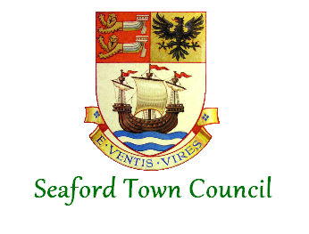

Bad Debt Policy

Policy Ref. | F10
Date Last Adopted | October 2022 - NB. Revised in March 2025 following the Finance Regulations Policy Update
Date of Next Review | October 2025
Possible Prompts for Earlier Review | - Use of the policy and areas for improvement identified  - Change in legislation and/or codes of practice
Previous Adoption Dates | June 2016  June 2015
Author | Responsible Financial Officer

Bad Debt Policy

1. Introduction
This policy outlines Seaford Town Council’s procedures for dealing with late payments and outstanding accounts (bad debts) in accordance with Financial Regulations.

2. Policy Objectives
The aim of this policy is to make clear the procedure that Seaford Town Council will follow to identify, minimise and recover potential bad debts and write off any debts which cannot be recovered.

3. Credit Control
All income due will be collected in accordance with Financial Regulations and any sums found to be irrecoverable or any subsequent bad debts shall be reported to the Finance & General Purposes Committee and where necessary, Full Council.

Unpaid income and bad debts shall be treated in the following manner:
- Invoices which remain unpaid after 30 days will receive a telephone call or email reminding the customer that the invoice remains unpaid.
- Invoices which remain unpaid after 45 days will receive a letter reminding the customer that the invoice remains unpaid.
- Invoices which remain unpaid after 60 days will receive a letter reminding the customer that the invoice remains unpaid and that all of the town councils’ financial information, including bad debts, is reported to the Finance & General Purposes Committee,
- Invoices which remain unpaid after 90 days will receive a letter reminding the customer that the invoice remains unpaid, and notifying of the withdrawal of the service provided and that Seaford Town Council will actively pursue all outstanding debts through the legal system.
- All letters will be accompanied by a statement of account from the town council’s financial system.

4. Write off bad debts
Seaford Town Council will seek to minimise the cost of write offs by taking all necessary action to recover what is due. Debts will be subject to the full recovery, collection and all reasonable legal procedures.

The Town Council recognises that where a debt is irrecoverable, prompt and regular write off of such debts is good practice. Whilst writing off bad debts is a non-routine function; all practical means should be taken to recover outstanding amounts due to the Town Council before the RFO recommends writing off a bad debt to the Finance & General Purposes Committee. Before this decision is made, due diligence consideration should include the following: -

- The cost of recovery against the amount owed.
- The likelihood of success.
- Were the correct credit control procedures followed.
- Could procedure and practices be improved.

Any debts to be written off should be reported in the form of a write off schedule to the Finance & General Purposes Committee, who have delegated powers to write off bad debts of up to £5,000; any larger debts must be reported to Full Council. The write off schedule should contain the following information:

- Customer Reference.
- Invoice number.
- Date of invoice.
- Amount of debt.
- Reason for write off.
- Recovery history.
- Date of write off.
- Authorisation of write off.

5. Year-end write offs
The RFO should ensure any bad debts and doubtful debts are correctly accounted for at year end.

