SF1 – Chyngton Field Response – Supporting Images
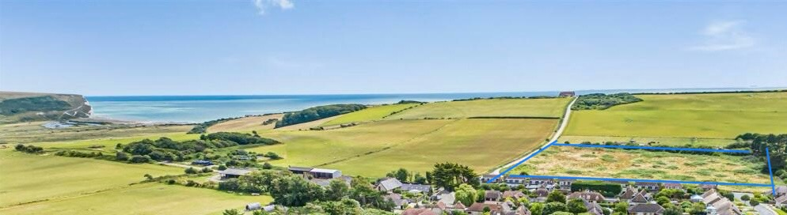
Image 1: This image shows the iconic, highly popular landscape and where the site is situated in relation to this (outline in blue).

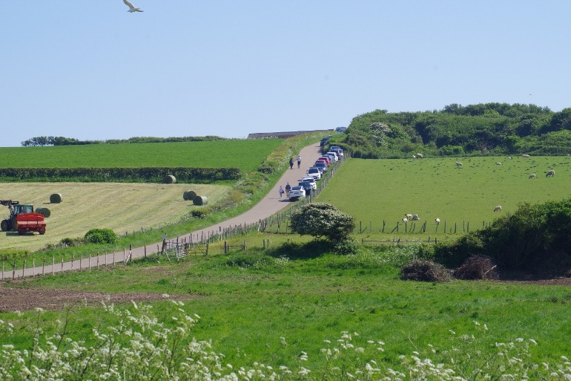 | Image 2: This image displays the open character of the landscape from the site as the gateway to the SDNP.
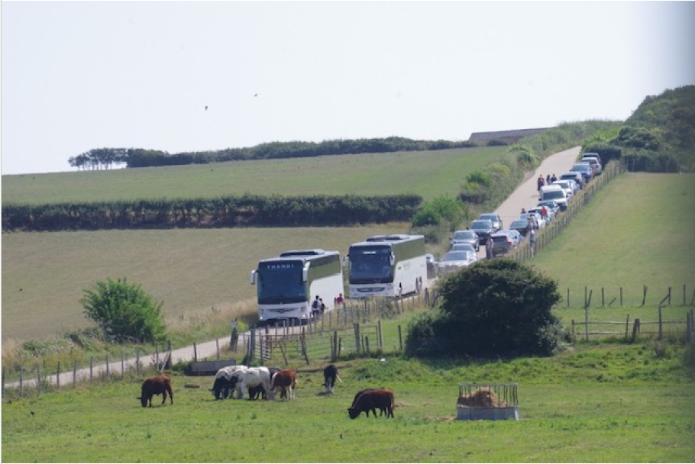 | Image 3: This image highlights the popularity of this tourist area and the traffic issues that brings.
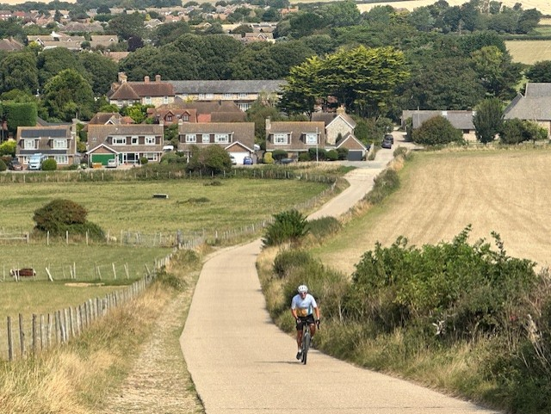 | Image 4: This image presents the landscape looking inland, which shows the site area on the left and why it forms part of the cherished countryside landscape and is described as the gateway to the SDNP.

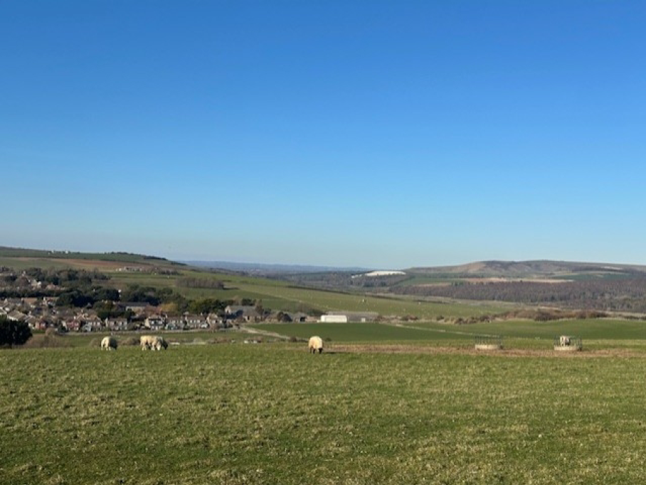 | Image 5: This image presents the landscape from Seaford Head, which shows the site area to the left down the hill, highlighting that this will change this iconic view point from the SDNP.
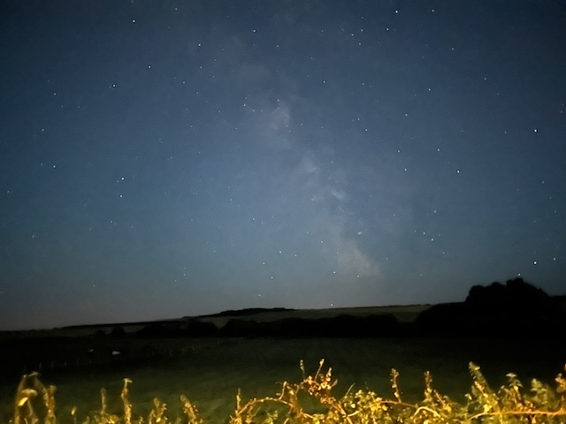 | Image 6: From the site itself, showing just one of the many night’s sky images taken by Dark Skies enthusiasts living in and visiting this iconic area.

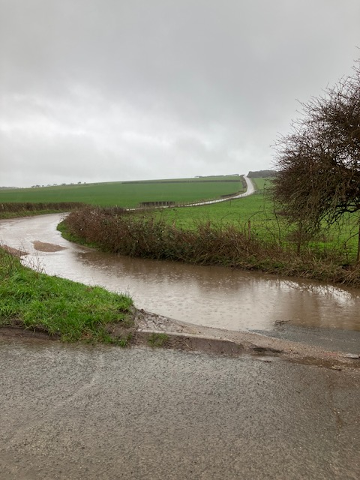 | Image 6: This image shows the surface water flooding just on a light rain day – on heavy rain days it is much worse.
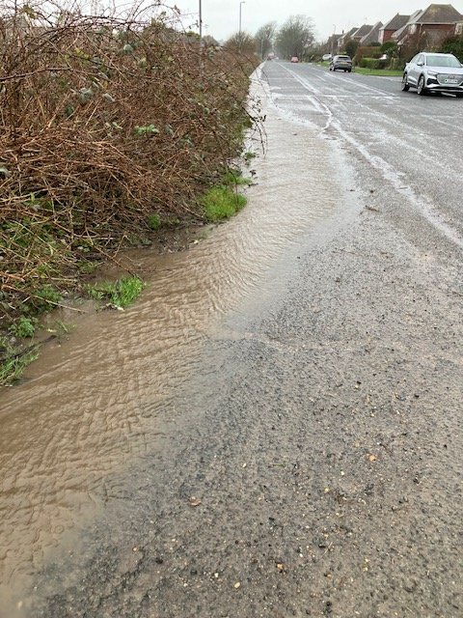 | Image 7: This image shows the water run-off already in this area. Further increase of hard surfaces would increase flooding and run-off to more roads in the area.

