Seaford Town Council – Requests to East Sussex County Council for the Lewes District On-Street Parking Review

No. | Site | Road/s | Request | Reasoning | Supporting Image
1 | Seafront | Esplanade – top of Cliff Gardens and east to Splash Point | Double yellow lines from the southern end of Cliff Gardens east to Splash Point, on both sides of the road, including the turning circle but excluding the designated parking bays on the seaside and the disabled bays in the turning circle | - To allow proper use of the turning circle  - To allow safe access for emergency services (fire and ambulance, larger vehicles) to splash point and the rear of the houses at Cliff Close | 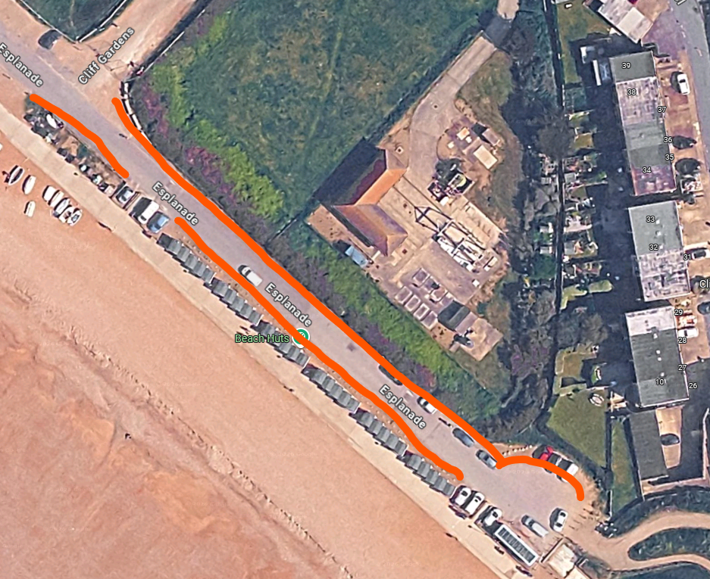
2 | Seafront | Martello Road | Extension of the current double yellow lines on the eastern side from the junction with the Esplanade to the unmade stretch of road | - To avoid unpassable roads during peak months when the seafront is overwhelmed with visitors by vehicles  - To protect the entry into and out of Martello Mews  - To maintain parking on the western side where there is exit onto a pavement | 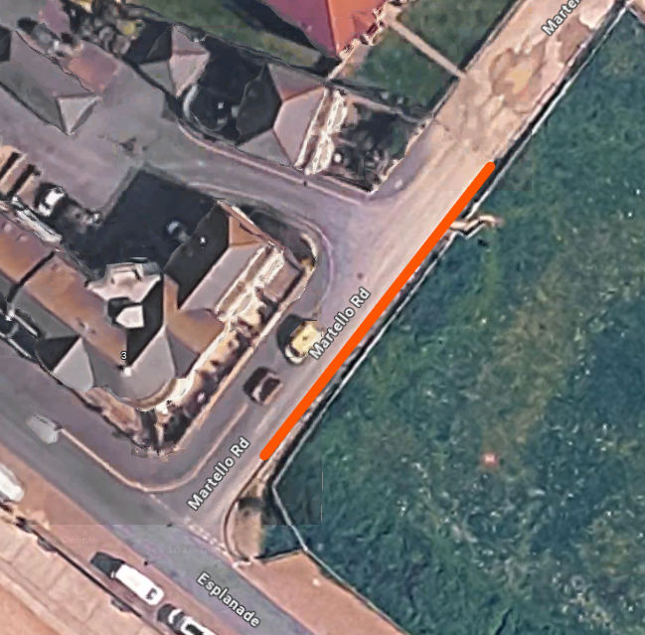
3 | Seafront | Cricketfield Road – section between Martello Fields | Double red lines to be put on both sides of the road (with double yellow currently on one only).  If double red lines are not possible, then double yellow lines on both sides of the road. | - This road is vital for access to the seafront, part of the local bus route and used very heavily in the peak months  - Parking on one side of this road causes congestion in the Esplanade, College Road and Cricketfield Road, where there are frequently lots of pedestrians and beach users  - There is no pavement on the unmarked side of the road, restricting safe access to and from parked vehicles | 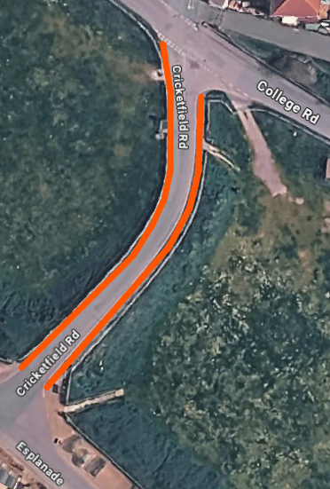
4 | Town Centre | High Street – ‘upper’ / eastern stretch, left from bottom of Broad Street | Parking restriction during daytime hours (8am to 6pm, Monday to Saturday) on its southern side | - To allow safer passage along a narrow road during peak hours, including larger delivery vehicles for the businesses within the town centre  - To allow easier exit from the business park (blue circle) on to High Street, which is currently restricted by vehicles parked opposite the entrance | 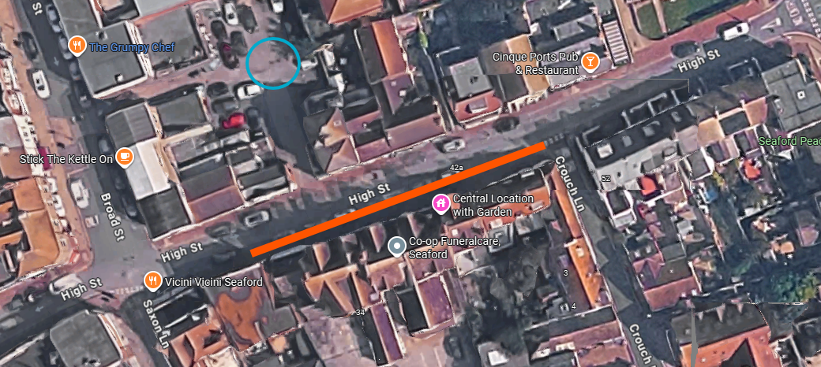
5 | Town Centre | Broad Street (entire length of) | Change current parking restriction from 8am to 8pm, to 8am to 6pm | - Majority of businesses within the town centre close at 5/5.30pm, so a restriction until 8pm is not needed. Also supports restaurants and convenience shops who are open later and benefit from ease of customer parking | -
6 | Schools | Steyne Road – between Crooked Lane and Ashurst Road | Double yellow lines on school side of Steyne Road | - To ease current pinch point of traffic, causing congestion and erratic driving so near to a school entrance | 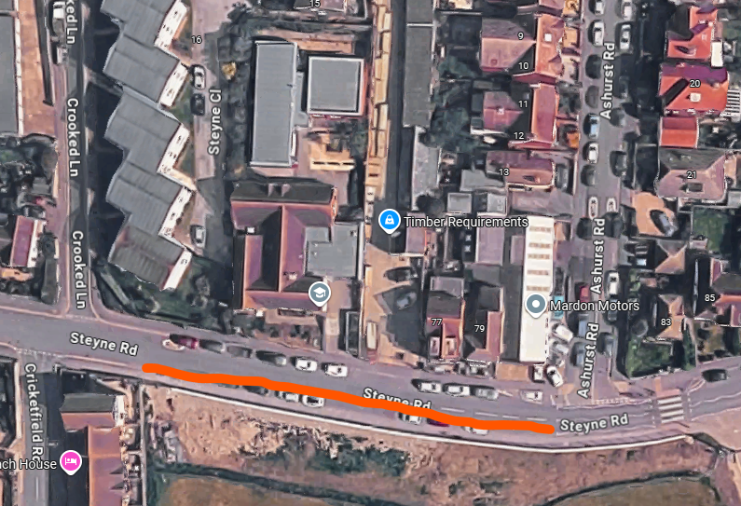
7 | Schools | Lexden Road | Double yellow lines on Lexden Road opposite the junction with Upper Belgrave Road | - This area is frequently used for parking for the nearby school making this well used junction dangerous and causing congestion  - This is part of a local bus route (buses coming down Upper Belgrave Road and turning left on to Lexden Road) and cars parked opposite the junction can cause issues for the bus to swing round the corner | 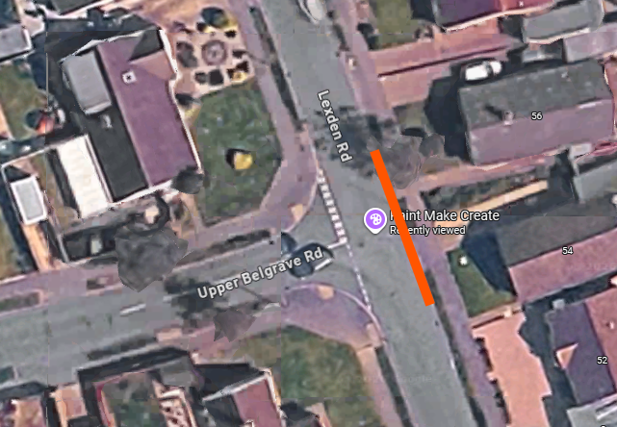
8 | Other | North Way & Upper Belgrave Road | Double yellow lines around corner of junction of North Way and Upper Belgrave Road | - Vehicles frequently park close to the corner in North Way, causing restricted vision for vehicles turning into North Way and subsequent congestion on Upper Belgrave Road which is used as a cut through to avoid main roads and particularly busy around school times | 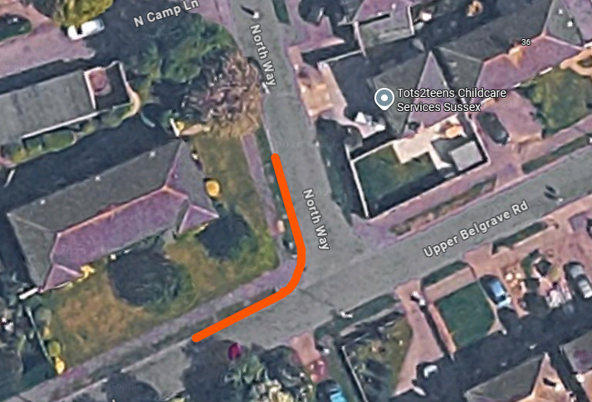
9 | Other | Alfriston Road | The Town Council understand that this is a complex area given the limited parking, residential homes and new convenience store. The Town Council requests that ESCC assesses the parking arrangements on Alfriston Road (from the junction with Hindover Road to Blue Haze Avenue) | - There are frequently vehicles parked with two wheels on the kerb on Alfriston Road (the stretch including 3 – 71 Alfriston Road) creating pinch points on this busy road (being one of the three main entry roads into the town) | -
10 | Other | Brooklyn Road & Chichester Road | The Town Council acknowledges that these are narrow roads and navigating these can be very challenging – the request is for ESCC to assess the parking arrangements for suitability and any potential improvements | - Residents have expressed concerns regarding the parking in these roads, exacerbated by vehicles from local car dealerships and users of the train and bus stations | -
11 | Other | Hawth Hill, Hawth Crescent and Hawth Park Road, Bishopstone – entire length of | Double yellow lines on one side of the entire road | - This is a bus route providing vital access to public transport to this estate – the current road is at times barely passable for the bus, with vehicles parked everywhere, frequently on kerbs and grass verges restricting the path through for any large vehicles (including large emergency service vehicles and deliveries)  - There has been incidences of the local bus having to turn around at Hawth Grove because it cannot carry on | -
12 | Other | Vale Road | The Town Council acknowledges that Vale Road is a complex road, with a high demand for on street parking for residents, being on a regularly used bus route and often being used locally as the ‘rat run’ to avoid the A259. The request is for ESCC to assess the parking arrangements for suitability and any potential improvements | - Residents have expressed concerns regarding the parking in this road and the lack of vision at junctions e.g. with Sutton Drove and Lexden Road junctions, and as vehicles enter Vale Road from Alfriston Road and road bends | -
13 | Other | Walmer Road | Double yellow lines on the junctions of Walmer Road with side roads coming off it: Hythe Crescent, Bodiam Close, Saltwood Road, and Romney Close | - To allow greater vision and safer passageway on to a main road used as a bus route, to service the local primary school, for the local post office, well used churches / community halls, in a densely populated residential area | -
14 | Other | Station Road, Bishopstone | Request for a disabled parking bay at the train station | - The train station does not have a disabled parking bay  - As well as access to the train service, the station also houses a thriving community hub (Friends of Bishopstone Station) that is well used throughout the week by local residents for a variety of purposes
15 | Other | Chyngton Way and surrounding roads | The Town Council requests that ESCC makes appropriate mitigation along Chyngton Way and surrounding roads in recognition of the trial pay and display scheme at South Hill Barn commencing April 2026 | - There is a high likelihood risk that the pay & display trial will lead to displaced cars looking for elsewhere to park in the nearby residential streets | -

General Comments
- Better enforcement is needed in general across the town day and night
- Better enforcement is needed near junctions on double yellow lines, particularly at night when they seem to be routinely ignored.
- More double yellow lines at junctions needed to ensure the safety of road users (vehicles, cyclists and pedestrians)
- More enforcement is needed during peak times, especially along seafront and northern side of the road/pavement during the summer months
Requests from Members of the Public
There were a number of individual requests from members of the public that the Town Council has not been able to consider in detail. The Town Council is therefore forwarding these requests to ESCC for consideration and does not have an adopted position on them:
Seafront
- A dedicated area for coaches and for them to be charged for parking
- Introducing EV charging points
- Increasing the size of parking bays
- Slanting the parking for improved safety
- Improving safety for pedestrians crossing between the promenade and Dane Road by addressing the issue with cars parked right up against the wall (opposite the junction with Dane Road)
Other
- Edinburgh Road and Claremont Road, request for double yellow lines around the junction
- Heathfield Road and Bainbridge Road, request for double yellow lines around the junction and white lines round driveways, due to restricted visibility
- Rye Close, restrictions needed on narrow section from Saltwood Road
- Buckle Drive and Buckle Close, request for double yellows on both sides of the road
- Fitzgerald Avenue and Fitzgerald Park, request for double yellow lines on one side of
- Kingsmead, request for double yellow lines at the ends of the road
- Richmond Road, request for double yellow lines to prevent parking on pavement, causing issues for pedestrians
- Ringmer Road, request for no parking area opposite the car park exit, between Cunningham Road and number 12.
- Vale Close, introduction of parking bays
- Double yellow lines on Southdown Road at junction with Sutton Road for 50 metres
- Blatchington Road, review of need for double yellow lines at junctions with side roads
- Queen Park Gardens, request for double yellow lines on corners.

